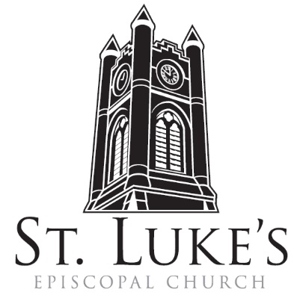
Holy Eucharist ~ July 21, 2024
8am in the Chapel; 10am in the Church

Ninth Sunday After Pentecost

St. Luke’s Episcopal Church
North Main at Fourth Street
Jamestown, New York
The Rt. Rev. Sean Rowe, Bishop, Presiding Bishop-Elect
The Rev. Luke Fodor, Rector; The Rev. Deacon Cathy Smith;
Mr. Paul Johnson, Verger; Mrs. Cindy Lind Hanson, Guest Organist
The Rev. Jessica Frederick, Curate for Children, Youth & Family Ministry
www.stlukesjamestown.org ~ email: stlukes@stlukesjamestown.org

The mission is simple: to Connect all people, help them Discover God's love, empower them to Serve and watch them Grow.”

WELCOME TO ST. LUKE’S
We welcome you this morning to St. Luke’s Church and are delighted to have you join us for worship today. If you are visiting for the first time, or are looking for a church home, please fill in a pew card and place it in the offering plate.
At the time of Communion, all are invited to God’s Table. In addition to the altar rail, at the 10 a.m. service a floor-level Communion station is made available, which includes gluten-free wafers and grape juice, please indicate your preference. Available to children is a visit to the Children’s Corner, or the use of a “Children’s Activity Bag” found near the front of the church nave (ask an usher). Nursery care is provided downstairs. Clergy and members of the congregation look forward to greeting you after services. Join us downstairs for refreshments. All are welcome! Audio transmitters are available for those who have difficulty hearing the service; please ask an usher. There is a hearing loop installed on the left side of the sanctuary. If you need to leave the sanctuary during the service, please use the side aisles. Please also use the side aisles to return to your seat after Communion.
~ Copies of today’s sermon are available at the doors. ~

prelude

opening hymn: #518 christ is made the sure foundation -Blue Pew Hymnal

opening acclamation
Blessed be God: Father, Son, and Holy Spirit.
People: And blessed be God’s kingdom, now and for ever. Amen.

Collect for Purity, said by all
Almighty God, to you all hearts are open, all desires known, and from you no secrets are hid: Cleanse the thoughts of our hearts by the inspiration of your Holy Spirit, that we may perfectly love you, and worthily magnify your holy Name; through Christ our Lord. Amen.

Gloria, said by all at 8am, sung at 10am. -S280, Blue Pew Hymnal
Glory to God in the highest, and peace to God’s people on earth. Lord God, heavenly King, almighty God and Father, we worship you, we give you thanks, we praise you for your glory. Lord Jesus Christ, only Son of the Father, Lord God, Lamb of God, you take away the sin of the world; have mercy on us; you are seated at the right hand of the Father; receive our prayer. For you alone are the Holy One, you alone are the Lord, you alone are the Most High, Jesus Christ, with the Holy Spirit, in the glory of God the Father. Amen.

The Collect of the Day: The Lord be with you. Response: And also with you.
Let us pray: Almighty God, the fountain of all wisdom, you know our necessities before we ask and our ignorance in asking: Have compassion on our weakness, and mercifully give us those things which for our unworthiness we dare not, and for our blindness we cannot ask; through the worthiness of your Son Jesus Christ our Lord, who lives and reigns with you and the Holy Spirit, one God, now and for ever. Amen.

The First Reading: 2 Samuel 7:1-14a
When the king was settled in his house, and the Lord had given him rest from all his enemies around him, the king said to the prophet Nathan, “See now, I am living in a house of cedar, but the ark of God stays in a tent.” Nathan said to the king, “Go, do all that you have in mind; for the Lord is with you.” But that same night the word of the Lord came to Nathan: Go and tell my servant David: Thus says the Lord: Are you the one to build me a house to live in? I have not lived in a house since the day I brought up the people of Israel from Egypt to this day, but I have been moving about in a tent and a tabernacle. Wherever I have moved about among all the people of Israel, did I ever speak a word with any of the tribal leaders of Israel, whom I commanded to shepherd my people Israel, saying, “Why have you not built me a house of cedar?” Now therefore thus you shall say to my servant David: Thus says the Lord of hosts: I took you from the pasture, from following the sheep to be prince over my people Israel; and I have been with you wherever you went, and have cut off all your enemies from before you; and I will make for you a great name, like the name of the great ones of the earth. And I will appoint a place for my people Israel and will plant them, so that they may live in their own place, and be disturbed no more; and evildoers shall afflict them no more, as formerly, from the time that I appointed judges over my people Israel; and I will give you rest from all your enemies. Moreover the Lord declares to you that the Lord will make you a house. When your days are fulfilled and you lie down with your ancestors, I will raise up your offspring after you, who shall come forth from your body, and I will establish his kingdom. He shall build a house for my name, and I will establish the throne of his kingdom forever. I will be a father to him, and he shall be a son to me.
The Word of the Lord. Thanks be to God.

Psalm #89:20-37, please join in saying the psalm responsively by half verse. -St. Helena Psalter
²⁰ I have found David my servant; * with my holy oil have I anointed him.
²¹ My hand will hold him fast * and my arm will make him strong.
²² No enemy shall deceive him, * nor any adversary bring him down.
²³ I will crush his foes before him * and strike down those who hate him.
²⁴ My faithfulness and love shall be with him, * and he shall be victorious through my Name.
²⁵ I shall make his dominion extend * from the Great Sea to the River.
²⁶ He will say to me, ‘You are my Creator, * my God and the rock of my salvation.’
²⁷ I will make him my firstborn * and higher than the rulers of the earth.
²⁸ I will keep my love for him for ever, * and my covenant will stand firm for him.
²⁹ I will establish his line for ever * and his throne as the days of heaven.”
³⁰ “If his children forsake my law * and do not walk according to my judgments;
³¹ If they break my statutes * and do not keep my commandments;
³² I will punish their transgressions with a rod * and their iniquities with the lash;
³³ But I will not take my love from him, * nor let my faithfulness prove false.
³⁴ I will not break my covenant, * nor change what has gone out of my lips.
³⁵ Once for all I have sworn by my holiness: * ‘I will not lie to David.
³⁶ His line shall endure for ever * and his throne as the sun before me;
³⁷ It shall stand fast for evermore like the moon, * the abiding witness in the sky.’ ”

The Second Reading: Ephesians 2:11-22
Remember that at one time you Gentiles by birth, called “the uncircumcision” by those who are called “the circumcision” —a physical circumcision made in the flesh by human hands— remember that you were at that time without Christ, being aliens from the commonwealth of Israel, and strangers to the covenants of promise, having no hope and without God in the world. But now in Christ Jesus you who once were far off have been brought near by the blood of Christ. For he is our peace; in his flesh he has made both groups into one and has broken down the dividing wall, that is, the hostility between us. He has abolished the law with its commandments and ordinances, that he might create in himself one new humanity in place of the two, thus making peace, and might reconcile both groups to God in one body through the cross, thus putting to death that hostility through it. So he came and proclaimed peace to you who were far off and peace to those who were near; for through him both of us have access in one Spirit to the Father. So then you are no longer strangers and aliens, but you are citizens with the saints and also members of the household of God, built upon the foundation of the apostles and prophets, with Christ Jesus himself as the cornerstone. In him the whole structure is joined together and grows into a holy temple in the Lord; in whom you also are built together spiritually into a dwelling place for God. The Word of the Lord. Thanks be to God.

Gospel sequence hymn: #529 in christ there is no east or west -Blue Pew Hymnal

The Holy Gospel of our Lord Jesus Christ, according to Mark 6:30-34, 53-56
Response before the Gospel: Glory to you, Lord Christ.
The apostles gathered around Jesus, and told him all that they had done and taught. He said to them, “Come away to a deserted place all by yourselves and rest a while.” For many were coming and going, and they had no leisure even to eat. And they went away in the boat to a deserted place by themselves. Now many saw them going and recognized them, and they hurried there on foot from all the towns and arrived ahead of them. As he went ashore, he saw a great crowd; and he had compassion for them, because they were like sheep without a shepherd; and he began to teach them many things. When they had crossed over, they came to land at Gennesaret and moored the boat. When they got out of the boat, people at once recognized him, and rushed about that whole region and began to bring the sick on mats to wherever they heard he was. And wherever he went, into villages or cities or farms, they laid the sick in the marketplaces, and begged him that they might touch even the fringe of his cloak; and all who touched it were healed. The Gospel of the Lord. Praise to you, Lord Christ.

Gospel sequence hymn: #529 in christ there is no east or west -Blue Pew Hymnal

Sermon -The Rev. Jessica Frederick, Curate

Nicene Creed, said by all, standing as able
We believe in one God, the Father, the Almighty, maker of heaven and earth, of all that is, seen and unseen. We believe in one Lord, Jesus Christ, the only Son of God, eternally begotten of the Father, God from God, Light from Light, true God from true God, begotten, not made, of one Being with the Father; through him all things were made. For us and for our salvation he came down from heaven, was incarnate of the Holy Spirit and the Virgin Mary and became truly human. For our sake he was crucified under Pontius Pilate; he suffered death and was buried. On the third day he rose again in accordance with the Scriptures; he ascended into heaven and is seated at the right hand of the Father. He will come again in glory to judge the living and the dead, and his kingdom will have no end. We believe in the Holy Spirit, the Lord, the giver of life, who proceeds from the Father, who with the Father and the Son is worshiped and glorified, who has spoken through the prophets. We believe in one holy catholic and apostolic Church. We acknowledge one baptism for the forgiveness of sins. We look for the resurrection of the dead, and the life of the world to come. Amen.

Prayers of the People: Form I -BCP 383
With all our heart and with all our mind, let us pray to the Lord, saying "Lord, have mercy."

For the peace of the world, for the welfare of the Holy Church of God, and for the unity of all peoples, let us pray to the Lord. Lord, have mercy.

For our Michael, our Presiding Bishop, for Sean, the Bishop of our Diocesan Partnership and Presiding Bishop-Elect, for the Episcopal Partnership churches of Holy Trinity (Brookville), St. Paul’s (Angola) and St. Luke’s (Attica), for The Church of Ireland, for Luke, Jessica, Cathy and Tom, our clergy and for all the clergy and people, let us pray to the Lord. Lord, have mercy.

For Joe, our President, Kathy, our Governor, Kim, our Mayor, for the members of Congress and the Supreme Court, for the people of Ukraine and the people of the Holy Land, for the leaders of the nations, and for all in authority, let us pray to the Lord. Lord, have mercy.

For this city, for every city and community, and for those who live in them, let us pray to
the Lord. Lord, have mercy.

For the good earth which God has given us, and for the wisdom and will to conserve it, let us pray to the Lord. Lord, have mercy.

For the aged and infirm, for the widowed and orphans, and for the sick and the suffering, let us pray to the Lord. Lord, have mercy.

Please join me in saying aloud the names of the people on our prayer list: Tim Pickett, Joyce Crate, Mary Holton, Carol Boling, Mac Dawson, David Small, Preston, Matteo Dominick, Dennis Lassi, Beth Kresge, Sandy Stewart, Owen Gould, Gayla Bolles Schwartzman, Nate Rappole, and those others we now name. The people are invited to say names aloud or in their hearts.

Let us pray to the Lord; Lord, have mercy.

For all who have died in the hope of the resurrection, and for all the departed, let us pray to the Lord. Lord, have mercy.

For deliverance from all danger, violence, oppression, and degradation, let us pray to the Lord. Lord, have mercy.

That we may end our lives in faith and hope, without suffering and without reproach, let us pray to the Lord. Lord, have mercy.

In the communion of Saint Luke and all the saints, let us commend ourselves, and one another, and all our life, to Christ our God. To thee, O Lord our God.

The Celebrant adds a concluding Collect.
O God, you have made of one blood all the peoples of the earth, and sent your blessed Son to preach peace to those who are far off and to those who are near: Grant that people everywhere may seek after you and find you, bring the nations into your fold, pour out your Spirit upon all flesh, and hasten the coming of your kingdom; through Jesus Christ our Lord, who lives and reigns with you and the Holy Spirit, one God, now and for ever. Amen.

Confession of Sin
Most merciful God, we confess that we have sinned against you in thought, word, and deed, by what we have done, and by what we have left undone. We have not loved you with our whole heart; we have not loved our neighbors as ourselves. We are truly sorry and we humbly repent. For the sake of your Son Jesus Christ, have mercy on us and forgive us; that we may delight in your will, and walk in your ways, to the glory of your Name. Amen.

Absolution

The Peace Let us exchange the Peace of Christ with one another!
The peace of the Lord be always with you. People And also with you.

THE HOLY COMMUNION
if you’d like to give electronically, scan the QR code using the camera on your phone.

8am Offertory: All things come of thee, O Lord. And of thine own have we given thee. Amen.
10am offertory hymn: #708 savior like a shepherd lead us -Blue Pew Hymnal

10am doxology, sung by all
Praise God from whom all blessings flow; praise God all creatures here below; praise God above ye heavenly hosts; Praise Father, Son and Holy Ghost. Amen.

The Great Thanksgiving: Eucharistic Prayer: Enriching Our Worship 3
The Lord be with you. And also with you.
Lift up your hearts. We lift them up to the Lord.
Let us give thanks to the Lord our God. It is right to give our thanks and praise.

All thanks and praise are yours at all times and in all places, our true and loving God; through Jesus Christ, your eternal Word, the Wisdom from on high by whom you created all things. You laid the foundations of the world and enclosed the sea when it burst out from the womb; you brought forth all creatures of the earth and gave breath to humankind. Wondrous are you, Holy One of Blessing, all you create is a sign of hope for our journey; and so as the morning stars sing your praises we join the heavenly beings and all creation as we shout with joy:

Sanctus & Benedictus, spoken at 8am, sung at 10am #S125 Blue pew hymnal
Holy, Holy, Holy Lord, God of power and might, heaven and earth are full of your glory. Hosanna in the highest. Blessed is the One who comes in the name of the Lord. Hosanna in the highest.

Glory and honor are yours, Creator of all, your Word has never been silent; you called a people to yourself, as a light to the nations, you delivered them from bondage and led them to a land of promise. Of your grace, you gave Jesus to be human, to share our life, to proclaim the coming of your holy reign and give himself for us, a fragrant offering. Through Jesus Christ our Redeemer, you have freed us from sin, brought us into your life, reconciled us to you, and restored us to the glory you intend for us. We thank you that on the night before he died for us Jesus took bread, and when he had given thanks to you, he broke it, gave it to his friends and said: “Take, eat, this is my Body, broken for you. Do this for the remembrance of me.” After supper Jesus took the cup of wine, said the blessing, gave it to his friends and said: “Drink this, all of you: this cup is the new Covenant in my Blood, poured out for you and for all for the forgiveness of sin. Do this for the remembrance of me.” And so, remembering all that was done for us: the cross, the tomb, the resurrection and ascension, longing for Christ’s coming in glory, and presenting to you these gifts your earth has formed and human hands have made, we acclaim you, O Christ:

Dying, you destroyed our death. Rising, you restored our life. Christ Jesus, come in glory!

Send your Holy Spirit upon us and upon these gifts of bread and wine that they may be to us the Body and Blood of your Christ. Grant that we, burning with your Spirit’s power, may be a people of hope, justice and love. Giver of Life, draw us together in the Body of Christ, and in the fullness of time gather us with blessed Saint Luke, and all your people into the joy of our true eternal home. Through Christ and with Christ and in Christ, by the inspiration of your Holy Spirit, we worship you our God and Creator in voices of unending praise. Blessed are you now and for ever. AMEN.

And now, as our Savior Christ has taught us, we are bold to say,
Our Father, who art in heaven, hallowed be thy Name, thy kingdom come, thy will be done, on earth as it is in heaven. Give us this day our daily bread. And forgive us our trespasses, as we forgive those who trespass against us. And lead us not into temptation, but deliver us from evil. For thine is the kingdom, and the power, and the glory, for ever and ever. Amen.

The Breaking of the Bread Silent moment

8am: Alleluia, Christ our Passover is sacrificed for us; Therefore let us keep the feast. Alleluia.

10am: fraction anthem -S164 Blue Pew Hymnal
Jesus Lamb of God: have mercy on us. Jesus bearer of our sins: have mercy on us. Jesus, redeemer, redeemer of the world: give us your peace, give us your peace.

The Communion Wherever you are on your spiritual journey, all are invited to receive Communion.
Gluten-free wafers, as well as grape juice, are available, please indicate your preference;
If you have difficulty coming forward, communion can be brought to you at your seat.
You are invited to light a candle for a person or concern in your prayers.
A candle station is located at the back of the Chapel.

Communion music: #693 just as i am
jesus remember me
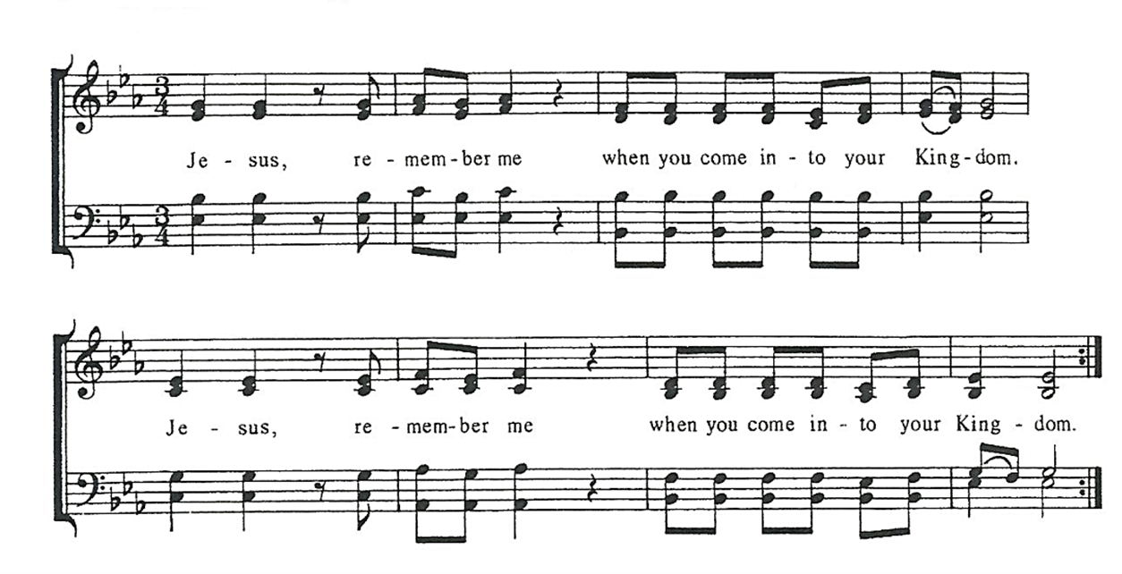

Post Communion Prayer, said by all
Eternal God, heavenly Father, you have graciously accepted us as living members
of your Son, our Savior Jesus Christ, and you have fed us with spiritual food in the
sacrament of his Body and Blood. Send us now into the world in peace, and grant
us strength and courage to love and serve you with gladness and singleness of heart;
through Christ our Lord. Amen.

Blessing
sending hymn: the house of god is our delight
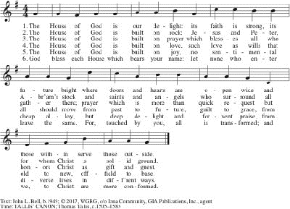

Dismissal Go in peace to love and serve the Lord. Alleluia, alleluia, alleluia!
Response: Thanks be to God! Alleluia, Alleluia, Alleluia!

postlude

The flowers on the altar are given to the Glory of God by Janet Card.

Announcements

Altar Flowers
We have a few open Sundays for sponsoring altar flowers this year, particularly in late summer, early fall, and December. If you have someone you’d like to honor on an important date (birthday, anniversary, memorial, etc.) please look at the flower board in the vestibule. The cost is $94. You can choose what flowers you’d like to have used in the arrangement, and after the 10am service the flowers go to the sponsoring parishioner and/or are delivered to community members with St. Luke’s love and prayers. Contact the Parish Administrator with any questions.

Chadakoin Chamber Ensemble Summer Recital: TODAY @ 4pm in the Church
This concert will feature Aaron and Boaz Meacham, local musicians who have shared their gifts at St. Luke’s, most recently at our Christmas Eve Service. Selections include pieces on the violin, organ and piano by Biber, Shubert and Weeks. As always, the concert is free, with donations accepted to benefit the Ensemble.

Wednesday Group 7/24 @ 11:30am in the Undercroft
The next Wednesday Group is this week, July 24 at 11:30am in the Undercroft. The Rev. Jessica Frederick will lead the service, followed by lunch. Call the church office (716) 483-6405 if you need transportation.

Monday Night Café 7/29 @ 6pm in the Undercroft
Save the date for next Monday Night Café, scheduled for July 29th at 6pm in the Undercroft. If you’d like to volunteer, contact Nick Weith at nick.weith@stlukesjamestown.org. All are welcome to enjoy a locally sourced meal with old and new friends.

