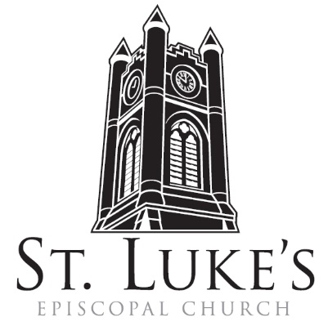
Holy Eucharist ~ July 7, 2024
8am in the Chapel; 10am in the Church

Seventh Sunday After Pentecost

St. Luke’s Episcopal Church
North Main at Fourth Street
Jamestown, New York
The Rt. Rev. Sean Rowe, Bishop, Presiding Bishop-Elect
The Rev. Luke Fodor, Rector; The Rev. Deacon Cathy Smith;
Mr. Paul Johnson, Verger; Mr. Owen Reyda, Guest Organist
The Rev. Jessica Frederick, Curate for Children, Youth & Family Ministry
www.stlukesjamestown.org ~ email: stlukes@stlukesjamestown.org

The mission is simple: to Connect all people, help them Discover God's love, empower them to Serve and watch them Grow.”

WELCOME TO ST. LUKE’S
We welcome you this morning to St. Luke’s Church and are delighted to have you join us for worship today. If you are visiting for the first time, or are looking for a church home, please fill in a pew card and place it in the offering plate.
At the time of Communion, all are invited to God’s Table. In addition to the altar rail, at the 10 a.m. service a floor-level Communion station is made available, which includes gluten-free wafers and grape juice, please indicate your preference. Available to children is a visit to the Children’s Corner, or the use of a “Children’s Activity Bag” found near the front of the church nave (ask an usher). Nursery care is provided downstairs. Clergy and members of the congregation look forward to greeting you after services. Join us downstairs for refreshments. All are welcome! Audio transmitters are available for those who have difficulty hearing the service; please ask an usher. There is a hearing loop installed on the left side of the sanctuary. If you need to leave the sanctuary during the service, please use the side aisles. Please also use the side aisles to return to your seat after Communion.

~ Copies of today’s sermon are available at the doors. ~

prelude

opening hymn: #657 love divine all love excelling -Blue Pew Hymnal

opening acclamation
Blessed be God: Father, Son, and Holy Spirit.
People: And blessed be God’s kingdom, now and for ever. Amen.

Collect for Purity, said by all
Almighty God, to you all hearts are open, all desires known, and from you no secrets are hid: Cleanse the thoughts of our hearts by the inspiration of your Holy Spirit, that we may perfectly love you, and worthily magnify your holy Name; through Christ our Lord. Amen.

Gloria, said by all at 8am, sung at 10am. -S280, Blue Pew Hymnal
Glory to God in the highest, and peace to God’s people on earth.
Lord God, heavenly King, almighty God and Father,
we worship you, we give you thanks, we praise you for your glory.
Lord Jesus Christ, only Son of the Father, Lord God, Lamb of God,
you take away the sin of the world; have mercy on us;
you are seated at the right hand of the Father; receive our prayer.
For you alone are the Holy One, you alone are the Lord,
you alone are the Most High, Jesus Christ,
with the Holy Spirit, in the glory of God the Father. Amen.

The Collect of the Day: The Lord be with you. Response: And also with you.
Let us pray: O God, you have taught us to keep all your commandments by loving you and our neighbor: Grant us the grace of your Holy Spirit, that we may be devoted to you with our whole heart, and united to one another with pure affection; through Jesus Christ our Lord, who lives and reigns with you and the Holy Spirit, one God, for ever and ever. Amen.

The First Reading: 2 Samuel 5:1-5, 9-10
All the tribes of Israel came to David at Hebron, and said, “Look, we are your bone and flesh. For some time, while Saul was king over us, it was you who led out Israel and brought it in. The Lord said to you: It is you who shall be shepherd of my people Israel, you who shall be ruler over Israel.” So all the elders of Israel came to the king at Hebron; and King David made a covenant with them at Hebron before the Lord, and they anointed David king over Israel. David was thirty years old when he began to reign, and he reigned forty years. At Hebron he reigned over Judah seven years and six months; and at Jerusalem he reigned over all Israel and Judah thirty-three years. David occupied the stronghold, and named it the city of David. David built the city all around from the Millo inwards. And David became greater and greater, for the Lord, the God of hosts, was with him. The Word of the Lord. Thanks be to God.

Psalm #48, please join in saying the psalm responsively by whole verse. -St. Helena Psalter
¹ God is great and highly to be praised; *in the city of our God is the holy hill.
² Beautiful and lofty, the joy of all the earth, is the hill of Zion, * the very center of the world and the city of the great Sovereign.
³ God is in its citadels; * God is known to be its sure refuge.
⁴ Behold, the monarchs of the earth assembled * and marched forward together.
⁵ They looked and were astounded; * they retreated and fled in terror.
⁶ Trembling seized them there; * they writhed like a woman in childbirth, like ships of the sea when the east wind shatters them.
⁷ As we have heard, so have we seen, in the city of the God of hosts, in the city of our God; *
God has established it for ever.
⁸ We have waited in silence on your loving-kindness, O God, *in the midst of your temple.
⁹ Your praise, like your Name, O God, reaches to the world’s end; *your right hand is full of justice.
¹⁰ Let Mount Zion be glad and the cities of Judah rejoice, *because of your judgments.
¹¹ Make the circuit of Zion; walk round about it; * count the number of its towers.
¹² Consider well its bulwarks; examine its strongholds, *that you may tell those who come after:
¹³ This God is our God for ever and ever *and shall be our guide for evermore.

The Second Reading: 2 Corinthians 12:2-10
I know a person in Christ who fourteen years ago was caught up to the third heaven—whether in the body or out of the body I do not know; God knows. And I know that such a person—whether in the body or out of the body I do not know; God knows— was caught up into Paradise and heard things that are not to be told, that no mortal is permitted to repeat. On behalf of such a one I will boast, but on my own behalf I will not boast, except of my weaknesses. But if I wish to boast, I will not be a fool, for I will be speaking the truth. But I refrain from it, so that no one may think better of me than what is seen in me or heard from me, even considering the exceptional character of the revelations. Therefore, to keep me from being too elated, a thorn was given me in the flesh, a messenger of Satan to torment me, to keep me from being too elated. Three times I appealed to the Lord about this, that it would leave me, but he said to me, “My grace is sufficient for you, for power is made perfect in weakness.” So, I will boast all the more gladly of my weaknesses, so that the power of Christ may dwell in me. Therefore I am content with weaknesses, insults, hardships, persecutions, and calamities for the sake of Christ; for whenever I am weak, then I am strong. The Word of the LORD. Thanks be to God.

Gospel sequence hymn: #635 if thou but trust god to guide thee v. 1 -Blue Pew Hymnal

The Holy Gospel of our Lord Jesus Christ, according to Mark 6:1-13
Response before the Gospel: Glory to you, Lord Christ.
Jesus came to his hometown, and his disciples followed him. On the sabbath he began to teach in the synagogue, and many who heard him were astounded. They said, “Where did this man get all this? What is this wisdom that has been given to him? What deeds of power are being done by his hands! Is not this the carpenter, the son of Mary and brother of James and Joses and Judas and Simon, and are not his sisters here with us?” And they took offense at him. Then Jesus said to them, “Prophets are not without honor, except in their hometown, and among their own kin, and in their own house.” And he could do no deed of power there, except that he laid his hands on a few sick people and cured them. And he was amazed at their unbelief.

Then he went about among the villages teaching. He called the twelve and began to send them out two by two, and gave them authority over the unclean spirits. He ordered them to take nothing for their journey except a staff; no bread, no bag, no money in their belts; but to wear sandals and not to put on two tunics. He said to them, “Wherever you enter a house, stay there until you leave the place. If any place will not welcome you and they refuse to hear you, as you leave, shake off the dust that is on your feet as a testimony against them.” So they went out and proclaimed that all should repent. They cast out many demons, and anointed with oil many who were sick and cured them. The Gospel of the Lord. Praise to you, Lord Christ.

Gospel sequence hymn: #635 if thou but trust god to guide thee v. 2 -Blue Pew Hymnal

Sermon -The Rev. Luke Fodor, Rector

Nicene Creed, said by all, standing as able
We believe in one God, the Father, the Almighty, maker of heaven and earth, of all that is, seen and unseen. We believe in one Lord, Jesus Christ, the only Son of God, eternally begotten of the Father, God from God, Light from Light, true God from true God, begotten, not made, of one Being with the Father; through him all things were made. For us and for our salvation he came down from heaven, was incarnate of the Holy Spirit and the Virgin Mary and became truly human. For our sake he was crucified under Pontius Pilate; he suffered death and was buried. On the third day he rose again in accordance with the Scriptures; he ascended into heaven and is seated at the right hand of the Father. He will come again in glory to judge the living and the dead, and his kingdom will have no end. We believe in the Holy Spirit, the Lord, the giver of life, who proceeds from the Father, who with the Father and the Son is worshiped and glorified, who has spoken through the prophets. We believe in one holy catholic and apostolic Church. We acknowledge one baptism for the forgiveness of sins. We look for the resurrection of the dead, and the life of the world to come. Amen.

Prayers of the People: Form I -BCP 383
With all our heart and with all our mind, let us pray to the Lord, saying "Lord, have mercy."

For the peace of the world, for the welfare of the Holy Church of God, and for the unity of all peoples, let us pray to the Lord. Lord, have mercy.

For our Michael, our Presiding Bishop, for Sean, the Bishop of our Diocesan Partnership and Presiding Bishop-Elect, for the Episcopal Partnership churches of Ascension (Bradford), Christ Church (Albion) and St. Aidan’s (Alden), for the Dioceses of Rio Grande, for Luke, Jessica, Cathy and Tom, our clergy and for all the clergy and people, let us pray to the Lord. Lord, have mercy.

For Joe, our President, Kathy, our Governor, Kim, our Mayor, for the members of Congress and the Supreme Court, for the people of Ukraine and the people of the Holy Land, for the leaders of the nations, and for all in authority, let us pray to the Lord. Lord, have mercy.

For this city, for every city and community, and for those who live in them, let us pray to
the Lord. Lord, have mercy.

For the good earth which God has given us, and for the wisdom and will to conserve it, let us pray to the Lord. Lord, have mercy.

For the aged and infirm, for the widowed and orphans, and for the sick and the suffering, let us pray to the Lord. Lord, have mercy.

Please join me in saying aloud the names of the people on our prayer list: Tim Pickett, Joyce Crate, Mary Holton, Carol Boling, Mac Dawson, David Small, Preston, Matteo Dominick, Dennis Lassi, Beth Kresge, Sandy Stewart, and those others we now name. The people are invited to say names aloud or in their hearts.

Let us pray to the Lord; Lord, have mercy.

For all who have died in the hope of the resurrection, and for all the departed, let us pray to the Lord. Lord, have mercy.

For deliverance from all danger, violence, oppression, and degradation, let us pray to the Lord. Lord, have mercy.

That we may end our lives in faith and hope, without suffering and without reproach, let us pray to the Lord. Lord, have mercy.

In the communion of Saint Luke and all the saints, let us commend ourselves, and one another, and all our life, to Christ our God. To thee, O Lord our God.

The Celebrant adds a concluding Collect.
Lord, hear the prayers of your people; and what we have asked faithfully, grant that we may obtain effectually, to the glory of your Name; through Jesus Christ our Lord. Amen.

Confession of Sin
Most merciful God, we confess that we have sinned against you in thought, word, and deed, by what we have done, and by what we have left undone. We have not loved you with our whole heart; we have not loved our neighbors as ourselves. We are truly sorry and we humbly repent. For the sake of your Son Jesus Christ, have mercy on us and forgive us; that we may delight in your will, and walk in your ways, to the glory of your Name. Amen.

Absolution

The Peace Let us exchange the Peace of Christ with one another!
The peace of the Lord be always with you. People And also with you.

THE HOLY COMMUNION
if you’d like to give electronically, scan the QR code using the camera on your phone.

8am Offertory: All things come of thee, O Lord. And of thine own have we given thee.
10am offertory hymn #636 how firm a foundation -Blue Pew Hymnal

10am doxology, sung by all
Praise God from whom all blessings flow; praise God all creatures here below; praise God above ye heavenly hosts; Praise Father, Son and Holy Ghost. Amen.

The Great Thanksgiving: Eucharistic Prayer: Enriching Our Worship 3
The Lord be with you. And also with you.
Lift up your hearts. We lift them up to the Lord.
Let us give thanks to the Lord our God. It is right to give our thanks and praise.

All thanks and praise are yours at all times and in all places, our true and loving God; through Jesus Christ, your eternal Word, the Wisdom from on high by whom you created all things. You laid the foundations of the world and enclosed the sea when it burst out from the womb; you brought forth all creatures of the earth and gave breath to humankind. Wondrous are you, Holy One of Blessing, all you create is a sign of hope for our journey; and so as the morning stars sing your praises we join the heavenly beings and all creation as we shout with joy:

Sanctus & Benedictus, spoken at 8am, sung at 10am #S125 Blue pew hymnal
Holy, Holy, Holy Lord, God of power and might,
heaven and earth are full of your glory.
Hosanna in the highest.
Blessed is the One who comes in the name of the Lord.
Hosanna in the highest.

Glory and honor are yours, Creator of all, your Word has never been silent; you called a people to yourself, as a light to the nations, you delivered them from bondage and led them to a land of promise. Of your grace, you gave Jesus to be human, to share our life, to proclaim the coming of your holy reign and give himself for us, a fragrant offering. Through Jesus Christ our Redeemer, you have freed us from sin, brought us into your life, reconciled us to you, and restored us to the glory you intend for us. We thank you that on the night before he died for us Jesus took bread, and when he had given thanks to you, he broke it, gave it to his friends and said: “Take, eat, this is my Body, broken for you. Do this for the remembrance of me.” After supper Jesus took the cup of wine, said the blessing, gave it to his friends and said: “Drink this, all of you: this cup is the new Covenant in my Blood, poured out for you and for all for the forgiveness of sin. Do this for the remembrance of me.” And so, remembering all that was done for us: the cross, the tomb, the resurrection and ascension, longing for Christ’s coming in glory, and presenting to you these gifts your earth has formed and human hands have made, we acclaim you, O Christ:

Dying, you destroyed our death. Rising, you restored our life. Christ Jesus, come in glory!

Send your Holy Spirit upon us and upon these gifts of bread and wine that they may be to us the Body and Blood of your Christ. Grant that we, burning with your Spirit’s power, may be a people of hope, justice and love. Giver of Life, draw us together in the Body of Christ, and in the fullness of time gather us with blessed Saint Luke, and all your people into the joy of our true eternal home. Through Christ and with Christ and in Christ, by the inspiration of your Holy Spirit, we worship you our God and Creator in voices of unending praise. Blessed are you now and for ever. AMEN.

And now, as our Savior Christ has taught us, we are bold to say,
Our Father, who art in heaven, hallowed be thy Name, thy kingdom come, thy will be done, on earth as it is in heaven. Give us this day our daily bread. And forgive us our trespasses, as we forgive those who trespass against us. And lead us not into temptation, but deliver us from evil. For thine is the kingdom, and the power, and the glory, for ever and ever. Amen.

The Breaking of the Bread Silent moment

8am: Alleluia, Christ our Passover is sacrificed for us; Therefore let us keep the feast. Alleluia.

10am: fraction anthem -S164 Blue Pew Hymnal
Jesus Lamb of God: have mercy on us. Jesus bearer of our sins: have mercy on us. Jesus, redeemer, redeemer of the world: give us your peace, give us your peace.

The Communion Wherever you are on your spiritual journey, all are invited to receive Communion.
Gluten-free wafers, as well as grape juice, are available, please indicate your preference;
If you have difficulty coming forward, communion can be brought to you at your seat.
You are invited to light a candle for a person or concern in your prayers.
A candle station is located at the back of the Chapel.

Communion music: # 671 Amazing Grace
jesus remember me
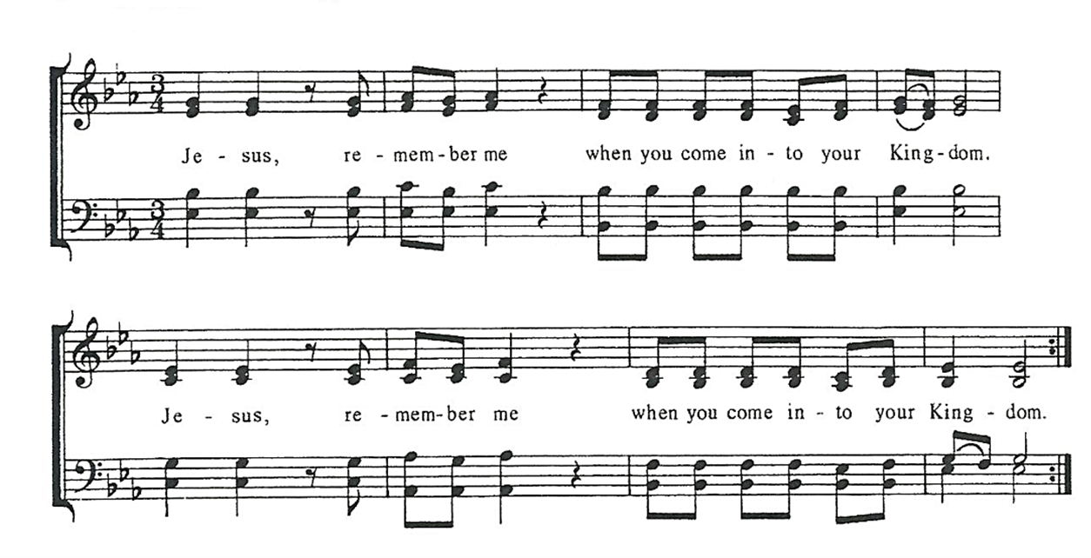

Post Communion Prayer, said by all
Eternal God, heavenly Father, you have graciously accepted us as living members
of your Son, our Savior Jesus Christ, and you have fed us with spiritual food in the
sacrament of his Body and Blood. Send us now into the world in peace, and grant
us strength and courage to love and serve you with gladness and singleness of heart;
through Christ our Lord. Amen.

Blessing

sending hymn: #778 We All are One in Mission -Blue pew hymnal

Dismissal Go in peace to love and serve the Lord. Alleluia, alleluia, alleluia!
Response: Thanks be to God! Alleluia, Alleluia, Alleluia!

postlude

The flowers on the altar are given to the Glory of God by Nicole Gustafson in memory of Canon Ron McEntire on his birthday. May his memory be a blessing to St. Luke’s.

Announcements
New Neighbors at Tarp Skunks Game 7/11 @ 6:30pm
Join new neighbors at the buyout Tarp Skunks game on Thursday, July 11th at 6:30pm, made possible by the generosity of Live CHQ. We are excited to enjoy America’s favorite pastime alongside new arrivals and the community. There is no cost to attend, and the event promises to be a fun time as the Jamestown Tarp Skunks take on the Geneva Red Wings. The game is at Russell E. Diethrick, Jr. Park at 485 Falconer Street in Jamestown (JCC campus). The New Neighbors Coalition hosted this event last summer and a great time was had by all! We are looking forward to bringing an even bigger, more diverse crown this year! Please come join in on the excitement and wear your best black, blue, and white! If you are interested in attending the event, please reach out to New Neighbors Manager, Momina Di Blasio at momina@stlukesjamestown.org or call the parish house at (716) 664-6405, so we know to save you a seat!

Forest Church: 7/13 @ 10am, CWC Dobbins Woods Preserve
Save the date for the next Forest Church-Saturday, July 13th at 10am. A new intergenerational service, Forest Church is an opportunity to experience God in creation with a brief communion service. All ages are welcome to attend and we will gather for about 90 minutes. We'll be gathering at the Chautauqua Watershed Preserve, Dobbins Woods (located at 5291 Bly Hill Rd in Ashville.) There are only 5 parking spaces, so we may attempt to carpool. Please contact the Rector (luke.fodor@stlukesjamestown.org) with questions and to confirm your interest.

Altar Flowers
We have a few open Sundays for sponsoring altar flowers this year, particularly in August. If you have someone you’d like to honor on an important date (birthday, anniversary, memorial, etc.) please look at the flower board in the vestibule. The cost is $94. You can choose what flowers you’d like to have used in the arrangement, and after the 10am service the flowers go to the sponsoring parishioner and/or are delivered to community members with St. Luke’s love and prayers. Contact the Parish Administrator with any questions.

