Contacting St. Luke’s…
Please contact the staff at the Church Office during regular business hours (8:00 AM-4:30AM M-F) at 483-6405. Mrs. Nicole Gustafson nicole.gustafson@stlukesjamestown.org is the Parish Administrator. In case of emergency, cell numbers are listed below. Please do not hesitate to contact the clergy with your questions. We will do our best to make your wedding day a joyous beginning for your marriage!

CHURCH OFFICE (716) 483-6405
Mailing address: 410 N. Main Street, Jamestown, NY 14701
E-mail: stlukes@stlukesjamestown.org

For invitation purposes: St. Luke’s Episcopal Church
Fourth and Main Streets

Jamestown, New York

Emergency numbers:
The Rev. Luke Fodor, Rector cell # (347) 495-1482

2024
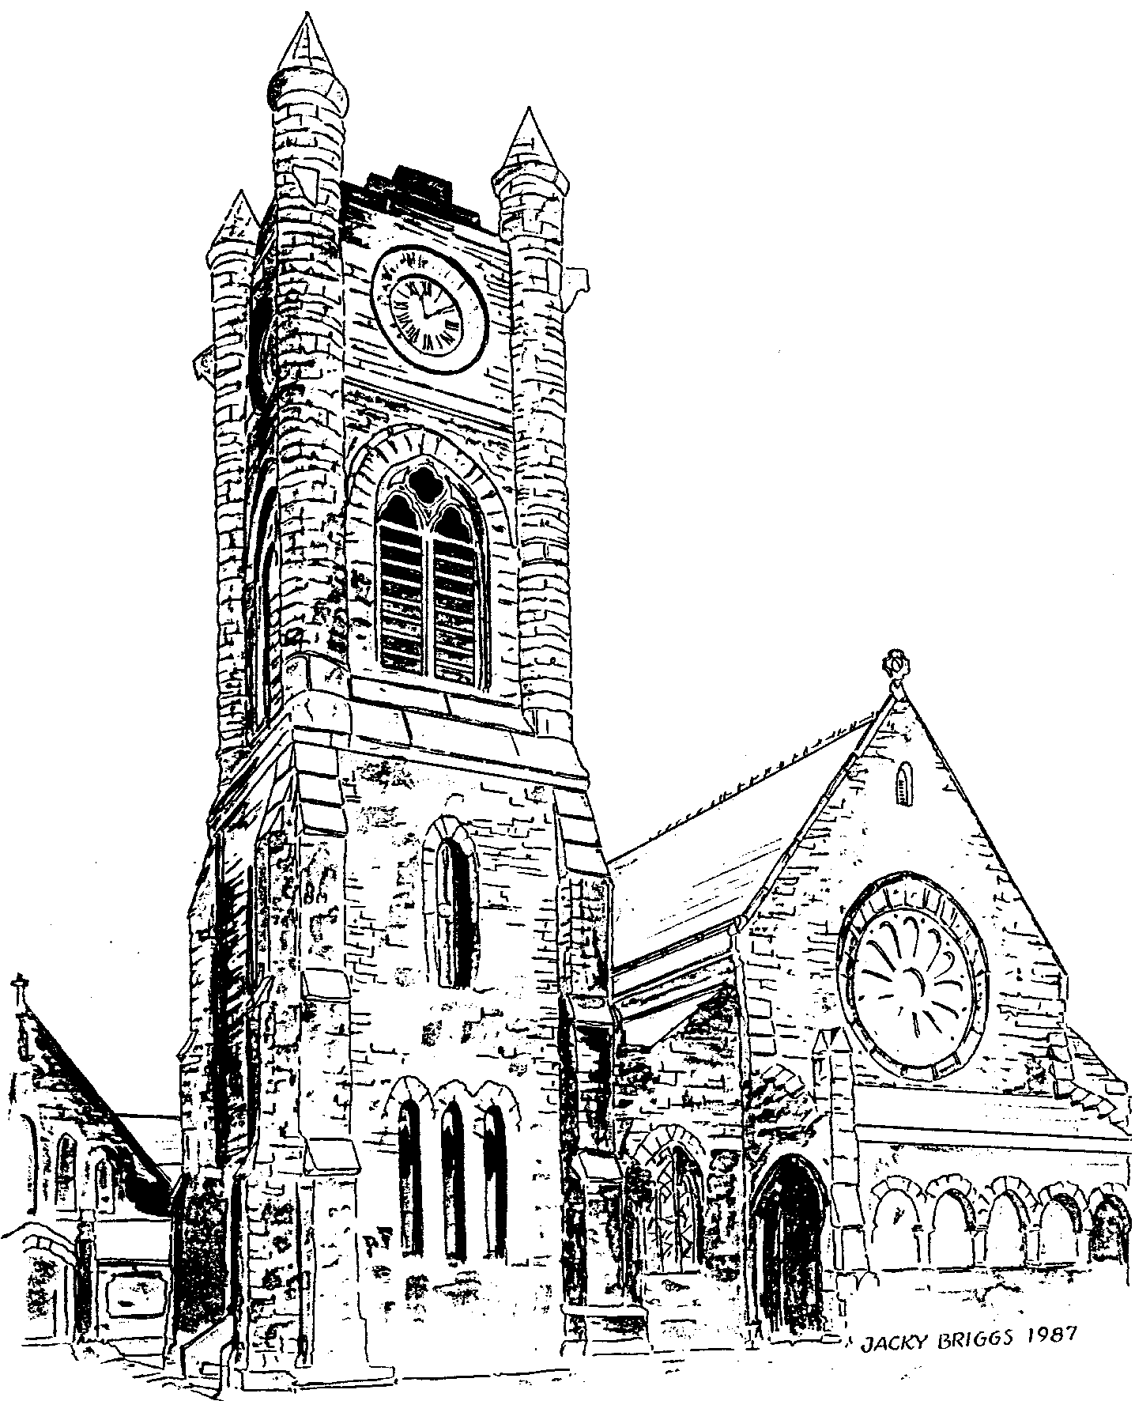

Planning Your Wedding
at
St. Luke’s Episcopal Church
Jamestown, New York

Congratulations!
It is good to know that you are beginning to make plans for your wedding. These will be busy days for you both, and for your family and friends who will be involved. The staff of St. Luke's hopes to help you prepare for your wedding so that it will be an occasion of great joy and meaning.
Marriage is the occasion for the establishment of a life-long covenant and is one of the Sacraments of the Church. Not all of life's questions can be dealt with fully at the time of one's marriage, yet this is the time for careful consideration of how one thinks and feels about love, faith, trust, vocation, commitment and other areas basic to human relationships.
Therefore, weddings are performed by a priest of the Church only after there has been exploration of the meaning of Christian marriage and the significance of the wedding service itself. Ordinarily we expect that there will be at least three interviews with the priest who will be conducting the service, and one with the church's organist.
Desiring the Sacraments of the Church presumes a relationship with the Church. As such, it is expected that you attend worship regularly, at St. Luke’s or (if you live out of the area) at another Episcopal church or have an honest conversation with the clergy. If this is not yet the case, please make a point to attend soon and re-introduce yourselves to the clergy. Our Sunday services are at 8:00 and 10:00 a.m.
This booklet is designed to assist in the planning process. We believe it will answer some of your questions. It may also prompt some other questions, and we look forward to discussing them with you.

Photographers and Picture-Taking
The wedding is a service of worship. It is important that all involved be able to give their full attention to this solemn and joyous event. Therefore, we ask that no flash photographs or videos, professional or amateur, be taken during the service (that is, after the initial procession). A professional photographer may take photos without flash from an inconspicuous location - please ask your photographer to check with the officiating clergy in advance of the service.
If the couple wish, the wedding party may reassemble in the Church following the service in order that pictures may be taken, including reenactments of moments in the wedding ceremony. We ask that this last no longer than 20 minutes beyond the conclusion of the liturgy.

About the Rehearsal
A rehearsal gives all involved the opportunity to practice. This means that the wedding service itself can be carried out without undue nervousness and confusion. Ordinarily, the rehearsal is conducted the day before the wedding. The rehearsal should take no more than an hour once all are assembled (please be prompt). The people needed for the rehearsal are: the couple, the wedding party, ushers, readers, soloists, and parents or guardians involved in the ceremony. The officiating priest oversees the rehearsal and all arrangements concerning the service itself.
It is important that all participants be present and ready for the rehearsal at least five minutes before the scheduled starting time. PLEASE BRING THE WEDDING LICENSE AND APPROPRIATE FEES TO THE REHEARSAL. This will avoid having to take care of such details on the wedding day.

The people standing at the altar before the processional should come to the Sacristy at least 15 minutes before the service is to begin. We do not have or provide dressing rooms for the wedding party. There is an area in the undercroft of the Church for to dress and prepare for the wedding service. The wedding party and attendants may arrive one hour before the wedding. If you require more than one hour please make arrangements with the church in advance; we cannot guarantee earlier access.
We ask that no rice, confetti, birdseed, glitter, rose petals or anything of the like be dispersed anywhere in or around the church buildings.
There is no smoking or alcohol consumption inside or outside the church building, at the rehearsal or the day of the wedding.

There are no charges for receiving the Sacraments of the Church, and no one will be excluded from the ministry of the Church for financial reasons. Below are our customary donations. Please consult the clergy if finances are difficult for you at this time, and adjustments can be made to ensure that our fees are not a burden to your wedding budget.
Wedding Fees at St. Luke’s:
- Altar flowers are selected and paid for by the couple.
- The Organist is paid $250.00 by individual check, which includes the wedding and rehearsal. Rehearsals with requested soloists and extraordinary practice time necessitated by request for difficult or unusual music shall be compensated at the rate of $150 per hour.
- A custodian’s fee is paid $100.00.
- The Building Use Fee is $500.00 (if no reception) or $1,000 (with reception)
- There is no set fee for the clergy. It is customary, however, for couples to donate to the priest’s discretionary fund. ($250-$500)
- Church Occupancy 500
- Chapel Occupancy 70
- Optional Additions:
  - Aisle Candles, $100.00
  - Bulletins printed by St. Luke’s, $50.00 per 100
  - Video Recording of the Service, $100
Let’s Begin
All arrangements for your wedding at St. Luke's begin with making an appointment to see the clergy. Please do not make any plans until you have talked with the clergy about your wedding. An appointment can be made by calling the Church Office at 483-6405.
The officiating priest should be involved in all plans for the service itself and exercises final approval for all liturgical decisions. Please let the priest know if a professional wedding planner is assisting you and seeks input into the liturgy.
It is expected that the clergy of St. Luke's will officiate at all weddings at the church. Should you wish to have another minister or priest participate in your wedding service, please talk with the clergy here as early as possible. Any invitation to another minister or priest must be issued by the Rector of St. Luke's.

About Canon Law
Canon (church) Law requires of Episcopal marriages that the couple meet at least three times for pre-marital counseling with a priest or trained counselor; and that the bishop’s permission be obtained before remarriage of a divorced person. If the former marriage of one or both of the parties was terminated by civil action, this should be discussed with the clergy at the first interview. The bishop expects that couples seeking such permission be active members of the church for at least six months prior to making the request; and that his permission be sought at least thirty days prior to the wedding date.
In all cases, at least one of the persons to be married must have received Holy Baptism (within any Christian denomination).

About Civil Law
Any couple intending to be married at St. Luke's must have a valid New York State marriage license. You must both apply in person to any town or city clerk in the state. If there has been a divorce, those papers must also be brought with you. The license is valid for 60 days from date of issue. Further details concerning civil marriage requirements may be obtained from the city clerk.

Where will the Wedding Service be?
The wedding service may be held in either the Church or the Chapel. Usually, the decision on which of these to use is based on how many guests are expected at the service. The chapel seats about 60-70 persons.
The sanctuary of the church seats approximately 500. It is entirely appropriate to have a “small” wedding in the main church. Both chapel and church are lovely; both have fine organs available for music.

About Music
The organist of St. Luke's oversees arrangements for music as well as playing for the wedding service. Final decisions concerning the music to be used rest with the organist; you will discover that they have many helpful suggestions to make. Call for an early appointment or speak to them after church on Sunday.
If you wish to have additional musicians, soloists, etc. please consult both the organist and the priest as soon as possible. Most requests can be accommodated with adequate notice and planning. Soloists are expected to rehearse at the convenience of the organist minimally twice prior to the wedding rehearsal.
It is our recommendation to avoid “secular” or “popular” music in wedding services – as they often create dissonance in the sacred space. Most often these selections can be used more effectively at the wedding reception.

About Decorations and Flowers
The custom of the Episcopal Church and St. Luke's Parish dictate that the only decorations or flowers used for a wedding are those placed in the church vases at the Altar. Usually the florist designated by the couple picks up the vase liners from the Church, and returns them filled with flowers on the day of the wedding. Flowers to be used by the bridal party are usually delivered to the Church on the day of the wedding by the florist. The florist should call the Church Office to arrange a time to pick up the liners and deliver the flowers on the day of the wedding.

It has been the custom at St. Luke’s that the flowers remain at the church after the service, for use on Sunday. We acknowledge your gift with thanks in the bulletin.
There are candles on the altar of the church and chapel, which are lighted during the service. No other candles are available for use in the chapel. It is possible to have candles in holders placed down the aisle in the nave of the main church, such as we use at Christmas time. Should these be wanted for a wedding, there is an additional charge to help defray the cost of the candles and their installation and removal. The Episcopal marriage liturgy does not provide for “unity candles.” Their use could be incorporated into the wedding reception, if desired.
We have found from much experience that an aisle runner detracts from the beauty of the church and poses serious safety risks. We do not permit their use at St. Luke’s.
If you wish to have a printed wedding program, we have examples on file for your consideration. If you wish to print your own, we can provide information on the order of service, page numbers, etc. Please show the proof of the program to the officiating clergy before the final printing. A simple bulletin similar to our Sunday leaflet can be provided by the church; in all cases the cost of printing a program is borne by the couple.

About the Wedding Day
In scheduling the hour for the wedding, it may be helpful if you know that a wedding service takes about 25 minutes without Holy Communion, and 45-60 minutes with Communion.
This may be of significance when calculating the time of arrival at the place where the wedding reception, if there is one, is to be held.
Ushers should plan on being at the church, ready to play their important role of greeting the guests, at least 45 minutes before the scheduled start of the wedding.

