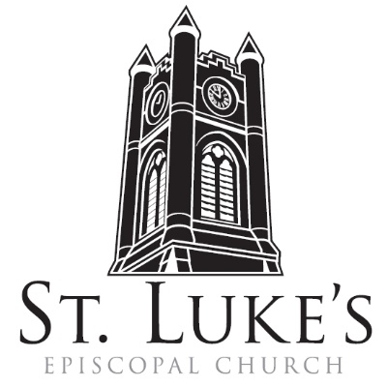
Ash Wednesday Service with Holy Eucharist

~ February 14, 2024~

7:00 am; 12:00 noon & 7:00 pm

St. Luke’s Episcopal Church
North Main at Fourth Street
Jamestown, New York
The Rt. Rev. Sean Rowe, Bishop
The Rev. Luke Fodor, Rector;
The Rev. Jessica Frederick, Curate for Children, Youth & Family Ministry
The Rev. Deacon Cathy Smith; Mr. Paul Johnson, Verger;
Mr. Loren Masánqué, Minister of Music
www.stlukesjamestown.org ~ email: stlukes@stlukesjamestown.org
The mission is simple: to Connect all people, help them Discover God's love, empower them to Serve and watch them Grow.”

The service begins in silence.
The Lord be with you. And also with you. Let us pray.
Almighty and everlasting God, you hate nothing you have made and forgive the sins of all who are penitent: Create and make in us new and contrite hearts, that we, worthily lamenting our sins and acknowledging our wretchedness, may obtain of you, the God of all mercy, perfect remission and forgiveness; through Jesus Christ our Lord, who lives and reigns with you and the Holy Spirit, one God, for ever and ever. Amen.
The Lesson: Joel 2:1-2, 12-17
Blow the trumpet in Zion; sound the alarm on my holy mountain! Let all the inhabitants of
the land tremble, for the day of the Lord is coming, it is near-- a day of darkness and gloom, a day
of clouds and thick darkness! Like blackness spread upon the mountains a great and powerful army
comes; their like has never been from of old, nor will be again after them in ages to come. Yet even
now, says the Lord, return to me with all your heart, with fasting, with weeping, and with mourning;
rend your hearts and not your clothing. Return to the Lord, your God, for he is gracious and
merciful, slow to anger, and abounding in steadfast love, and relents from punishing. Who knows
whether he will not turn and relent, and leave a blessing behind him, a grain offering and a drink
offering for the Lord, your God? Blow the trumpet in Zion; sanctify a fast; call a solemn assembly;
gather the people. Sanctify the congregation; assemble the aged; gather the children, even infants
at the breast. Let the bridegroom leave his room, and the bride her canopy. Between the vestibule
and the altar let the priests, the ministers of the Lord, weep. Let them say, "Spare your people,
O Lord, and do not make your heritage a mockery, a byword among the nations. Why should
it be said among the peoples, `Where is their God?'" The Word of the Lord. Thanks be to God.
Gradual Psalm #103:8-14 said responsively by whole verse at 7am and noon, sung at 7pm (see next page.)
8 You are full of compassion and mercy, *
slow to anger and of great kindness.
9 You will not always accuse us, *
nor will you keep your anger for ever.
10 You have not dealt with us according to our sins, *
nor rewarded us according to our wickedness.

11 For as the heavens are high above the earth, *
so is your mercy great upon those who fear you.
12 As far as the east is from the west, *
so far have you removed our sins from us.
13 As a parent cares for a child, *
so do you care for those who fear you.
14 For you yourself know whereof we are made; *
you remember that we are but dust.

7pm, sung by all:
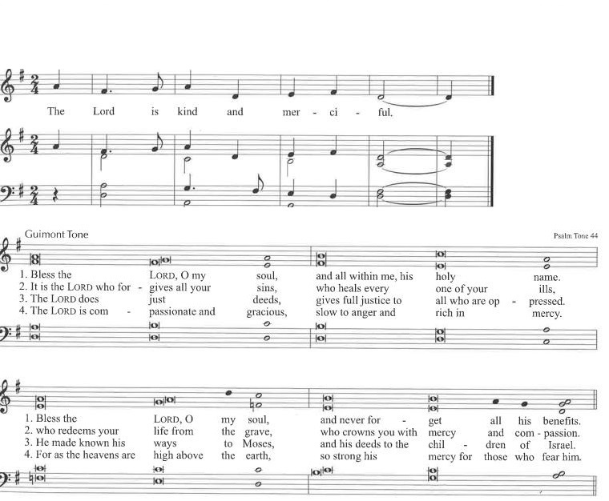

7am: Sequence Hymn #142: Lord, who throughout these forty days, v. 1-3
The Holy Gospel of our Lord Jesus Christ according to Matthew 6:1-6, 16-21
Response before the Gospel: Glory to you, Lord Christ.
Jesus said: “Beware of practicing your piety before others in order to be seen by them; for then you have no reward from your Father in heaven. So whenever you give alms, do not sound a trumpet before you, as the hypocrites do in the synagogues and in the streets, so that they may be praised by others. Truly I tell you, they have received their reward. But when you give alms, do not let your left hand know what your right hand is doing, so that your alms may be done in secret; and your Father who sees in secret will reward you. And whenever you pray, do not be like the hypocrites; for they love to stand and pray in the synagogues and at the street corners, so that they may be seen by others. Truly I tell you, they have received their reward. But whenever you pray, go into your room and shut the door and pray to your Father who is in secret; and your Father who sees in secret will reward you. And whenever you fast, do not look dismal, like the hypocrites, for they disfigure their faces so as to show others that they are fasting. Truly I tell you, they have received their reward. But when you fast, put oil on your head and wash your face, so that your fasting may be seen not by others but by your Father who is in secret; and your Father who sees in secret will reward you. Do not store up for yourselves treasures on earth, where moth and rust consume and where thieves break in and steal; but store up for yourselves treasures in heaven, where neither moth nor rust consumes and where thieves do not break in and steal. For where your treasure is, there your heart will be also.” The Gospel of the Lord. Praise to you, Lord Christ.

7am: Sequence Hymn #142: Lord, who throughout these forty days, v. 5
The Homily
Invitation to a Holy Lent
Dear People of God: The first Christians observed with great devotion the days of our Lord's passion and resurrection, and it became the custom of the Church to prepare for them by a season of penitence and fasting. This season of Lent provided a time in which converts to the faith were prepared for Holy Baptism. It was also a time when those who, because of notorious sins, had been separated from the body of the faithful were reconciled by penitence and forgiveness, and restored to the fellowship of the Church. Thereby, the whole congregation was put in mind of the message of pardon and absolution set forth in the Gospel of our Savior, and of the need which all Christians continually have to renew their repentance and faith. I invite you, therefore, in the name of the Church, to the observance of a holy Lent, by self-examination and repentance; by prayer, fasting, and self-denial; and by reading and meditating on God's holy Word. And, to make a right beginning of repentance, and as a mark of our mortal nature, let us now kneel before the Lord, our maker and redeemer.
Silence is then kept for a time.
Almighty God, you have created us out of the dust of the earth: Grant that these ashes may be to us a sign of our mortality and penitence, that we may remember that it is only by your gracious gift that we are given everlasting life; through Jesus Christ our Savior. Amen.

Imposition of Ashes All are invited to come forward
The ashes are imposed with the following words:
Remember that you are dust, and to dust you shall return.

Psalm # 51, said in unison at 7am and 12 noon; sung by the choir at 7p.m. - setting by E. C. Bairstow
1 Have mercy on me, O God, according to your loving-kindness; *
in your great compassion blot out my offenses.

2 Wash me through and through from my wickedness *
and cleanse me from my sin.

3 For I know my transgressions, *
and my sin is ever before me.

4 Against you only have I sinned *
and done what is evil in your sight.

5 And so you are justified when you speak *
and upright in your judgment.

6 Indeed, I have been wicked from my birth, *
a sinner from my mother's womb.

7 For behold, you look for truth deep within me, *
and will make me understand wisdom secretly.

8 Purge me from my sin, and I shall be pure; *
wash me, and I shall be clean indeed.

9 Make me hear of joy and gladness, *
that the body you have broken may rejoice.

10 Hide your face from my sins *
and blot out all my iniquities.
11 Create in me a clean heart, O God, *
and renew a right spirit within me.

12 Cast me not away from your presence *
and take not your holy Spirit from me.

13 Give me the joy of your saving help again *
and sustain me with your bountiful Spirit.

14 I shall teach your ways to the wicked, *
and sinners shall return to you.

15 Deliver me from death, O God, *
and my tongue shall sing of your righteousness, O God of my salvation.

16 Open my lips, O Lord, *
and my mouth shall proclaim your praise.

17 Had you desired it, I would have offered sacrifice, *
but you take no delight in burnt-offerings.

18 The sacrifice of God is a troubled spirit; *
a broken and contrite heart, O God, you will not despise.

19 Be favorable and gracious to Zion, *
and rebuild the walls of Jerusalem.

20 Then you will be pleased with the appointed sacrifices,
with burnt-offerings and oblations; * then shall they offer young bullocks upon your altar.

Glory to the Father, and to the Son, and to the Holy Spirit: *
as it was in the beginning, is now, and will be for ever. Amen.
Litany of Penitence, all kneeling, said by the Celebrant and People together.
Most holy and merciful Father: We confess to you and to one another, and to the whole communion of saints in heaven and on earth, that we have sinned by our own fault in thought, word, and deed; by what we have done, and by what we have left undone.
The Celebrant continues
We have not loved you with our whole heart, and mind, and strength.
We have not loved our neighbors as ourselves.
We have not forgiven others, as we have been forgiven.
Have mercy on us, Lord.
We have been deaf to your call to serve, as Christ served us.
We have not been true to the mind of Christ. We have grieved your Holy Spirit.
Have mercy on us, Lord.
We confess to you, Lord, all our past unfaithfulness:
The pride, hypocrisy, and impatience of our lives,
We confess to you, Lord.
Our self-indulgent appetites and ways, and our exploitation of other people,
We confess to you, Lord.
Our anger at our own frustration, and our envy of those more fortunate than ourselves,
We confess to you, Lord.
Our intemperate love of worldly goods and comforts, and our dishonesty in daily life and work,
We confess to you, Lord.
Our negligence in prayer and worship, and our failure to commend the faith that is in us,
We confess to you, Lord.
Accept our repentance, Lord, for the wrongs we have done:
for our blindness to human need and suffering, and our indifference to injustice and cruelty,
Accept our repentance, Lord.
For all false judgments, for uncharitable thoughts toward our neighbors,
and for our prejudice and contempt toward those who differ from us,
Accept our repentance, Lord.
For our waste and pollution of your creation, and our lack of concern for those who come after us,
Accept our repentance, Lord.

Restore us, good Lord, and let your anger depart from us;
Favorably hear us, for your mercy is great.

Accomplish in us the work of your salvation,
That we may show forth your glory in the world.

Reassurance of Pardon and Absolution
By the cross and passion of your Son our Lord,
Bring us with all your saints to the joy of his resurrection.

Almighty God, the Father of our Lord Jesus Christ, who desires not the death of sinners, but rather that they may turn from their wickedness and live, has given power and commandment to his ministers to declare and pronounce to his people, being penitent, the absolution and remission of their sins. He pardons and absolves all those who truly repent, and with sincere hearts believe his holy Gospel.

Therefore we beseech him to grant us true repentance and his Holy Spirit, that those things may please him which we do on this day, and that the rest of our life hereafter may be pure and holy, so that at the last we may come to his eternal joy; through Jesus Christ our Lord. Amen.

The Peace Let us exchange the Peace of Christ with one another.
The peace of the Lord be always with you. People: And also with you.

THE HOLY COMMUNION
7PM: Offertory Anthem: When Jesus Wept
7PM: DOXOLOGY, sung by all:
Praise God throughout these forty days. Praise Christ, our Lord, whom God did raise.
And praise the Spirit who imparts God’s love in Christ into our hearts. Amen.

The Great Thanksgiving: Eucharistic Prayer A
The Lord be with you. And also with you.
Lift up your hearts. We lift them to the Lord.
Let us give thanks to the Lord our God. It is right to give God thanks and praise.

It is right, and a good and joyful thing, always and every where to give thanks to you, Father Almighty,
Creator of heaven and earth. Through Jesus Christ our Lord; who was tempted in every way as we are, yet did not sin. By his grace we are able to triumph over every evil, and to live no longer for ourselves alone, but for him who died for us and rose again. Therefore we praise you, joining our voices with Angels and Archangels and with all the company of heaven, who for ever sing this hymn to proclaim the glory of your Name:

Sanctus & Benedictus S-122, Martens, Front pages of the Blue Hymnal
said at 7am and 12 noon; sung at 7pm
Holy, holy, holy Lord, God of power and might, heaven and earth are full of your glory.
Hosanna in the highest. Blessed is the One who comes in the name of the Lord.
Hosanna in the highest. The Celebrant continues
On the night he was handed over to suffering and death, our Lord Jesus Christ took bread; and when he had given thanks to you, he broke it, and gave it to his disciples, and said, "Take, eat: This is my Body, which is given for you. Do this for the remembrance of me." After supper he took the cup of wine; and when he had given thanks, he gave it to them, and said, "Drink this, all of you: This is my Blood of the new Covenant, which is shed for you and for many for the forgiveness of sins. Whenever you drink it, do this for the remembrance of me." Therefore we proclaim the mystery of faith:
Celebrant and People
Christ has died. Christ is risen. Christ will come again.

We celebrate the memorial of our redemption, O Father, in this sacrifice of praise and thanksgiving. Recalling his death, resurrection, and ascension, we offer you these gifts. Sanctify them by your Holy Spirit to be for your people the Body and Blood of your Son, the holy food and drink of new and unending life in him. Sanctify us also that we may faithfully receive this holy Sacrament, and serve you in unity, constancy, and peace; and at the last day bring us with all your saints into the joy of your eternal kingdom. All this we ask through your Son Jesus Christ: By him, and with him, and in him, in the unity of the Holy Spirit all honor and glory is yours, Almighty Father, now and for ever. AMEN.

And now, as our Savior Christ has taught us, we are bold to say,
Our Father, who art in heaven, hallowed be thy Name,
thy kingdom come, thy will be done, on earth as it is in heaven.
Give us this day our daily bread. And forgive us our trespasses,
as we forgive those who trespass against us.
And lead us not into temptation, but deliver us from evil.
For thine is the kingdom, and the power, and the glory, for ever and ever. Amen.

The Breaking of the Bread Silent moment

Agnus Dei said at 7am and 12 noon; sung at 7pm - S-160, Martens; the front pages of the 1982 pew Hymnal
Lamb of God you take away the sin of the world, have mercy on us
Lamb of God you take away the sin of the world, have mercy on us
Lamb of God you take away the sin of the world, grant us your peace.

The Communion Wherever you are on your spiritual journey, all are invited to receive Communion.
Gluten-free wafers, as well as grape juice, are available, please indicate your preference;
If you have difficulty coming forward, communion can be brought to you at your seat.

Music at Communion
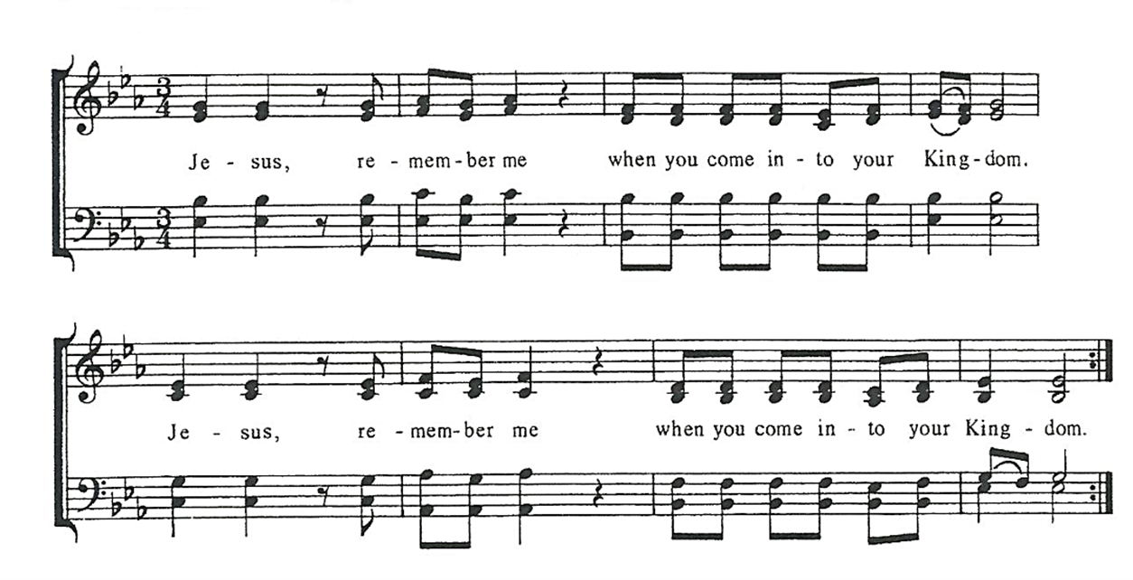

Post Communion Prayer, said by all
Eternal God, heavenly Father, you have graciously accepted us as living members
of your Son, our Savior Jesus Christ, and you have fed us with spiritual food in the
sacrament of his Body and Blood. Send us now into the world in peace, and grant
us strength and courage to love and serve you with gladness and singleness of heart;
through Christ our Lord. Amen.

solemn prayer

7:00 PM: Sending Hymn # 143, The Glory of These Forty Days

Dismissal

The people depart in silence.

