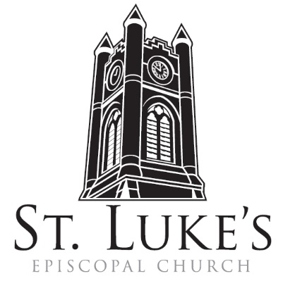
The Holy Eucharist

Sunday, February 11, 2024
Last Sunday after the Epiphany

St. Luke’s Episcopal Church
North Main at Fourth Street, Jamestown, New York
The Rt. Rev. Sean Rowe, Bishop
The Rev. Luke Fodor, Rector,
The Rev. Jessica Frederick, Curate for Children, Youth & Family Ministry
The Rev. Deacon Cathy Smith; Mr. Paul Johnson, Verger; Mr. Loren Masánqué, Minister of Music
www.stlukesjamestown.org ~ email: stlukes@stlukesjamestown.org

The mission is simple: to Connect all people, help them Discover God's love, empower them to Serve and watch them Grow.”

WELCOME TO ST. LUKE’S
We welcome you this morning to St. Luke’s Church and are delighted to have you join us for worship today. If you are visiting for the first time, or are looking for a church home, please fill in a pew card and place it in the offering plate.
At the time of Communion, all are invited to God’s Table. In addition to the altar rail, at the 10 a.m. service a floor-level Communion station is made available, which includes gluten-free wafers and grape juice. Please indicate your preference.
Available to children is Children’s Chapel downstairs during the 10am service, a visit to the Children’s Corner, or the use of a “Children’s Activity Bag” found near the front of the church nave (ask an usher). Join us downstairs for refreshments. All are welcome! Audio transmitters are available for those who have difficulty hearing the service; please ask an usher.
~ Copies of today’s sermon are available at the doors. ~

Prelude: Meditation on Beautiful Savior -arr. Cathy Moklebust

Words of Welcome -The Curate

Introit: Veni Creator Spiritus - Mr. Loren Masánqué, Cantor

1. Veni, creator spiritus,  Mentes tuorum visita,  Imple superna gratia  Quae tu creasti pectora.  2. Qui diceris paraclitus,  Altissimi donum dei,  Fons vivus, ignis, caritas,  Et spiritalis unctio.  3. Tu, septiformis munere,  Digitus paternae dexterae,  Tu rite promissum patris,  Sermone ditans guttura.. | 1. Come, holy ghost, creator blest,  Vouchsafe within our souls to rest;  Come with thy grace and heavenly aid  And fill the hearts which thou hast made.  2. To thee, the comforter, we cry,  To thee, the gift of god most high,  The fount of life, the fire of love,  The soul's anointing from above.  3. The sevenfold gifts of grace are thine,  O finger of the hand divine;  True promise of the father thou,  Who dost the tongue with speech endow.
Prayer of Preparation
Take away from us our iniquities, we beseech you, O Lord, that we may be worthy to enter with pure minds into the Holy of Holies; and grant that we may worthily praise and magnify your Holy Name through the sacrifice we are to offer you; through Jesus Christ our Lord. Amen.

Opening Hymn: #529 In Christ There is No East or West -Blue Pew Hymnal
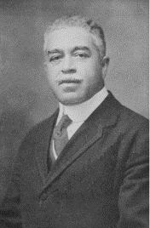
The text of this hymn was written by William J. Dunkerly under the pseudonym John Oxenham and adapted from a spiritual by Harry T. Burleigh (1866-1949). Burleigh composed over two hundred works in the ‘American art song’ genre. He was the first African-American composer celebrated for his concert songs and his adaptations of African-American spirituals. An accomplished baritone, meticulous editor, and a charter member of the American Society of Composers, Authors, and Publishers (ASCAP), he studied at the National Conservatory of Music in New York. This experience led to a lifelong association and friendship with composer Antonín Dvorák, the Conservatory's director. Trivia Prompt: Guess where he was born.

Opening Acclamation
Celebrant: Blessed be God: Father, Son, and Holy Spirit.
People: And blessed be God’s kingdom, now and for ever. Amen.

Collect for Purity, said by all
Almighty God, to you all hearts are open, all desires known, and from you no secrets are hid: Cleanse the thoughts of our hearts by the inspiration of your Holy Spirit, that we may perfectly love you, and worthily magnify your holy Name; through Christ our Lord. Amen.

Gloria, said or sung by all
Glory to God in the highest, and peace to God’s people on earth. Lord God, heavenly King, almighty God and Father, we worship you, we give you thanks, we praise you for your glory. Lord Jesus Christ, only Son of the Father, Lord God, Lamb of God, you take away the sin of the world; have mercy on us; you are seated at the right hand of the Father; receive our prayer. For you alone are the Holy One, you alone are the Lord, you alone are the Most High, Jesus Christ, with the Holy Spirit, in the glory of God the Father. Amen.

The Collect of the Day:
The Lord be with you. Response: And also with you.
Let us pray. O God, who before the passion of your only-begotten Son revealed his glory upon the holy mountain: Grant to us that we, beholding by faith the light of his countenance, may be strengthened to bear our cross, and be changed into his likeness from glory to glory; through Jesus Christ our Lord, who lives and reigns with you and the Holy Spirit, one God, for ever and ever. Amen.

The First Reading is from 2 Kings 2:1-12

When the Lord was about to take Elijah up to heaven by a whirlwind, Elijah and Elisha were on their way from Gilgal. Elijah said to Elisha, “Stay here; for the Lord has sent me as far as Bethel.” But Elisha said, “As the Lord lives, and as you yourself live, I will not leave you.” So they went down to Bethel. The company of prophets who were in Bethel came out to Elisha, and said to him, “Do you know that today the Lord will take your master away from you?” And he said, “Yes, I know; keep silent.” Elijah said to him, “Elisha, stay here; for the Lord has sent me to Jericho.” But he said, “As the Lord lives, and as you yourself live, I will not leave you.” So they came to Jericho. The company of prophets who were at Jericho drew near to Elisha, and said to him, “Do you know that today the Lord will take your master away from you?” And he answered, “Yes, I know; be silent.” Then Elijah said to him, “Stay here; for the Lord has sent me to the Jordan.” But he said, “As the Lord lives, and as you yourself live, I will not leave you.” So the two of them went on. Fifty men of the company of prophets also went, and stood at some distance from them, as they both were standing by the Jordan. Then Elijah took his mantle and rolled it up, and struck the water; the water was parted to the one side and to the other, until the two of them crossed on dry ground. When they had crossed, Elijah said to Elisha, “Tell me what I may do for you, before I am taken from you.” Elisha said, “Please let me inherit a double share of your spirit.” He responded, “You have asked a hard thing; yet, if you see me as I am being taken from you, it will be granted you; if not, it will not.” As they continued walking and talking, a chariot of fire and horses of fire separated the two of them, and Elijah ascended in a whirlwind into heaven. Elisha kept watching and crying out, “Father, father! The chariots of Israel and its horsemen!” But when he could no longer see him, he grasped his own clothes and tore them in two pieces. The Word of the Lord. Thanks be to God.

Psalm #50:1-6 Please join in saying the Psalm in unison. -St. Helena Psalter
1 The God of gods has spoken; God has called the earth from the rising of the sun to its setting.

2 Out of Zion, perfect in its beauty, God is revealed in glory.

3 O God, you will come and will not keep silence; before you there is a consuming flame,
and round about you a raging storm.

4 You call the heavens and the earth from above to witness the judgment of your people.

5 “Gather before me my loyal followers, those who have made a covenant with me and sealed it with sacrifice.”

6 Let the heavens declare the rightness of your cause, for you alone are judge.

The Second Reading is from 2 Corinthians 4:3-6 Even if our gospel is veiled, it is veiled to those who are perishing. In their case the god of this world has blinded the minds of the unbelievers, to keep them from seeing the light of the gospel of the glory of Christ, who is the image of God. For we do not proclaim ourselves; we proclaim Jesus Christ as Lord and ourselves as your slaves for Jesus’ sake. For it is the God who said, “Let light shine out of darkness,” who has shone in our hearts to give the light of the knowledge of the glory of God in the face of Jesus Christ. The Word of the LORD. Thanks be to God.

Gospel Sequence Hymn #460: Alleluia! Sing to Jesus v. 1 & 2 -Blue Pew Hymnal

The Holy Gospel of our Lord Jesus Christ, according to Mark 9:2-9
Response before the Gospel: Glory to you, Lord Christ.
Jesus took with him Peter and James and John, and led them up a high mountain apart, by themselves. And he was transfigured before them, and his clothes became dazzling white, such as no one on earth could bleach them. And there appeared to them Elijah with Moses, who were talking with Jesus. Then Peter said to Jesus, “Rabbi, it is good for us to be here; let us make three dwellings, one for you, one for Moses, and one for Elijah.” He did not know what to say, for they were terrified. Then a cloud overshadowed them, and from the cloud there came a voice, “This is my Son, the Beloved; listen to him!” Suddenly when they looked around, they saw no one with them any more, but only Jesus. As they were coming down the mountain, he ordered them to tell no one about what they had seen, until after the Son of Man had risen from the dead. The Gospel of the Lord. Praise to You, Lord Christ.

Gospel Sequence Hymn # 460: Alleluia! Sing to Jesus v. 4 & 5 -Blue Pew Hymnal

Sermon -The Curate

Nicene Creed, said by all, standing in body or in spirit.
We believe in one God, the Father, the Almighty, maker of heaven and earth, of all that is, seen
and unseen. We believe in one Lord, Jesus Christ, the only Son of God, eternally begotten of the
Father, God from God, Light from Light, true God from true God, begotten, not made, of one
Being with the Father; through him all things were made. For us and for our salvation he came
down from heaven, was incarnate of the Holy Spirit and the Virgin Mary and became truly
human. For our sake he was crucified under Pontius Pilate; he suffered death and was buried.
On the third day he rose again in accordance with the Scriptures; he ascended into heaven and is seated at the right hand of the Father. He will come again in glory to judge the living and the dead, and his kingdom will have no end. We believe in the Holy Spirit, the Lord, the giver of life, who proceeds from the Father, who with the Father and the Son is worshiped and glorified, who has spoken through the prophets. We believe in one holy catholic and apostolic Church. We acknowledge one baptism for the forgiveness of sins. We look for the resurrection of the dead, and the life of the world to come. Amen.

The Prayers of the People, Form VI -BCP 392
In peace, we pray to you, Lord God. Silence

For all people in their daily life and work; For our families, friends, and neighbors, and for those who are alone.

For this community, the nation, and the world; For all who work for justice, freedom, and peace.

For the just and proper use of your creation; For the victims of hunger, fear, injustice, and oppression.

For all who are in danger, sorrow, or any kind of trouble; For those who minister to the sick, the friendless, and the needy.

For the peace and unity of the Church of God; For all who proclaim the Gospel, and all who seek the Truth.

For Michael our Presiding Bishop, for Sean, the Bishop of our Diocesan Partnership, for the Episcopal Partnership churches of The Cathedral of St. Paul, (Erie), St. Phillip’s, (Buffalo), and St. Simon’s, (Buffalo), for The Anglican Church of South America; for Luke, Jessica and Cathy, our clergy, and for all bishops, priests and deacons; For all who serve God in the Church.
For the special needs and concerns of this congregation. Silence
Please join me in saying aloud the names of the people on our prayer list:
Tim Pickett, Carol Boling, Pete Nagle, Joyce Crate, Mary Holton, Deacon Pierce, Mac Dawson, Mark Fiore, for the people of the Ukraine and the People of the Holy Land, and those others we now name. Silence

Hear us, Lord; For your mercy is great.

We thank you, Lord, for all the blessings of this life.

We will exalt you, O God our King; And praise your Name for ever and ever.
We pray for all who have died, that they may have a place in your eternal kingdom. Silence
Lord, let your loving-kindness be upon them; Who put their trust in you.
We pray to you also for the forgiveness of our sins.
Lay Reader and People
God of all mercy, we confess that we have sinned against you, opposing your will in our lives.
We have denied your goodness in each other, in ourselves, and in the world you have created.
We repent of the evil that enslaves us, the evil we have done, and the evil done on our behalf.
Forgive, restore, and strengthen us through our Savior Jesus Christ, that we may abide in your love and serve only your will. Amen.

Absolution

Commissioning of italy pilgrimage participants
Let us pray. Brother Jesus, you equipped and sent forth your friends to bring the Good News from Jerusalem into Judea and all the world: Be present as we send forth these friends and companions on this pilgrimage adventure. As we embark on this journey of faith, give inquiring and discerning hearts, the courage to will and to persevere, and a spirit to know and to love you, and the gift of joy and wonder in all your works. Amen.

The Peace Let us exchange the Peace of Christ with one another!
The peace of the Lord be always with you. People And also with you.

Announcements

THE HOLY COMMUNION
If you’d like to give electronically, use your phone’s camera to scan the QR code.

Offertory

8:00 AM, said by all: All things come of Thee O Lord, and of Thine Own have we given Thee. Amen.

10:00 AM: Offertory Anthem: If ye love me -St. Luke’s Choir
10:00 AM: Doxology, sung by all
Praise God from whom all blessings flow; praise God all creatures here below
praise God above, ye heav’nly host, praise Father, Son and Holy Ghost. Amen.

THE GREAT THANKSGIVING: Eucharistic Prayer: Enriching Our Worship 3

The Lord be with you. And also with you.
Lift up your hearts. We lift them to the Lord.
Let us give thanks to the Lord our God. It is right to give our thanks and praise.

All thanks and praise are yours at all times and in all places, our true and loving God; through Jesus Christ, your eternal Word, the Wisdom from on high by whom you created all things. You laid the foundations of the world and enclosed the sea when it burst out from the womb; You brought forth all creatures of the earth and gave breath to humankind. Wondrous are you, Holy One of Blessing, all you create is a sign of hope for our journey; And so as the morning stars sing your praises we join the heavenly beings and all creation as we shout with joy:

Holy, Holy, Holy Lord, God of power and might,
heaven and earth are full of your glory. Hosanna in the highest.
Blessed is the One who comes in the name of the Lord. Hosanna in the highest.

Glory and honor are yours, Creator of all, your Word has never been silent; you called a people to yourself, as a light to the nations, you delivered them from bondage and led them to a land of promise. Of your grace, you gave Jesus to be human, to share our life, to proclaim the coming of your holy reign and give himself for us, a fragrant offering. Through Jesus Christ our Redeemer, you have freed us from sin, brought us into your life, reconciled us to you, and restored us to the glory you intend for us. We thank you that on the night before he died for us Jesus took bread, and when he had given thanks to you, he broke it, gave it to his friends and said: “Take, eat, this is my Body, broken for you. Do this for the remembrance of me.” After supper Jesus took the cup of wine, said the blessing, gave it to his friends and said: “Drink this, all of you: this cup is the new Covenant in my Blood, poured out for you and for all for the forgiveness of sin. Do this for the remembrance of me.” And so, remembering all that was done for us: the cross, the tomb, the resurrection and ascension, longing for Christ’s coming in glory, and presenting to you these gifts your earth has formed and human hands have made, we acclaim you, O Christ:

Celebrant and People:
Dying, you destroyed our death. Rising, you restored our life. Christ Jesus, come in glory!

Send your Holy Spirit upon us and upon these gifts of bread and wine that they may be to us the Body and Blood of your Christ. Grant that we, burning with your Spirit’s power, may be a people of hope, justice and love. Giver of Life, draw us together in the Body of Christ, and in the fullness of time gather us with blessed Saint Luke, and all your people into the joy of our true eternal home. Through Christ and with Christ and in Christ, by the inspiration of your Holy Spirit, we worship you our God and Creator in voices of unending praise.

Celebrant and People: Blessed are you now and for ever. Amen. 10:00 AM sing below:

And now, as our Savior Christ has taught us, we are bold to say,
Our Father, who art in heaven, hallowed be thy Name, thy kingdom come, thy will be done,
on earth as it is in heaven. Give us this day our daily bread.
And forgive us our trespasses, as we forgive those who trespass against us.
And lead us not into temptation, but deliver us from evil. For thine is the kingdom, and the power, and the glory, for ever and ever. Amen.

The Breaking of the Bread
8:00 AM: Alleluia, Christ our Passover is sacrificed for us.
People: Therefore, let us keep the feast. Alleluia.

10:00 AM: Jesus Lamb of God, have mercy on us. Jesus, bearer of our sins, have mercy on us.
Jesus, Redeemer, Redeemer of the world, give us your peace, give us your peace.

The Communion Wherever you are on your spiritual journey, all are invited to receive Communion.
Gluten-free wafers, as well as grape juice, are available, please indicate your preference;
at the 10AM service, at the floor communion station. If you have difficulty coming forward, communion can be brought to you at your seat. You are invited to light a candle for a person or concern in your prayers.
A candle station is located at the rear of the Chapel; and to the right of the pulpit in the Church.

Communion Music
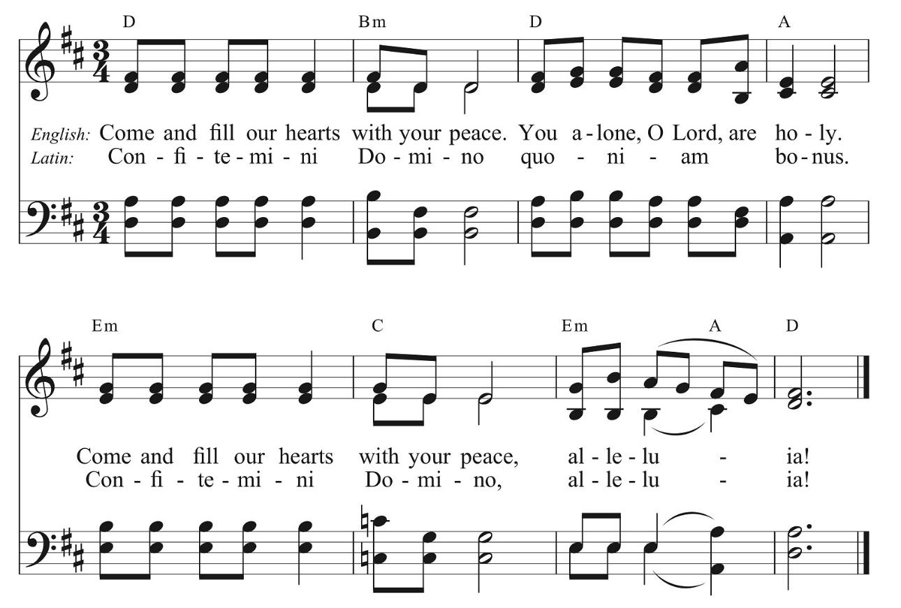

Post Communion Prayer, said by all
Eternal God, heavenly Father, you have graciously accepted us as living members of your Son, our Savior Jesus Christ, and you have fed us with spiritual food in the sacrament of his Body and Blood. Send us now into the world in peace, and grant us strength and courage to love and serve you with gladness and singleness of heart; through Christ our Lord. Amen.

Blessing

Sending Hymn #366 Holy God, we praise thy name -1982 pew Hymnal

Dismissal Go in peace to love and serve the Lord. Alleluia, Alleluia, Alleluia!
Response: Thanks be to God! Alleluia, Alleluia, Alleluia!

Postlude: Prelude in D -Franz Schmidt

The altar flowers are given to the Glory of God in celebration of Jean Voltmann’s 90th birthday by her family.

Announcements
Global Perspectives Book Club
Dina Nayeri’s acclaimed book, “The Ungrateful Refugee, What Immigrants Never Tell You,” is the first selection for a new book club formed by the New Neighbors Coalition to be hosted at St. Luke’s. We'll be meeting tomorrow, Monday, February 12 at 7pm in the Fenn Library in St. Luke's Undercroft. Nayeri, an Iranian refugee, writes of difficulties fitting into Western culture as she describes her firsthand experiences and those of other immigrants. For additional details or to let us know you’re coming, please contact Momina at momina@stlukesjamestown.org or (716) 483-6405.
Shrove Tuesday Pancake Supper & Prayer Stations
Before the austerity of Lent, we celebrate with a pre-Lenten feast of pancakes and sausage on Shrove (from the Old English—to shrive: to confess) Tuesday, February 13th from 5pm to 7pm in the Undercroft. The dinner costs $7 and all the proceeds will support the Youth Pilgrimage to Italy. This year, the festivities will also include some interactive and educational prayer stations to mark the Feast of The Rev. Absalom Jones, who was the first African American to be ordained as a priest in the Episcopal Church of the United States. While you are waiting to be served or after you have eaten, you are invited to engage with a series of interactive stations that will lead you to listen, learn, lament and love. These Stations are a project of the Dismantling Racism Committee.
Ash Wednesday Services
Lent starts off with Ash Wednesday on February 14th. We will have services at 7am, 12pm (in the Chapel) and 7pm (in the Church) at St. Luke’s, in addition to Ashes to Go offered from 1pm to 3pm offered in front of the church, on Main Street. We will also have a Spanish Service at 5pm (in the Chapel), with the praying of the rosary in Spanish beginning at 4pm.
Andiamo!
The Rev. Jessica Frederick and the Rev. Luke Fodor will be leading a pilgrimage to Italy for from 2/15-2/24. Please keep them and the youth in your prayers as they travel and learn together. A big thank you to the Rev. Tom Broad for covering 1st Sunday of Lent (the 18th) and Lenten program that week! If a need arises while the Rector is away, please contact Deacon Cathy Smith.
Pick up your Blue Bags this week!
February’s Blue Bag Sunday on 2/18 benefits MHA. Here’s a list of suggested donations: disinfectant surface cleaner, men’s & women’s underwear, instant oatmeal, granola bars, chap stick, can openers, combs, brushes, feminine hygiene products, razors & shaving cream, fingernail trimmers, toothbrushes & paste, deodorant, gloves & hats.

