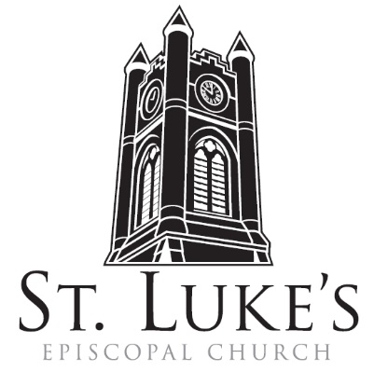
Holy Eucharist ~ Sunday, March 17, 2024

The 5th Sunday in Lent/St. Patrick’s Day

St. Luke’s Episcopal Church
North Main at Fourth Street
Jamestown, New York
The Rt. Rev. Sean Rowe, Bishop
The Rev. Luke Fodor, Rector; The Rev. Deacon Cathy Smith;
Mr. Paul Johnson, Verger; Mr. Loren Masánqué, Minister of Music
The Rev. Jessica Frederick, Curate for Children, Youth & Family Ministry
www.stlukesjamestown.org ~ email: stlukes@stlukesjamestown.org
The mission is simple: to Connect all people, help them Discover God's love, empower them to Serve and watch them Grow.”

WELCOME TO ST. LUKE’S
We welcome you this morning to St. Luke’s Church and are delighted to have you join us for worship today. If you are visiting for the first time, or are looking for a church home, please fill in a pew card and place it in the offering plate.
At the time of Communion, all are invited to God’s Table. In addition to the altar rail, at the 10 a.m. service a floor-level Communion station is made available, which includes gluten-free wafers and grape juice, please indicate your preference.
Available to children is a visit to the Children’s Corner, Children’s Chapel during the 10am service in the Undercroft, or the use of a “Children’s Activity Bag” found near the front of the church nave (ask an usher). Join us downstairs for refreshments. All are welcome! Audio transmitters are available for those who have difficulty hearing the service; please ask an usher. Copies of today’s sermon are available at the doors.
PRELUDE -Water Horse
Opening Hymn #488, Be thou my vision -1982 Blue Pew Hymnal

Opening Responses

Celebrant: With nature in its power and beauty, with rain and wind and sunshine, with the ancient rocks and the budding flower,
People: We gather in praise of God.
With believers and seekers and the whole world wide, with people in every land, and speakers of every language,
We gather in praise of God.
With the angels and saints in heaven, with Saint Patrick, Saint Bridgid and all the saints who built community and with all who have worshipped in this place,
We gather in praise of God.
With Jesus who promised his presence and the Spirit who showers her blessings;
We gather in praise of God.
Here let heaven and earth embrace;
Here may God’s people find home.

prayer of confession and restoration, the people kneeling
Let us pray: Eternal Maker of the endless heavens, lowly Christ, befriender of the changing earth, Holy Spirit, wind over the flowing waters, in earth, sea, and sky you are ever present.
People: O hidden mystery, sun behind all suns, soul within all souls, in everything we touch, in everyone we meet you are there, and we give you thanks. But where we have not touched but trampled you in creation, where we have not honored but avoided you in one another, where we have not received but rejected your goodness, forgive us, and hear our plea for your pardon.

8:00 am Lord, have mercy upon us. Christ, have mercy upon us. Lord, have mercy upon us.
10:00 am - S102, front pages of 1982 pew Hymnal
Know that God is good, and that to those who are truly sorry God forgives what is past and enables us to begin again. Once we were no people, now we are God’s people. Once we were beyond God’s mercy, now mercy has been given to us. So let us live as those who treasure God’s costly generosity, by safeguarding God’s earth, delighting in its people, and loving our Maker to whom be glory forever. Thanks be to God. Amen.

The Collect of the Day: The Lord be with you. Response: And also with you.
Let us pray: Almighty God, you alone can bring into order the unruly wills and affections of sinners: Grant your people grace to love what you command and desire what you promise; that, among the swift and varied changes of the world, our hearts may surely there be fixed where true joys are to be found; through Jesus Christ our Lord, who lives and reigns with you and the Holy Spirit, one God, now and forever. Amen.

The First Reading is from Jeremiah 31:31-34

The days are surely coming, says the Lord, when I will make a new covenant with the house of Israel and the house of Judah. It will not be like the covenant that I made with their ancestors when I took them by the hand to bring them out of the land of Egypt—a covenant that they broke, though I was their husband, says the Lord. But this is the covenant that I will make with the house of Israel after those days, says the Lord: I will put my law within them, and I will write it on their hearts; and I will be their God, and they shall be my people. No longer shall they teach one another, or say to each other, “Know the Lord,” for they shall all know me, from the least of them to the greatest, says the Lord; for I will forgive their iniquity, and remember their sin no more. The Word of the LORD. Thanks be to God.

Psalm #119:9-16 Please join in saying the psalm responsively by whole verse.

9 How shall young ones cleanse their ways? By keeping to your words.

10 With my whole heart I seek you; let me not stray from your commandments.

11 I treasure your promise in my heart, that I may not sin against you.

12 Blest are you, O God; instruct me in your statutes.

13 With my lips will I recite all the judgments of your mouth.

14 I have taken greater delight in the way of your decrees than in all manner of riches.

15 I will meditate on your commandments and give attention to your ways.

16 My delight is in your statutes; I will not forget your word.

The Second Reading is from Hebrews 5:5-10

Christ did not glorify himself in becoming a high priest, but was appointed by the one who said to him, “You are my Son, today I have begotten you”; as he says also in another place, “You are a priest forever, according to the order of Melchizedek.” In the days of his flesh, Jesus offered up prayers and supplications, with loud cries and tears, to the one who was able to save him from death, and he was heard because of his reverent submission. Although he was a Son, he learned obedience through what he suffered; and having been made perfect, he became the source of eternal salvation for all who obey him, having been designated by God a high priest according to the order of Melchizedek. The Word of the Lord. Thanks be to God.

Gospel Sequence Hymn #8, morning has broken, v. 1 & 2

The Holy Gospel of our Lord Jesus Christ, according to John 12:20-33
Response before the Gospel: Glory to you, Lord Christ.
Now among those who went up to worship at the festival were some Greeks. They came to Philip, who was from Bethsaida in Galilee, and said to him, “Sir, we wish to see Jesus.” Philip went and told Andrew; then Andrew and Philip went and told Jesus. Jesus answered them, “The hour has come for the Son of Man to be glorified. Very truly, I tell you, unless a grain of wheat falls into the earth and dies, it remains just a single grain; but if it dies, it bears much fruit. Those who love their life lose it, and those who hate their life in this world will keep it for eternal life. Whoever serves me must follow me, and where I am, there will my servant be also. Whoever serves me, the Father will honor. “Now my soul is troubled. And what should I say—‘Father, save me from this hour’? No, it is for this reason that I have come to this hour. Father, glorify your name.” Then a voice came from heaven, “I have glorified it, and I will glorify it again.” The crowd standing there heard it and said that it was thunder. Others said, “An angel has spoken to him.” Jesus answered, “This voice has come for your sake, not for mine. Now is the judgment of this world; now the ruler of this world will be driven out. And I, when I am lifted up from the earth, will draw all people to myself.” He said this to indicate the kind of death he was to die. The Gospel of the Lord. Praise to you, Lord Christ.

Gospel Sequence Hymn #8 morning has broken, v. 3

Sermon -The Rector

creed, said by all, standing as able
We believe in God, who conceived all that is created, God, who fathers and mothers all people.
We believe in Jesus Christ God's firstborn and only Lord of the earth. He came from both heaven and the womb of the virgin Mary; he lived in solidarity with humankind, befriending, teaching, healing and restoring; he was denied and betrayed by his friends; and was done to death by the state. He descended to the place of oblivion, rose to life again on the third day, and ascended to heaven where he sits at God's right hand. This same Jesus will come again in glory to judge the living and dead. We believe in the Holy Spirit, whose dynamic presence can make all things new. And we believe in the holy catholic church, the communion of saints, the forgiveness of sins, the resurrection of the body and the life everlasting. Amen.

Prayers for Ourselves and Others
Leader Let us pray for ourselves and the world. Hear our prayers for the places where beauty has turned to ugliness, food has been replaced by famine, friendship has been forgotten, and fear, hostility and hopelessness reign. We pray especially for Gaza, Palestine and the Ukraine. We pray for the Episcopal Partnership Churches of Holy Trinity (Houtzdale), Trinity (Fredonia) and Saint Mary’s (Gowanda), the Church in Wales, for Luke, Jessica, Cathy and Tom, our clergy, and for all bishops and other ministers. God, in your mercy,

People: Bring healing, bring peace.

Hear our prayers for people who cannot pray because of pain, loss, or worry; and for
those who will not love themselves and so cannot love their neighbor. Please join me in
saying aloud the names of the people on our prayer list:

Tim Pickett, Carol Boling, Pete Nagle, Joyce Crate, Mary Holton, Deacon Pierce, Mac Dawson, Mark Fiore, Ed & Barb Slumsky, David Small, Joe Rickards, Casey, Johnny, Tom, Tim Morrison, Sloan, Harley, Crystal, John Hagberg, Michelle, Treza Holmberg, and those others we now name. Silence. Lord in your mercy, bring healing, bring peace.

Hear our prayers for ourselves — our private yearnings, our secret hopes, and any doubt,
jealousy, or anger to which we hold too tightly God, in your mercy, bring healing,
bring peace.

Hear our concerns for the earth, especially where it is damaged by human carelessness and threatened by human greed; and we pray that we may learn to care for the earth as you do. Loving God, bring healing, bring peace.

Hear our thanksgivings for all the blessings of this life. Loving God, we praise you for
your mercy.

We remember especially your Saints and our loved ones, especially Susan Harris and Ronald Cunningham. Loving God, we praise you for your mercy.

The Celebrant adds a concluding collect.
Merciful God, your strength and courage pour forth to sustain the witness of your faithful people. Awaken in us the humility to serve wherever creation is broken and needy, that we may follow in the way of our brother, Jesus, die as he did to all that separates us from you, and be raised, as he was, to new life. Amen.

The Peace Let us exchange the Peace of Christ with one another!
The peace of the Lord be always with you. People: And also with you.

THE HOLY COMMUNION
Offertory
If you’d like to give electronically, use your phone’s camera to scan the QR code.

8am: All things come of Thee, O Lord. And of thine own have we given Thee. Amen.
10am: offertory -Water Horse

10am: Doxology, sung by all
Praise God from whom all blessing flow, Praise God all creatures here below, Praise God above, ye heavenly hosts, Praise Father, Son and Holy Ghost. Amen.

The Great Thanksgiving: Iona Abbey Worship Book
The Lord be with you. And also with you. Lift up your hearts. We lift them up to God.
Let us give thanks to God. It is right to give our thanks and praise.

For you Creator God, the valleys laugh and sing, and the trees of the field clap their hands. Your earth summons us to break silence and be one with the song of creation. We give you thanks and praise.

For you, God of all, the church in its myriad forms and countless languages honors its Savior. Millions upon millions invite us to be one with them in the drama of worship. We give you thanks and praise.

In heaven and beyond our seeing, the angels and saints are caught up in song, and those we have loved and lost are part of that great company. In heaven and beyond our seeing, the angels and saints are caught up in song, and those we have loved and lost are part of that great company. They call us to be one with the harmony of heaven. We give you thanks and praise.

So gladly we join or voices to those of earth, sea, and sky, in the universal hymn of praise, which echoes through time and eternity:

Sanctus & Benedictus, spoken at 8am, sung at 10am - St. Bride Setting
Holy, Holy, Holy Lord, God of power and might; Heaven and Earth are full of Your glory;
Hosanna in the highest. Blessed is the One who comes in the name of the Lord;
Hosanna in the highest.

Come now, O Christ, bone of our bone, flesh of our flesh, forever bound to us in promise and mystery; breath your spirit on us and on this bread and wine. Let them become, for us, the seal and sign of your love healing, redeeming, making us whole. And through them let us become, for you, your body, loving the world as God loves, serving its people as God wills, and always being transformed until we and all humanity resemble the One whose food we now share. The sacrament began on the night of Jesus’ arrest, when he and disciples gathered around a table. During their meal, Jesus took bread, and when he had blessed it, he broke it and said, “This is my body. It is given for you. Do this to remember me. As Jesus broke bread, we break this bread. (the bread is raised.)

Later he took a cup of wine, and when he had blessed it he said, “This cup is the new relationship with God made possible because of my death. Drink it, all of you, to remember me.” As Jesus shared wine we share this cup (the cup is raised.)

Hear us as we say the words Jesus taught us to pray:
Our Father, who art in heaven, hallowed be thy name. Thy kingdom come, thy will be done, on Earth as it is in Heaven. Give us this day our daily bread, and forgive us our trespasses, as we forgive those who trespass against us. And lead us not into temptation, but deliver us from evil. For thine is the kingdom, and the power and the glory forever and ever. Amen.

Breaking of the Bread, silent moment

Agnus Dei, spoken at the 8am, sung at the 10am - St. Bride Setting
Lamb of God, You take away the sins of the world; have mercy on us.
Lamb of God, You take away the sins of the world; have mercy on us.
Lamb of God, You take away the sins of the world; grant us Your peace.

As those who have been invited to God’s table, feed on this holy food through which God comes to us so that we can come to God.

The Communion
Wherever you are on your spiritual journey, all are invited to receive Communion. Gluten-free wafers, as well as grape juice, are available, please indicate your preference; at the 10AM service, at the floor communion station. If you have difficulty coming forward, communion can be brought to you at your seat. You are invited to light a candle for a person or concern in your prayers. A candle station is located at the rear of the Chapel; and to the right of the pulpit in the Church.

Music at Communion
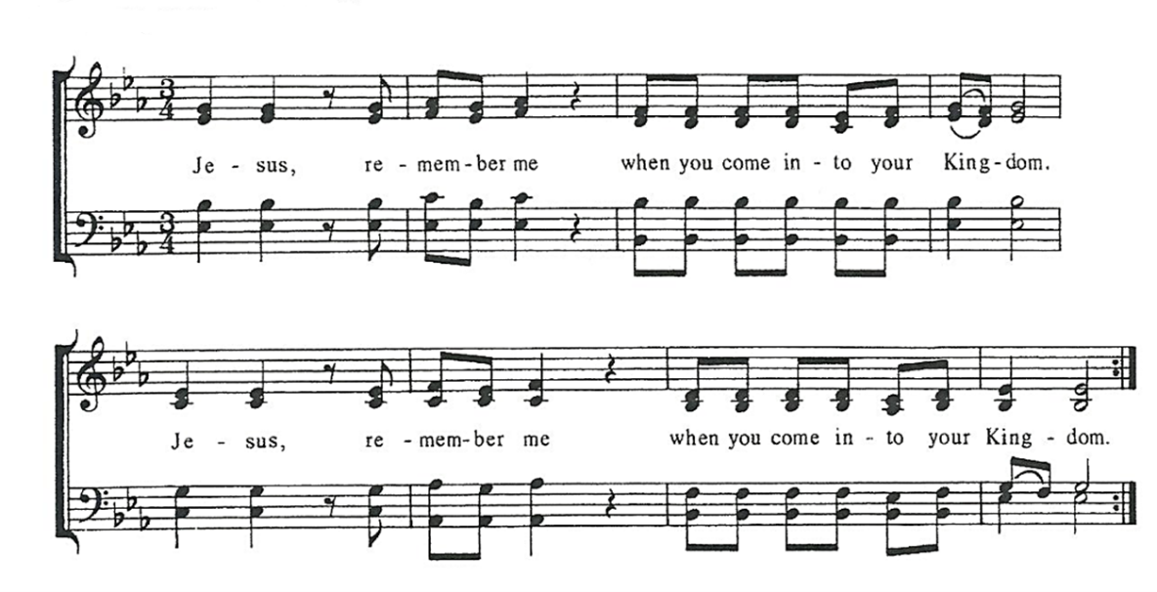

Post Communion Prayer, said by all
Generous and faithful God, you have fed us at your table. May the nourishment we have received enable us to enrich the lives of others wherever we may go from here. Whether the future be dark or bright, the road be smooth or rough, whether our cares be light or heavy, our song be strong or weak, keep our hearts warm and our hands open, our lives ever embracing, and ever embraced by your love. Amen.

Blessing
May the heavens bless you. May the sun shine on you. May the rain dance on your wellies. May the stars make you wonder and smile. May the earth bless you, and may you bless the earth in planting and protest, and sharing food, in the name of the Father, and of the Son, and of the Holy Spirit. Amen.

sending hymn
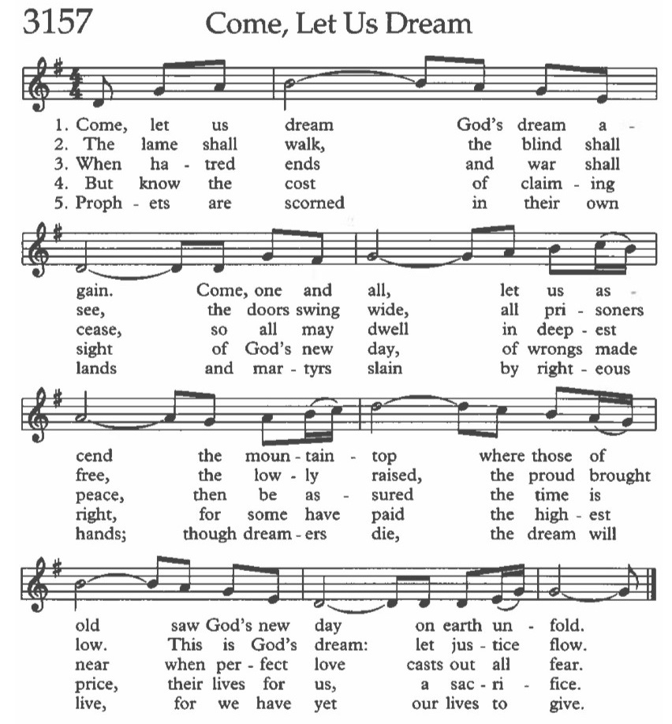

Dismissal Go in peace to love and serve the Lord.
Response: Thanks be to God.
Postlude -Water Horse

Announcements
Lenten Program On Tuesday 3/19 at 6:30 pm in the Undercroft, we will conclude this year’s Lenten program with the curriculum called Bearing Witness, created by the American Friends of the Episcopal Diocese of Jerusalem. We’ll begin with the ancient Stations of the Cross service, using a special set of stations that imagines Jesus as a monarch butterfly on migration to his eventual transformation.
MHA Luncheon Volunteers needed
St. Luke’s will be hosting the monthly Recovery Luncheon at the Mental Health Association at the Gateway Center on Water St on Tuesday, March 19th at 12 pm. We need volunteers to prepare, transport, and serve the meal. If you have questions or want to volunteer contact Sandy Kearney at skearney@windstream.net or (716) 969-3988.

Palm Cross Making on 3/21 @ 5pm
Nimble-fingered or not, you are invited to join the Altar Guild and friends for a fun night of palm cross making. A pizza dinner and adult refreshments are provided. Come learn a new skill and make some new friends on Thursday, March 21st at 5pm in the undercroft.

March Monday Night Café & CSA Launch
As the new year rolls on, our Monday Night Café returns! Come on March 25th from 6 – 7:30 pm in the Undercroft for Grow Jamestown’s free locally sourced dinner. The Monday Night Café is an invitation everyone in the community to come together and celebrate each other and support our hardworking farmers and producers. Most of the meal is sourced locally in Chautauqua County and NYS. This month we will feature locally baked bread with flour grown right here in New York State, made by Grain Bakery in Westfield. This bread will also be featured in this year’s Eat Fresh, Do Good CSA (Community Supported Agriculture) program — along with egg and meat shares as weekly add ons! CSA sign up will kick off during the Monday Night Café. Email Nick at nick.weith@stlukesjamestown.org to sign up to volunteer or sign up on the bulletin board by the stairs.

Holy Week Services:
Holy Tuesday, March 26
8:30 a.m. Morning Prayer – in church and streamed on Facebook.
11:00 a.m. Diocesan Chrism Mass - in person in church.
Wednesday, March 27
8:30 a.m. Morning Prayer – in church and streamed on Facebook.
12:00 p.m. Holy Eucharist – chapel.
7:00 p.m. Tenebrae, a service of light and meditation – chapel.
Maundy Thursday, March 28
8:30 a.m. Morning Prayer – in church and streamed on Facebook.
12:00 p.m. Holy Eucharist with Foot Washing and Stripping the Chapel Altar.
7:00 p.m. Holy Eucharist with Foot Washing and Stripping of the Church Altar
8:00 p.m. Night Watch (a vigil through the night to watch and wait with Jesus; sign up
on the sheet in the stairway entrance; or online using the QR code.
Good Friday, March 29
8:30 a.m. Morning Prayer – in church and streamed on Facebook.
12:00 p.m. Overnight Watch ends with Mass of the Pre-Sanctified and
Veneration of the Cross – Church.
7:00 p.m. Mass of the Pre-Sanctified and Veneration of the Cross – Church.
Holy Saturday, March 30
7:00 p.m. The Great Vigil of Easter: First Eucharist of Easter and Baptism.
Easter Sunday, March 31
8:00 a.m. Holy Eucharist – Chapel.
9:30 a.m. Children’s Easter Egg Hunt.
10:00 a.m. Festival Eucharist with Choir – church & live streamed.

