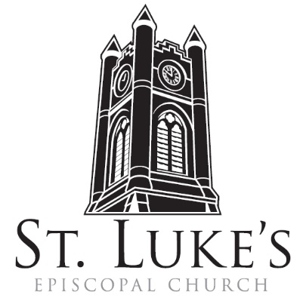
The Holy Eucharist

Sunday, February 4, 2024
Fifth Sunday after the Epiphany

St. Luke’s Episcopal Church
North Main at Fourth Street, Jamestown, New York
The Rt. Rev. Sean Rowe, Bishop
The Rev. Luke Fodor, Rector; The Rev. Deacon Cathy Smith;
Mr. Paul Johnson, Verger; Mr. Loren Masánqué, Minister of Music
The Rev. Deacon Jessica Frederick, Curate for Children, Youth & Family Ministry
www.stlukesjamestown.org ~ email: stlukes@stlukesjamestown.org

The mission is simple: to Connect all people, help them Discover God's love, empower them to Serve and watch them Grow.”

WELCOME TO ST. LUKE’S
We welcome you this morning to St. Luke’s Church and are delighted to have you join us for worship today. If you are visiting for the first time, or are looking for a church home, please fill in a pew card and place it in the offering plate.
At the time of Communion, all are invited to God’s Table. In addition to the altar rail, at the 10 a.m. service a floor-level Communion station is made available, which includes gluten-free wafers and grape juice. Please indicate your preference.
Available to children is Children’s Chapel downstairs during the 10am service, a visit to the Children’s Corner, or the use of a “Children’s Activity Bag” found near the front of the church nave (ask an usher). Join us downstairs for refreshments. All are welcome! Audio transmitters are available for those who have difficulty hearing the service; please ask an usher.
~ Copies of today’s sermon are available at the doors. ~

Prelude: Fairest Lord Jesus -Arr. by Warren Allred
Opening Hymn: #423 Immortal, Invisible, God Only Wise v. 1, 3 & 4 -Blue Pew Hymnal

Opening Acclamation
Celebrant: Blessed be God: Father, Son, and Holy Spirit.
People: And blessed be God’s kingdom, now and for ever. Amen.

Collect for Purity, said by all
Almighty God, to you all hearts are open, all desires known, and from you no secrets are hid: Cleanse the thoughts of our hearts by the inspiration of your Holy Spirit, that we may perfectly love you, and worthily magnify your holy Name; through Christ our Lord. Amen.

Gloria, 8am spoken, 10am see insert for song of praise, “God Beyond All Praising,” v. 1 & 3
Glory to God in the highest, and peace to God’s people on earth. Lord God, heavenly King, almighty God and Father, we worship you, we give you thanks, we praise you for your glory. Lord Jesus Christ, only Son of the Father, Lord God, Lamb of God, you take away the sin of the world; have mercy on us; you are seated at the right hand of the Father; receive our prayer. For you alone are the Holy One, you alone are the Lord, you alone are the Most High, Jesus Christ, with the Holy Spirit, in the glory of God the Father. Amen.

The Collect of the Day:
The Lord be with you. Response: And also with you.
Let us pray. Set us free, O God, from the bondage of our sins, and give us the liberty of that abundant life which you have made known to us in your Son our Savior Jesus Christ; who lives and reigns with you, in the unity of the Holy Spirit, one God, now and for ever. Amen.

The First Reading is from Isaiah 40:21-31

Have you not known? Have you not heard? Has it not been told you from the beginning? Have you not understood from the foundations of the earth? It is he who sits above the circle of the earth, and its inhabitants are like grasshoppers; who stretches out the heavens like a curtain, and spreads them like a tent to live in; who brings princes to naught, and makes the rulers of the earth as nothing. Scarcely are they planted, scarcely sown, scarcely has their stem taken root in the earth, when he blows upon them, and they wither, and the tempest carries them off like stubble. To whom then will you compare me, or who is my equal? says the Holy One. Lift up your eyes on high and see: Who created these? He who brings out their host and numbers them, calling them all by name; because he is great in strength,
mighty in power, not one is missing. Why do you say, O Jacob, and speak, O Israel, "My way is hidden from the Lord, and my right is disregarded by my God"? Have you not known? Have you not heard? The Lord is the everlasting God, the Creator of the ends of the earth. He does not faint or grow weary;
his understanding is unsearchable. He gives power to the faint, and strengthens the powerless. Even youths will faint and be weary, and the young will fall exhausted; but those who wait for the Lord shall renew their strength, they shall mount up with wings like eagles, they shall run and not be weary,
they shall walk and not faint. The Word of the Lord. Thanks be to God.

Psalm #147:1-12, 21c 8am: Please join in saying the Psalm responsively by half verse. 10am: See next page

1 Alleluia! How good it is to sing praises to you, O God; *

how pleasant it is to honor you with praise!

2 For you rebuild Jerusalem * and gather the exiles of Israel.

3 You heal the brokenhearted * and bind up their wounds.

4 You count the number of the stars * and call them all by their names.

5 Great are you and mighty in power; * there is no limit to your wisdom.

6 You lift up the lowly, * but cast the wicked to the ground.

7 We sing to you, Most High, with thanksgiving; * we make music to you upon the harp,

8 For you cover the heavens with clouds * and prepare rain for the earth;

9 You make grass to grow upon the mountains * and green plants to serve humankind.

10 You provide food for flocks and herds * and for the young ravens when they cry.

11 You are not impressed by the might of a horse; * you have no pleasure in human strength;

12 But you have pleasure in those who fear you, * in those who await your gracious favor. Alleluia!

10am Psalm:

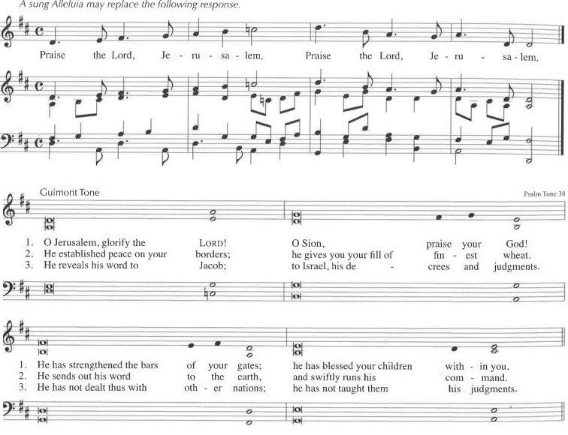

The Second Reading is from 1st Corinthians 9:16-23

If I proclaim the gospel, this gives me no ground for boasting, for an obligation is laid on me, and woe to me if I do not proclaim the gospel! For if I do this of my own will, I have a reward; but if not of my own will, I am entrusted with a commission. What then is my reward? Just this: that in my proclamation I may make the gospel free of charge, so as not to make full use of my rights in the gospel. For though I am free with respect to all, I have made myself a slave to all, so that I might win more of them. To the Jews I became as a Jew, in order to win Jews. To those under the law I became as one under the law (though I myself am not under the law) so that I might win those under the law. To those outside the law I became as one outside the law (though I am not free from God's law but am under Christ's law) so that I might win those outside the law. To the weak I became weak, so that I might win the weak. I have become all things to all people, that I might by all means save some. I do it all for the sake of the gospel, so that I may share in its blessings. The Word of the LORD. Thanks be to God.

Gospel Sequence Hymn: There is a balm in Gilead v. 1 & 2 -See Insert

The Holy Gospel of our Lord Jesus Christ, according to Mark 1:29-39
Response before the Gospel: Glory to you, Lord Christ.
After Jesus and his disciples left the synagogue, they entered the house of Simon and Andrew, with James and John. Now Simon’s mother-in-law was in bed with a fever, and they told him about her at once. He came and took her by the hand and lifted her up. Then the fever left her, and she began to serve them. That evening, at sundown, they brought to him all who were sick or possessed with demons. And the whole city was gathered around the door. And he cured many who were sick with various diseases, and cast out many demons; and he would not permit the demons to speak, because they knew him. In the morning, while it was still very dark, he got up and went out to a deserted place, and there he prayed. And Simon and his companions hunted for him. When they found him, they said to him, “Everyone is searching for you.” He answered, “Let us go on to the neighboring towns, so that I may proclaim the message there also; for that is what I came out to do.” And he went throughout Galilee, proclaiming the message in their synagogues and casting out demons. The Gospel of the Lord. Praise to You, Lord Christ.
Gospel Sequence Hymn: There is a balm in Gilead, v. 3 -See Insert

Sermon -The Rector

Nicene Creed, said by all, standing in body or in spirit.
We believe in one God, the Father, the Almighty, maker of heaven and earth, of all that is, seen
and unseen. We believe in one Lord, Jesus Christ, the only Son of God, eternally begotten of the
Father, God from God, Light from Light, true God from true God, begotten, not made, of one
Being with the Father; through him all things were made. For us and for our salvation he came
down from heaven, was incarnate of the Holy Spirit and the Virgin Mary and became truly
human. For our sake he was crucified under Pontius Pilate; he suffered death and was buried.
On the third day he rose again in accordance with the Scriptures; he ascended into heaven and is seated at the right hand of the Father. He will come again in glory to judge the living and the dead, and his kingdom will have no end. We believe in the Holy Spirit, the Lord, the giver of life, who proceeds from the Father, who with the Father and the Son is worshiped and glorified, who has spoken through the prophets. We believe in one holy catholic and apostolic Church. We acknowledge one baptism for the forgiveness of sins. We look for the resurrection of the dead, and the life of the world to come. Amen.

The Prayers of the People, Form VI -BCP 392
In peace, we pray to you, Lord God. Silence

For all people in their daily life and work; For our families, friends, and neighbors, and for those who are alone.

For this community, the nation, and the world; For all who work for justice, freedom, and peace.

For the just and proper use of your creation; For the victims of hunger, fear, injustice, and oppression.

For all who are in danger, sorrow, or any kind of trouble; For those who minister to the sick, the friendless, and the needy.

For the peace and unity of the Church of God; For all who proclaim the Gospel, and all who seek the Truth.

For Michael our Presiding Bishop, for Sean, the Bishop of our Diocesan Partnership, for the Episcopal Partnership churches of St. Augustine of Canterbury, Edinboro & Emmauel, Emporium, for St. Michael & All Angels, Buffalo and St. Paul’s Cathedral, Buffalo, for the Province of the Episcopal Church of Sudan; for Luke, Jessica and Cathy, our clergy, and for all bishops, priests and deacons; For all who serve God in the Church.
For the special needs and concerns of this congregation. Silence
Please join me in saying aloud the names of the people who have requested our prayers:
Tim Pickett, Carol Boling, Pete Nagle, Joyce Crate, Mary Holton, Deacon Pierce, Mac Dawson, Mark Fiore, for the people of the Ukraine and the People of the Holy Land, and those others we now name. Silence

Hear us, Lord; For your mercy is great.

We thank you, Lord, for all the blessings of this life.

We will exalt you, O God our King; And praise your Name for ever and ever.
We pray for all who have died, that they may have a place in your eternal kingdom. Silence
Lord, let your loving-kindness be upon them; Who put their trust in you.
We pray to you also for the forgiveness of our sins.
Lay Reader and People
God of all mercy, we confess that we have sinned against you, opposing your will in our lives.
We have denied your goodness in each other, in ourselves, and in the world you have created.
We repent of the evil that enslaves us, the evil we have done, and the evil done on our behalf.
Forgive, restore, and strengthen us through our Savior Jesus Christ, that we may abide in your love and serve only your will. Amen.

Absolution

Commissioning of vestry members and delegates

The Peace Let us exchange the Peace of Christ with one another!
The peace of the Lord be always with you. People And also with you.

Announcements

THE HOLY COMMUNION
If you’d like to give electronically, use your phone’s camera to scan the QR code.

Offertory

8:00 AM, said by all: All things come of Thee O Lord, and of Thine Own have we given Thee. Amen.

10:00 AM: Offertory Anthem: my shepherd will supply my need -St. Luke’s Choir
10:00 AM: Doxology, sung by all
Praise God from whom all blessings flow; praise God all creatures here below
praise God above, ye heav’nly host, praise Father, Son and Holy Ghost. Amen.

THE GREAT THANKSGIVING: Eucharistic Prayer: Enriching Our Worship 3

The Lord be with you. And also with you.
Lift up your hearts. We lift them to the Lord.
Let us give thanks to the Lord our God. It is right to give our thanks and praise.

All thanks and praise are yours at all times and in all places, our true and loving God; through Jesus Christ, your eternal Word, the Wisdom from on high by whom you created all things. You laid the foundations of the world and enclosed the sea when it burst out from the womb; You brought forth all creatures of the earth and gave breath to humankind. Wondrous are you, Holy One of Blessing, all you create is a sign of hope for our journey; And so as the morning stars sing your praises we join the heavenly beings and all creation as we shout with joy:

Holy, Holy, Holy Lord, God of power and might,
heaven and earth are full of your glory. Hosanna in the highest.
Blessed is the One who comes in the name of the Lord. Hosanna in the highest.

Glory and honor are yours, Creator of all, your Word has never been silent; you called a people to yourself, as a light to the nations, you delivered them from bondage and led them to a land of promise. Of your grace, you gave Jesus to be human, to share our life, to proclaim the coming of your holy reign and give himself for us, a fragrant offering. Through Jesus Christ our Redeemer, you have freed us from sin, brought us into your life, reconciled us to you, and restored us to the glory you intend for us. We thank you that on the night before he died for us Jesus took bread, and when he had given thanks to you, he broke it, gave it to his friends and said: “Take, eat, this is my Body, broken for you. Do this for the remembrance of me.” After supper Jesus took the cup of wine, said the blessing, gave it to his friends and said: “Drink this, all of you: this cup is the new Covenant in my Blood, poured out for you and for all for the forgiveness of sin. Do this for the remembrance of me.” And so, remembering all that was done for us: the cross, the tomb, the resurrection and ascension, longing for Christ’s coming in glory, and presenting to you these gifts your earth has formed and human hands have made, we acclaim you, O Christ:

Celebrant and People:
Dying, you destroyed our death. Rising, you restored our life. Christ Jesus, come in glory!

Send your Holy Spirit upon us and upon these gifts of bread and wine that they may be to us the Body and Blood of your Christ. Grant that we, burning with your Spirit’s power, may be a people of hope, justice and love. Giver of Life, draw us together in the Body of Christ, and in the fullness of time gather us with blessed Saint Luke, and all your people into the joy of our true eternal home. Through Christ and with Christ and in Christ, by the inspiration of your Holy Spirit, we worship you our God and Creator in voices of unending praise.

Celebrant and People: Blessed are you now and for ever. Amen. 10:00 AM sing below:

And now, as our Savior Christ has taught us, we are bold to say,
Our Father, who art in heaven, hallowed be thy Name, thy kingdom come, thy will be done,
on earth as it is in heaven. Give us this day our daily bread.
And forgive us our trespasses, as we forgive those who trespass against us.
And lead us not into temptation, but deliver us from evil. For thine is the kingdom, and the power, and the glory, for ever and ever. Amen.

The Breaking of the Bread
8:00 AM: Alleluia, Christ our Passover is sacrificed for us.
People: Therefore, let us keep the feast. Alleluia.

10:00 AM: Jesus Lamb of God, have mercy on us. Jesus, bearer of our sins, have mercy on us.
Jesus, Redeemer, Redeemer of the world, give us your peace, give us your peace.

The Communion Wherever you are on your spiritual journey, all are invited to receive Communion.
Gluten-free wafers, as well as grape juice, are available, please indicate your preference;
at the 10AM service, at the floor communion station. If you have difficulty coming forward, communion can be brought to you at your seat. You are invited to light a candle for a person or concern in your prayers.
A candle station is located at the rear of the Chapel; and to the right of the pulpit in the Church.

Communion Music
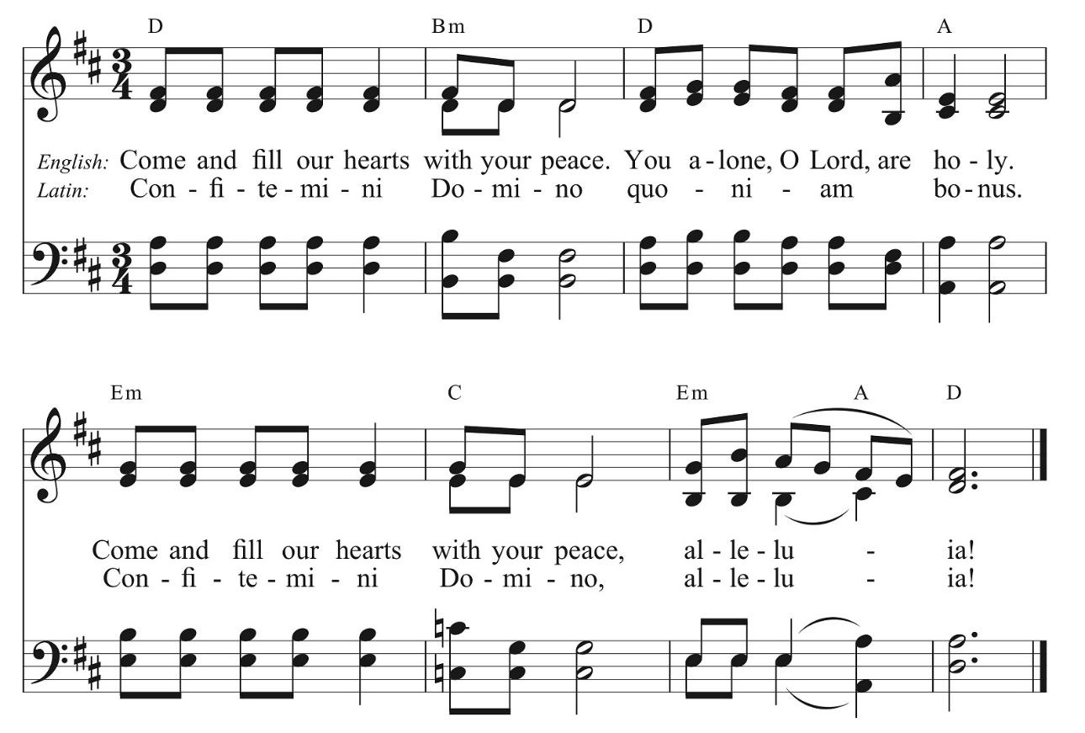

Post Communion Prayer, said by all
Eternal God, heavenly Father, you have graciously accepted us as living members of your Son, our Savior Jesus Christ, and you have fed us with spiritual food in the sacrament of his Body and Blood. Send us now into the world in peace, and grant us strength and courage to love and serve you with gladness and singleness of heart; through Christ our Lord. Amen.

Blessing

Sending Hymn #411 O Bless the lord, my soul v. 1, 5 & 6 -1982 pew Hymnal

Dismissal Go in peace to love and serve the Lord. Alleluia, Alleluia, Alleluia!
Response: Thanks be to God! Alleluia, Alleluia, Alleluia!

Postlude: God of Grace -Setting by Paul Manz
The altar flowers are given to the Glory of God and in loving memory of Sylvia Meacham Johnson by her children, grandchildren and great-grandchildren.
Announcements
Service on the Slopes
If you enjoy a snowy mountaintop experience on Sundays, be sure to visit Holiday Valley for the Service on the Slopes, a brief ecumenical service of prayer, scripture reading and communion with a conversational sermon on the slopes. We meet in the Warming Hut on top of Cindy's lift weekly on Sundays at 2:30pm until March 10.
The Ordination of the Reverend Jessica Frederick!
It’s official-Jessica will be ordained as a priest on February 10th at 11am here at St. Luke’s! Your prayers and presence are requested as we celebrate this milestone with her. A reception will follow the service. In celebration of her ordination, we are collecting donations towards a gift from the parish. If you'd like to donate, please write a check with "Jessica's Ordination gift" included in the memo line and mail it to the church or include it in the offering plate.

Global Perspectives Book Club
Dina Nayeri’s acclaimed book, “The Ungrateful Refugee, What Immigrants Never Tell You,” Is the first selection for a new book club formed by the New Neighbors Coalition to be hosted at St. Luke’s. We'll be meeting on Monday, February 12 at 7pm in the Fenn Library in St. Luke's Undercroft. Nayeri, an Iranian refugee, writes of difficulties fitting into Western culture as she describes her firsthand experiences and those of other immigrants. If you wish to purchase the book online, we recommend purchasing through Good Neighbor Bookstore, a local bookshop in Lakewood. You can opt to have it shipped to you for a fee or choose the free pick-up option (which we highly recommend so you can peruse all the other wonderful things Good Neighbor has to offer) once it has arrived. For additional details or to let us know you’re coming, please contact Momina at momina@stlukesjamestown.org or (716) 483-6405.

Shrove Tuesday Pancake Supper & Prayer Stations
Before the austerity of Lent, we celebrate with a pre-Lenten feast of pancakes and sausage on Shrove (from the Old English—to shrive: to confess) Tuesday, February 13th from 5pm to 7pm. The dinner costs $7 and all of the proceeds will support the Youth Pilgrimage to Italy. This year, the festivities will also include some interactive and educational prayer stations to mark the Feast of The Rev. Absalom Jones, who was the first African American to be ordained as a priest in the Episcopal Church of the United States. While you are waiting to be served or after you have eaten, you are invited to engage with a series of interactive stations that will lead you to listen, learn, lament and love. These Stations are a project of the Dismantling Racism Committee.

