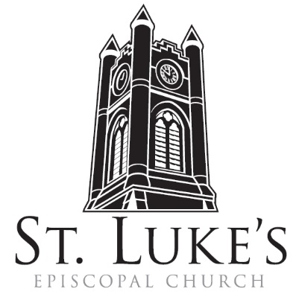
Holy Eucharist ~ Sunday, March 10, 2024

The 4th Sunday in Lent/Mothering Sunday

St. Luke’s Episcopal Church
North Main at Fourth Street
Jamestown, New York
The Rt. Rev. Sean Rowe, Bishop
The Rev. Luke Fodor, Rector; The Rev. Deacon Cathy Smith;
Mr. Paul Johnson, Verger; Mr. Loren Masánqué, Minister of Music
The Rev. Jessica Frederick, Curate for Children, Youth & Family Ministry
www.stlukesjamestown.org ~ email: stlukes@stlukesjamestown.org
The mission is simple: to Connect all people, help them Discover God's love, empower them to Serve and watch them Grow.”

WELCOME TO ST. LUKE’S
We welcome you this morning to St. Luke’s Church and are delighted to have you join us for worship today. If you are visiting for the first time, or are looking for a church home, please fill in a pew card and place it in the offering plate.
At the time of Communion, all are invited to God’s Table. In addition to the altar rail, at the 10 a.m. service a floor-level Communion station is made available, which includes gluten-free wafers and grape juice, please indicate your preference.
Available to children is a visit to the Children’s Corner, Children’s Chapel during the 10am service in the Undercroft, or the use of a “Children’s Activity Bag” found near the front of the church nave (ask an usher). Join us downstairs for refreshments. All are welcome! Audio transmitters are available for those who have difficulty hearing the service; please ask an usher. Copies of today’s sermon are available at the doors.
prelude: Fugue & Fantasia in G Minor -Bohm
Introit: #715 when Jesus wept -1982 Blue Pew Hymnal
Opening Hymn #379 god is love -1982 Blue Pew Hymnal

A Penitential order: Rite Two

Celebrant: Bless the Lord who forgives all our sins;
People: God’s mercy endures for ever.

The Decalogue, the people kneeling
Hear the commandments of God to his people: I am the Lord your God who brought you out of bondage. You shall have no other gods but me. Amen. Lord have mercy.
You shall not make for yourself any idol. Amen. Lord have mercy.
You shall not invoke with malice the Name of the Lord your God. Amen. Lord have mercy.
Remember the Sabbath day and keep it holy. Amen. Lord have mercy.
Honor your father and your mother. Amen. Lord have mercy.
You shall not commit murder. Amen. Lord have mercy.
You shall not commit adultery. Amen. Lord have mercy.
You shall not steal. Amen. Lord have mercy.
You shall not be a false witness. Amen. Lord have mercy.
You shall not covet anything that belongs to your neighbor. Amen. Lord have mercy.

If we say that we have no sin, we deceive ourselves, and the truth is not in us. But if we confess our sins, God, who is faithful and just, will forgive our sins and cleanse us from all unrighteousness.

Confession of Sin, said by all, kneeling as able.
Most merciful God, we confess that we have sinned against you in thought, word, and deed, by what we have done, and by what we have left undone. We have not loved you with our whole heart; we have not loved our neighbors as ourselves. We are truly sorry and we humbly repent.
For the sake of your Son Jesus Christ, have mercy on us and forgive us; that we may delight in your will, and walk in your ways, to the glory of your Name. Amen.

Absolution
8:00 am Lord, have mercy upon us. Christ, have mercy upon us. Lord, have mercy upon us.
10:00 am - S102, front pages of 1982 pew Hymnal

The Collect of the Day: The Lord be with you. Response: And also with you.
Let us pray: Gracious Father, whose blessed Son Jesus Christ came down from heaven to be the true bread which gives life to the world: Evermore give us this bread, that he may live in us, and we in him; who lives and reigns with you and the Holy Spirit, one God, now and for ever. Amen.

The First Reading is from Numbers 21:4-9

From Mount Hor the Israelites set out by the way to the Red Sea, to go around the land of Edom; but the people became impatient on the way. The people spoke against God and against Moses, “Why have you brought us up out of Egypt to die in the wilderness? For there is no food and no water, and we detest this miserable food.” Then the Lord sent poisonous serpents among the people, and they bit the people, so that many Israelites died. The people came to Moses and said, “We have sinned by speaking against the Lord and against you; pray to the Lord to take away the serpents from us.” So Moses prayed for the people. And the Lord said to Moses, “Make a poisonous serpent, and set it on a pole; and everyone who is bitten shall look at it and live.” So Moses made a serpent of bronze, and put it upon a pole; and whenever a serpent bit someone, that person would look at the serpent of bronze and live. The Word of the LORD. Thanks be to God.

Psalm #107:1-3, 17-22 please join in saying the psalm in unison. -Saint Helena Psalter
1 We give you thanks, O God, for you are good; your mercy endures for ever.

2 Let all those whom you have redeemed proclaim that you redeemed them from the hand of the foe.
3 You gathered them out of the lands; from the east and from the west, from the north and from the south.
17 Some were fools and took to rebellious ways; they were afflicted because of their sins.
18 They abhorred all manner of food and drew near to death’s door.
19 Then they cried to you in their trouble, and you delivered them from their distress.
20 You sent forth your word and healed them and saved them from the grave.
21 Let them give thanks to you for your mercy and the wonders you do for your children.
22 Let them offer a sacrifice of thanksgiving and tell of your acts with shouts of joy.

The Second Reading is from Ephesians 2:1-10

You were dead through the trespasses and sins in which you once lived, following the course of this world, following the ruler of the power of the air, the spirit that is now at work among those who are disobedient. All of us once lived among them in the passions of our flesh, following the desires of flesh and senses, and we were by nature children of wrath, like everyone else. But God, who is rich in mercy, out of the great love with which he loved us even when we were dead through our trespasses, made us alive together with Christ-- by grace you have been saved-- and raised us up with him and seated us with him in the heavenly places in Christ Jesus, so that in the ages to come he might show the immeasurable riches of his grace in kindness toward us in Christ Jesus. For by grace you have been saved through faith, and this is not your own doing; it is the gift of God-- not the result of works, so that no one may boast. For we are what he has made us, created in Christ Jesus for good works, which God prepared beforehand to be our way of life. The Word of the LORD. Thanks be to God.

Gospel Sequence Hymn: levas #70 I want Jesus to Walk with Me 1 & 2 -Insert

The Holy Gospel of our Lord Jesus Christ, according to John 3:14-21
Response before the Gospel: Glory to you, Lord Christ.
Jesus said, “Just as Moses lifted up the serpent in the wilderness, so must the Son of Man be lifted up, that whoever believes in him may have eternal life. “For God so loved the world that he gave his only Son, so that everyone who believes in him may not perish but may have eternal life. “Indeed, God did not send the Son into the world to condemn the world, but in order that the world might be saved through him. Those who believe in him are not condemned; but those who do not believe are condemned already, because they have not believed in the name of the only Son of God. And this is the judgment, that the light has come into the world, and people loved darkness rather than light because their deeds were evil. For all who do evil hate the light and do not come to the light, so that their deeds may not be exposed. But those who do what is true come to the light, so that it may be clearly seen that their deeds have been done in God.” The Gospel of the Lord. Praise to you, Lord Christ.
Gospel Sequence Hymn: levas #70 I want Jesus to Walk with Me 3 -Insert
Sermon -The Rector

Nicene Creed, said by all, standing as able
We believe in one God, the Father, the Almighty, maker of heaven and earth, of all that is, seen and unseen. We believe in one Lord, Jesus Christ, the only Son of God, eternally begotten of the Father, God from God, Light from Light, true God from true God, begotten, not made, of one Being with the Father; through him all things were made. For us and for our salvation he came down from heaven, was incarnate of the Holy Spirit and the Virgin Mary and became truly human.
For our sake he was crucified under Pontius Pilate; he suffered death and was buried. On the third day he rose again in accordance with the Scriptures; he ascended into heaven and is seated at the right hand of the Father. He will come again in glory to judge the living and the dead, and his kingdom will have no end. We believe in the Holy Spirit, the Lord, the giver of life,
who proceeds from the Father, who with the Father and the Son is worshiped and glorified,
who has spoken through the prophets. We believe in one holy catholic and apostolic Church.
We acknowledge one baptism for the forgiveness of sins. We look for the resurrection of the dead, and the life of the world to come. Amen.

Prayers of the People (Form I, BCP pg 384)
With all our heart and with all our mind, let us pray to the Lord, saying “Lord, have mercy.”
For the peace of the world, for the welfare of the Holy Church of God, and for the unity of all peoples, let us pray to the Lord. Lord, have mercy.
For Michael, our Presiding Bishop, for Sean, our Bishop, for the Episcopal partnership churches of Epiphany (Grove City) and Resurrection (Hermitage), for St. John’s (Ellicotville) and St. Barnabas (Frankinville), for the Dioceses of Colombia, for Luke, Jessica and Cathy, and for all the clergy and people, let us pray to the Lord. Lord, have mercy.
For the leaders of all the nations, for the nation of Ukraine and its people, for the Holy Land and its people, and for all in authority, let us pray to the Lord. Lord, have mercy.
For every city and community, and for those who live in them, let us pray to the Lord. Lord, have mercy.

For seasonable weather, and for an abundance of the fruits of the earth, let us pray to the Lord.
Lord, have mercy.
For the good earth which God has given us, and for the wisdom and will to conserve it, let us pray to the Lord. Lord, have mercy.
For those who travel on land, on water, in the air and through outer space, let us pray to the Lord.
Lord, have mercy.
For the aged and infirm, for the widowed and orphans, and for the sick and the suffering,
let us pray to the Lord. Lord, have mercy.

Please join me in saying aloud the names of the people on our prayer list:
Tim Pickett, Carol Boling, Pete Nagle, Joyce Crate, Mary Holton, Deacon Pierce, Mac Dawson, Mark Fiore, Ed & Barb Slumsky, David Small, Joe Rickards, Casey, Johnny, Tom, Tim Morrison, Sloan, Harley, Crystal, and those others we now name. Silence. Let us pray to the Lord. Lord, have mercy.
For the poor and the oppressed, for the unemployed and the destitute, for prisoners and captives, and for all who remember and care for them, let us pray to the Lord. Lord, have mercy.
For all who have died in the hope of the resurrection, and for all the departed, let us pray to the Lord. Lord, have mercy.
For deliverance from all danger, violence, oppression, and degradation, let us pray to the Lord.
Lord, have mercy.
That we may end our lives in faith and hope, without suffering and without reproach, let us pray to the Lord. Lord, have mercy.
Defend us, deliver us, and in thy compassion protect us, O Lord, by thy grace. Lord, have mercy.
In the communion of Saint Luke and of all the saints, let us commend ourselves, and one another,
and all our life, to Christ our God. To thee, O Lord our God.

The Celebrant adds a concluding Collect.
Almighty and eternal God, ruler of all things in heaven and earth: Mercifully accept the prayers of your people and strengthen us to do your will; through Jesus Christ our Lord. Amen.

Blessing of Simnel Cake
Almighty God, giver of all joy: Receive at our hands this cake, that it may be to us a symbol of our communion with you and with one another; as its flour was once scattered over our land as wheat and now is one, so let us be one in anticipation of your gift of the new Jerusalem which, as your redeemed people, is our joy, our hope, our destiny, and our home. Hear us, O Lord, through Jesus Christ your Son, to whom with you and the Holy Spirit be all honour and glory, now and for ever Amen.

The Peace Let us exchange the Peace of Christ with one another!
The peace of the Lord be always with you. People: And also with you.

THE HOLY COMMUNION
Offertory
If you’d like to give electronically, use your phone’s camera to scan the QR code.

8am: All things come of Thee, O Lord. And of thine own have we given Thee. Amen.
10am: The Lord is my shepherd -St. Luke’s Choir

10am: Doxology, sung by all
Praise God throughout these forty days. Praise Christ, our Lord, whom God did raise.
And praise the Spirit who imparts God’s love in Christ into our hearts. Amen.

The Great Thanksgiving: Eucharistic Prayer A
The Lord be with you. And also with you. Lift up your hearts. We lift them to the Lord.
Let us give thanks to the Lord our God. It is right to give God thanks and praise.
It is right, and a good and joyful thing, always and everywhere to give thanks to you, Father Almighty, Creator of heaven and earth. Through Jesus Christ our Lord; who was tempted in every way as we are, yet did not sin. By his grace we are able to triumph over every evil, and to live no longer for ourselves alone, but for him who died for us and rose again. Therefore we praise you, joining our voices with Angels and Archangels and with all the company of heaven, who forever sing this hymn to proclaim the glory of your Name:
Sanctus & Benedictus, spoken at 8am, sung at 10am - S122, front pages of 1982 pew Hymnal
The Celebrant continues
Holy and gracious Father: In your infinite love you made us for yourself, and, when we had fallen into sin and become subject to evil and death, you, in your mercy, sent Jesus Christ, your only and eternal Son, to share our human nature, to live and die as one of us, to reconcile us to you, the God and Father of all. He stretched out his arms upon the cross, and offered himself, in obedience to your will, a perfect sacrifice for the whole world. On the night he was handed over to suffering and death, our Lord Jesus Christ took bread; and when he had given thanks to you, he broke it, and gave it to his disciples, and said, "Take, eat: This is my Body, which is given for you. Do this for the remembrance of me. "After supper he took the cup of wine; and when he had given thanks, he gave it to them, and said, "Drink this, all of you: This is my Blood of the new Covenant, which is shed for you and for many for the forgiveness of sins. Whenever you drink it, do this for the remembrance of me." Therefore we proclaim the mystery of faith: Christ has died. Christ is risen. Christ will come again.

We celebrate the memorial of our redemption, O Father, in this sacrifice of praise and thanksgiving. Recalling his death, resurrection, and ascension, we offer you these gifts. Sanctify them by your Holy Spirit to be for your people the Body and Blood of your Son, the holy food and drink of new and unending life in him. Sanctify us also that we may faithfully receive this holy Sacrament, and serve you in unity, constancy, and peace; and at the last day bring us with all your saints into the joy of your eternal kingdom. All this we ask through your Son Jesus Christ: By him, and with him, and in him, in the unity of the Holy Spirit all honor and glory is yours, Almighty Father, now and for ever. AMEN.
And now, as our Savior Christ has taught us, we are bold to say,
Our Father, who art in heaven, hallowed be thy Name, thy kingdom come, thy will be done, on earth as it is in heaven. Give us this day our daily bread.
And forgive us our trespasses, as we forgive those who trespass against us.
And lead us not into temptation, but deliver us from evil.
For thine is the kingdom, and the power, and the glory, for ever and ever. Amen.

The Breaking of the Bread Silent moment

Agnus Dei, spoken at the 8am, sung at the 10am - S-160, the front pages of the 1982 pew Hymnal

The Communion
Wherever you are on your spiritual journey, all are invited to receive Communion. Gluten-free wafers, as well as grape juice, are available, please indicate your preference; at the 10AM service, at the floor communion station. If you have difficulty coming forward, communion can be brought to you at your seat. You are invited to light a candle for a person or concern in your prayers. A candle station is located at the rear of the Chapel; and to the right of the pulpit in the Church.

Music at Communion
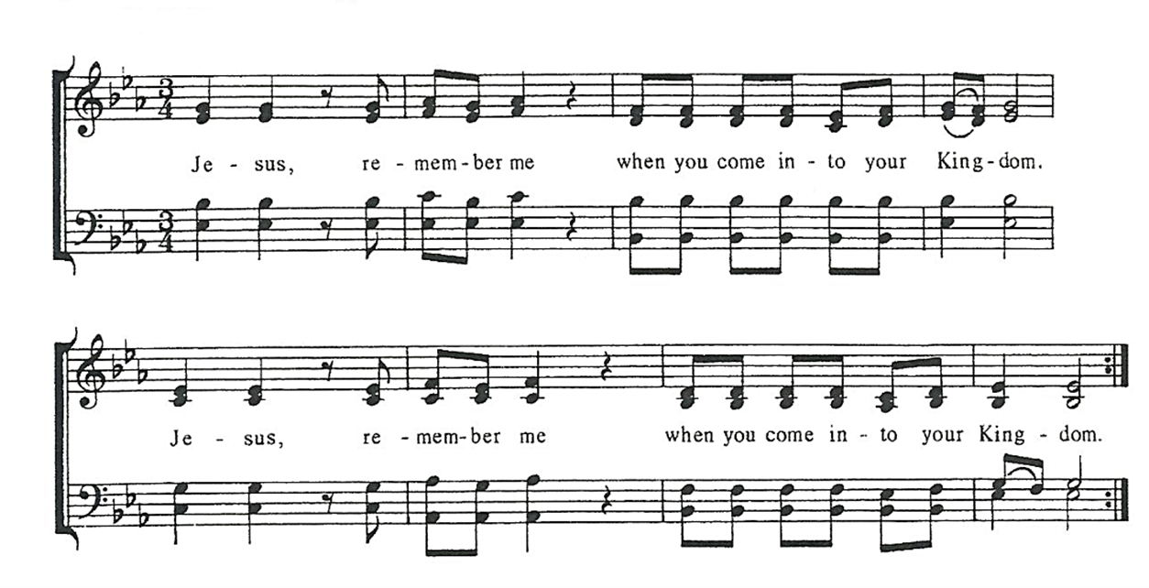

Post Communion Prayer, said by all
Eternal God, heavenly Father, you have graciously accepted us as living members
of your Son, our Savior Jesus Christ, and you have fed us with spiritual food in the
sacrament of his Body and Blood. Send us now into the world in peace, and grant
us strength and courage to love and serve you with gladness and singleness of heart;
through Christ our Lord. Amen.

solemn prayer

Sending Hymn #149, Eternal lord of love - 1982 pew Hymnal

Dismissal Go in peace to love and serve the Lord.
Response: Thanks be to God.

Postlude: little prelude in d minor -J.S. Bach
Announcements
Mothering Sunday at St. Luke’s Miss Annie Oates introduced the Simnel Cake to St. Luke’s in 1955. The Altar Guild took over the duty in 1968 and members started making the cakes. Three weeks before Mothering Sunday members of the Altar Guild gather in the church kitchen and make enough cakes to feed the congregation. After the cakes are baked, they are wrapped and stored in the refrigerator. The cakes are basted once a week for the next three weeks, some with brandy and some with apple juice. Pick up your cakes the worship service today, carrying on the old traditions of honoring our mother church and our families, as well as taking a break from Lenten Fasting.
Lenten Program On Tuesday 3/13 at 6:30 pm in the Undercroft, we will learn the story of our Anglican Palestine siblings using a curriculum called, Bearing Witness, created by the American Friends of the Episcopal Diocese of Jerusalem. The Rev. Jessica Frederick will lead most of these sessions. Each week we’ll begin with the ancient Stations of the Cross service, using a special set of stations that imagines Jesus as a monarch butterfly on migration to his eventual transformation.
Celebrate St. Patrick’s Day with a Celtic Mass
On March 17, we will offer a unique service with musical guests, Water Horse, the Celtic musical folk duo Sue Tillston and Jim Cunningham. They will offer special music; we will say Irish prayers and have a special celebratory coffee hour.

Confirmation
St. Luke’s will be hosting a regional confirmation service in May. If you are interested in being confirmed, please contact the Rector. Confirmation classes will be held during adult forum (9am on Sundays) and focus on a biography of the Book of Common Prayer.

My Name is Rachel Corrie
On March 15th and 16th at 7 pm at the Robert H. Jackson Center, Jessica Frederick will perform “My Name is Rachel Corrie” - a one-woman play about Rachel Corrie, an American diarist, activist, and human rights advocate who travels to Gaza in 2003. Jessica lived in the Occupied Palestinian Territories from 2007 to 2010, doing human rights documentation and advocacy work with Community Peacemaker Teams. Each performance will include a talkback session. Admission to the play is free, but there will be the opportunity to make a freewill offering. All donation proceeds collected at the event will go to support Gaza relief through the American Friends of the Episcopal Diocese of Jerusalem.

Monday Night Café returns
Our first Monday Night café of 2024 is on March 25 at 6pm. We’re looking for volunteers to help prep (either after the 3/24 10am service or the day of the café), serve and clean up. Email Nick at nick.weith@stlukesjamestown.org or sign up on the sheet at the bulletin board by the stairs.

