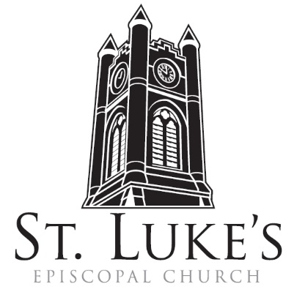
Holy Eucharist ~ Sunday, March 3, 2024

The 3rd Sunday in Lent

St. Luke’s Episcopal Church
North Main at Fourth Street
Jamestown, New York
The Rt. Rev. Sean Rowe, Bishop
The Rev. Luke Fodor, Rector; The Rev. Deacon Cathy Smith;
Mr. Paul Johnson, Verger; Mr. Loren Masánqué, Minister of Music
The Rev. Jessica Frederick, Curate for Children, Youth & Family Ministry
www.stlukesjamestown.org ~ email: stlukes@stlukesjamestown.org
The mission is simple: to Connect all people, help them Discover God's love, empower them to Serve and watch them Grow.”

WELCOME TO ST. LUKE’S
We welcome you this morning to St. Luke’s Church and are delighted to have you join us for worship today. If you are visiting for the first time, or are looking for a church home, please fill in a pew card and place it in the offering plate.
At the time of Communion, all are invited to God’s Table. In addition to the altar rail, at the 10 a.m. service a floor-level Communion station is made available, which includes gluten-free wafers and grape juice, please indicate your preference.
Available to children is a visit to the Children’s Corner, Children’s Chapel during the 10am service in the Undercroft, or the use of a “Children’s Activity Bag” found near the front of the church nave (ask an usher). Join us downstairs for refreshments. All are welcome! Audio transmitters are available for those who have difficulty hearing the service; please ask an usher. Copies of today’s sermon are available at the doors.
PRELUDE: Miserere Mei -transcribed from G. Allegri
Introit: #715 when Jesus wept -1982 Blue Pew Hymnal
Opening Hymn #143, the glory of these forty days, v. 1, 4 & 5 -1982 Blue Pew Hymnal

A Penitential order: Rite Two

Celebrant: Blessed be God: Father, Son and Holy Spirit.
People: And blessed be God’s kingdom, now and forever. Amen.

Celebrant: Bless the Lord who forgives all our sins;
People: God’s mercy endures for ever.

The Decalogue, the people kneeling
Hear the commandments of God to his people: I am the Lord your God who brought you out of bondage. You shall have no other gods but me. Amen. Lord have mercy.
You shall not make for yourself any idol. Amen. Lord have mercy.
You shall not invoke with malice the Name of the Lord your God. Amen. Lord have mercy.
Remember the Sabbath day and keep it holy. Amen. Lord have mercy.
Honor your father and your mother. Amen. Lord have mercy.
You shall not commit murder. Amen. Lord have mercy.
You shall not commit adultery. Amen. Lord have mercy.
You shall not steal. Amen. Lord have mercy.
You shall not be a false witness. Amen. Lord have mercy.
You shall not covet anything that belongs to your neighbor. Amen. Lord have mercy.

Jesus said, “The First Commandment is this: Hear, O Israel: The Lord our God is the only Lord. Love the Lord your God with all your heart, with all your soul, and with all your mind, and with all your strength. The second is this: Love your neighbor as yourself. There is no other commandment greater than these.”

Confession of Sin, said by all, kneeling as able.
Most merciful God, we confess that we have sinned against you in thought, word, and deed, by what we have done, and by what we have left undone. We have not loved you with our whole heart; we have not loved our neighbors as ourselves. We are truly sorry and we humbly repent.
For the sake of your Son Jesus Christ, have mercy on us and forgive us; that we may delight in your will, and walk in your ways, to the glory of your Name. Amen.

Absolution
8:00 am Lord, have mercy upon us. Christ, have mercy upon us. Lord, have mercy upon us.
10:00 am - S102, front pages of 1982 pew Hymnal

The Collect of the Day: The Lord be with you. Response: And also with you.
Let us pray: Almighty God, you know that we have no power in ourselves to help ourselves: Keep us both outwardly in our bodies and inwardly in our souls, that we may be defended from all adversities which may happen to the body, and from all evil thoughts which may assault and hurt the soul; through Jesus Christ our Lord, who lives and reigns with you and the Holy Spirit, one God, for ever and ever. Amen.

The First Reading is from Exodus 20:1-17

Then God spoke all these words: I am the Lord your God, who brought you out of the land of Egypt, out of the house of slavery; you shall have no other gods before me. You shall not make for yourself an idol, whether in the form of anything that is in heaven above, or that is on the earth beneath, or that is in the water under the earth. You shall not bow down to them or worship them; for I the Lord your God am a jealous God, punishing children for the iniquity of parents, to the third and the fourth generation of those who reject me, but showing steadfast love to the thousandth generation of those who love me and keep my commandments. You shall not make wrongful use of the name of the Lord your God, for the Lord will not acquit anyone who misuses his name. Remember the sabbath day, and keep it holy. For six days you shall labour and do all your work. But the seventh day is a sabbath to the Lord your God; you shall not do any work—you, your son or your daughter, your male or female slave, your livestock, or the alien resident in your towns. For in six days the Lord made heaven and earth, the sea, and all that is in them, but rested the seventh day; therefore the Lord blessed the sabbath day and consecrated it. Honor your father and your mother, so that your days may be long in the land that the Lord your God is giving you. You shall not murder. You shall not commit adultery. You shall not steal. You shall not bear false witness against your neighbor. You shall not covet your neighbor’s house; you shall not covet your neighbor’s wife, or male or female slave, or ox, or donkey, or anything that belongs to your neighbor. The Word of the LORD. Thanks be to God.

Psalm #19 please join in saying the psalm responsively by whole verse. -Saint Helena Psalter
1 The heavens declare your glory, O God, and the firmament shows your handiwork.
2 One day tells its tale to another, and one night imparts knowledge to another.
3 Although they have no words or language, and their voices are not heard,
4 Their sound has gone out into all lands, and their message to the ends of the world.
5 In the deep you have set a pavilion for the sun; it comes forth like a bridegroom out of his chamber;
it rejoices like a champion to run its course.
6 It goes forth from the uttermost edge of the heavens and runs about to the end of it again;
nothing is hidden from its burning heat.
7 Your law, O God, is perfect and revives the soul; your testimony is sure and gives wisdom to the innocent.
8 Your statutes are just and rejoice the heart; your commandment is clear and gives light to the eyes.
9 The fear of you is clean and endures for ever; your judgments are true and righteous altogether.
10 More to be desired are they than gold, more than much fine gold, sweeter far than honey, than honey in the comb.
11 By them also is your servant enlightened, and in keeping them there is great reward.
12 Who can tell how often one offends? Cleanse me from my secret faults.
13 Above all, keep your servant from presumptuous sins; let them not get dominion over me; then shall I be whole and sound, and innocent of a great offense.
14 Let the words of my mouth and the meditation of my heart be acceptable in your sight,
O God, my strength and my redeemer.

The Second Reading is from 1 Corinthians 1:18-25

The message about the cross is foolishness to those who are perishing, but to us who are being saved it is the power of God. For it is written, “I will destroy the wisdom of the wise, and the discernment of the discerning I will thwart.” Where is the one who is wise? Where is the scribe? Where is the debater of this age? Has not God made foolish the wisdom of the world? For since, in the wisdom of God, the world did not know God through wisdom, God decided, through the foolishness of our proclamation, to save those who believe. For Jews demand signs and Greeks desire wisdom, but we proclaim Christ crucified, a stumbling block to Jews and foolishness to Gentiles, but to those who are the called, both Jews and Greeks, Christ the power of God and the wisdom of God. For God’s foolishness is wiser than human wisdom, and God’s weakness is stronger than human strength. The Word of the LORD. Thanks be to God.

Gospel Sequence Hymn #142, Lord who throughout these forty days v. 1 & 4

The Holy Gospel of our Lord Jesus Christ, according to John 2:13-22
Response before the Gospel: Glory to you, Lord Christ.
The Passover of the Jews was near, and Jesus went up to Jerusalem. In the temple he found people selling cattle, sheep, and doves, and the money changers seated at their tables. Making a whip of cords, he drove all of them out of the temple, both the sheep and the cattle. He also poured out the coins of the money changers and overturned their tables. He told those who were selling the doves, “Take these things out of here! Stop making my Father’s house a marketplace!” His disciples remembered that it was written, “Zeal for your house will consume me.” The Jews then said to him, “What sign can you show us for doing this?” Jesus answered them, “Destroy this temple, and in three days I will raise it up.” The Jews then said, “This temple has been under construction for forty-six years, and will you raise it up in three days?” But he was speaking of the temple of his body. After he was raised from the dead, his disciples remembered that he had said this; and they believed the scripture and the word that Jesus had spoken. The Gospel of the Lord. Praise to you, Lord Christ.

Gospel Sequence Hymn #142, Lord who throughout these forty days v. 5

Sermon -The Rector

Nicene Creed, said by all, standing as able
We believe in one God, the Father, the Almighty, maker of heaven and earth, of all that is, seen and unseen. We believe in one Lord, Jesus Christ, the only Son of God, eternally begotten of the Father, God from God, Light from Light, true God from true God, begotten, not made, of one Being with the Father; through him all things were made. For us and for our salvation he came down from heaven, was incarnate of the Holy Spirit and the Virgin Mary and became truly human.
For our sake he was crucified under Pontius Pilate; he suffered death and was buried. On the third day he rose again in accordance with the Scriptures; he ascended into heaven and is seated at the right hand of the Father. He will come again in glory to judge the living and the dead, and his kingdom will have no end. We believe in the Holy Spirit, the Lord, the giver of life,
who proceeds from the Father, who with the Father and the Son is worshiped and glorified,
who has spoken through the prophets. We believe in one holy catholic and apostolic Church.
We acknowledge one baptism for the forgiveness of sins. We look for the resurrection of the dead, and the life of the world to come. Amen.

Prayers of the People (Form I, BCP pg 384)
With all our heart and with all our mind, let us pray to the Lord, saying “Lord, have mercy.”
For the peace of the world, for the welfare of the Holy Church of God, and for the unity of all peoples, let us pray to the Lord. Lord, have mercy.
For Michael, our Presiding Bishop, for Sean, our Bishop, for the Episcopal partnership churches of St. Clement’s (Greenville), St. Matthias’ (East Aurora), and St. Peter’s (Eggerstville), for the Church of the Province of Uganda, for Luke, Jessica and Cathy, and for all the clergy and people, let us pray to the Lord. Lord, have mercy.
For the leaders of all the nations, for the nation of Ukraine and its people, for the Holy Land and its people, and for all in authority, let us pray to the Lord. Lord, have mercy.
For every city and community, and for those who live in them, let us pray to the Lord. Lord, have mercy.

For seasonable weather, and for an abundance of the fruits of the earth, let us pray to the Lord.
Lord, have mercy.
For the good earth which God has given us, and for the wisdom and will to conserve it, let us pray to the Lord. Lord, have mercy.
For those who travel on land, on water, in the air and through outer space, let us pray to the Lord.
Lord, have mercy.
For the aged and infirm, for the widowed and orphans, and for the sick and the suffering,
let us pray to the Lord. Lord, have mercy.

Please join me in saying aloud the names of the people on our prayer list:
Tim Pickett, Carol Boling, Pete Nagle, Joyce Crate, Mary Holton, Deacon Pierce, Mac Dawson, Mark Fiore, Ed & Barb Slumsky, David Small, Joe Rickards, Casey, Johnny, and those others we now name. Silence. Let us pray to the Lord. Lord, have mercy.
For the poor and the oppressed, for the unemployed and the destitute, for prisoners and captives, and for all who remember and care for them, let us pray to the Lord. Lord, have mercy.
For all who have died in the hope of the resurrection, and for all the departed, especially Carole Sellstrom, let us pray to the Lord. Lord, have mercy.
For deliverance from all danger, violence, oppression, and degradation, let us pray to the Lord.
Lord, have mercy.
That we may end our lives in faith and hope, without suffering and without reproach, let us pray to the Lord. Lord, have mercy.
Defend us, deliver us, and in thy compassion protect us, O Lord, by thy grace. Lord, have mercy.
In the communion of Saint Luke and of all the saints, let us commend ourselves, and one another,
and all our life, to Christ our God. To thee, O Lord our God.

The Celebrant adds a concluding Collect.
Almighty and eternal God, ruler of all things in heaven and earth: Mercifully accept the prayers of your people and strengthen us to do your will; through Jesus Christ our Lord. Amen.

The Peace Let us exchange the Peace of Christ with one another!
The peace of the Lord be always with you. People: And also with you.

THE HOLY COMMUNION
Offertory
If you’d like to give electronically, use your phone’s camera to scan the QR code.

8am: All things come of Thee, O Lord. And of thine own have we given Thee. Amen.
10am: Choir Offertory Anthem: Ubi Caritas -St. Luke’s Choir

10am: Doxology, sung by all
Praise God throughout these forty days. Praise Christ, our Lord, whom God did raise.
And praise the Spirit who imparts God’s love in Christ into our hearts. Amen.

The Great Thanksgiving: Eucharistic Prayer A
The Lord be with you. And also with you. Lift up your hearts. We lift them to the Lord.
Let us give thanks to the Lord our God. It is right to give God thanks and praise.
It is right, and a good and joyful thing, always and everywhere to give thanks to you, Father Almighty, Creator of heaven and earth. Through Jesus Christ our Lord; who was tempted in every way as we are, yet did not sin. By his grace we are able to triumph over every evil, and to live no longer for ourselves alone, but for him who died for us and rose again. Therefore we praise you, joining our voices with Angels and Archangels and with all the company of heaven, who forever sing this hymn to proclaim the glory of your Name:
Sanctus & Benedictus, spoken at 8am, sung at 10am - S122, front pages of 1982 pew Hymnal
The Celebrant continues
Holy and gracious Father: In your infinite love you made us for yourself, and, when we had fallen into sin and become subject to evil and death, you, in your mercy, sent Jesus Christ, your only and eternal Son, to share our human nature, to live and die as one of us, to reconcile us to you, the God and Father of all. He stretched out his arms upon the cross, and offered himself, in obedience to your will, a perfect sacrifice for the whole world. On the night he was handed over to suffering and death, our Lord Jesus Christ took bread; and when he had given thanks to you, he broke it, and gave it to his disciples, and said, "Take, eat: This is my Body, which is given for you. Do this for the remembrance of me. "After supper he took the cup of wine; and when he had given thanks, he gave it to them, and said, "Drink this, all of you: This is my Blood of the new Covenant, which is shed for you and for many for the forgiveness of sins. Whenever you drink it, do this for the remembrance of me." Therefore we proclaim the mystery of faith: Christ has died. Christ is risen. Christ will come again.

We celebrate the memorial of our redemption, O Father, in this sacrifice of praise and thanksgiving. Recalling his death, resurrection, and ascension, we offer you these gifts. Sanctify them by your Holy Spirit to be for your people the Body and Blood of your Son, the holy food and drink of new and unending life in him. Sanctify us also that we may faithfully receive this holy Sacrament, and serve you in unity, constancy, and peace; and at the last day bring us with all your saints into the joy of your eternal kingdom. All this we ask through your Son Jesus Christ: By him, and with him, and in him, in the unity of the Holy Spirit all honor and glory is yours, Almighty Father, now and for ever. AMEN.
And now, as our Savior Christ has taught us, we are bold to say,
Our Father, who art in heaven, hallowed be thy Name, thy kingdom come, thy will be done, on earth as it is in heaven. Give us this day our daily bread.
And forgive us our trespasses, as we forgive those who trespass against us.
And lead us not into temptation, but deliver us from evil.
For thine is the kingdom, and the power, and the glory, for ever and ever. Amen.

The Breaking of the Bread Silent moment

Agnus Dei, spoken at the 8am, sung at the 10am - S-160, the front pages of the 1982 pew Hymnal

The Communion
Wherever you are on your spiritual journey, all are invited to receive Communion. Gluten-free wafers, as well as grape juice, are available, please indicate your preference; at the 10AM service, at the floor communion station. If you have difficulty coming forward, communion can be brought to you at your seat. You are invited to light a candle for a person or concern in your prayers. A candle station is located at the rear of the Chapel; and to the right of the pulpit in the Church.

Music at Communion
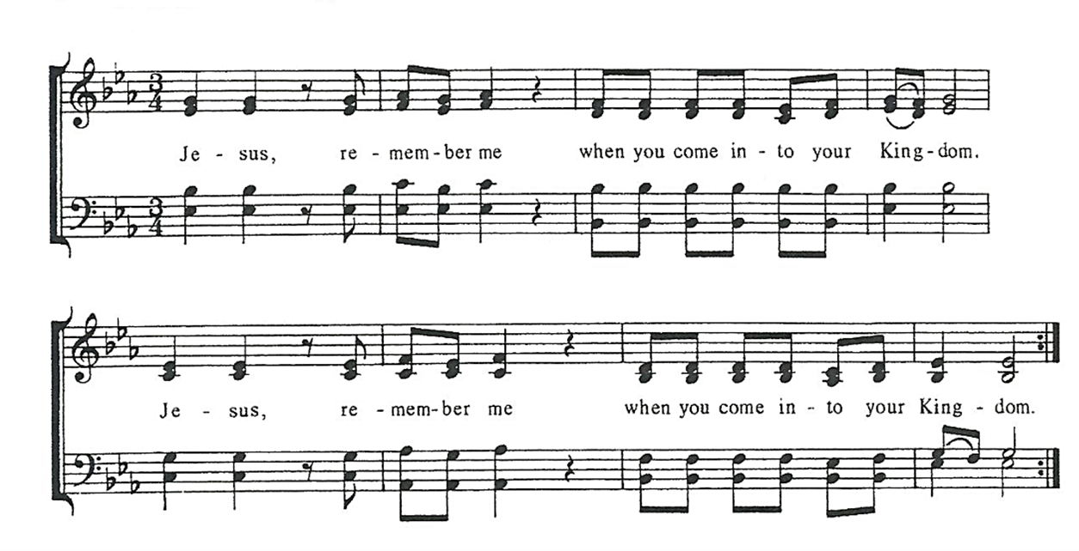

Post Communion Prayer, said by all
Eternal God, heavenly Father, you have graciously accepted us as living members
of your Son, our Savior Jesus Christ, and you have fed us with spiritual food in the
sacrament of his Body and Blood. Send us now into the world in peace, and grant
us strength and courage to love and serve you with gladness and singleness of heart;
through Christ our Lord. Amen.

solemn prayer

Sending Hymn # 150, Forty Days & Forty Nights, V. 1, 4 & 5 - 1982 pew Hymnal

Dismissal Go in peace to love and serve the Lord.
Response: Thanks be to God.

Postlude: Prelude, Courante and Sarabande in D Minor -Le Roux
Announcements
Lenten Program On Tuesday 3/5 at 6:30 pm in the Undercroft, we will learn the story of our Anglican Palestine siblings using a curriculum called, Bearing Witness, created by the American Friends of the Episcopal Diocese of Jerusalem. The Rev. Jessica Frederick will lead most of these sessions. Each week we’ll begin with the ancient Stations of the Cross service, using a special set of stations that imagines Jesus as a monarch butterfly on migration to his eventual transformation.
LGBTQ+ Drum Circle 3/6 @ 7pm in the Undercroft Come explore creative drumming, enjoy music in a playful atmosphere, and make connections with other LGBTQ+ members of the community! This group will foster joy and connection to yourself and with others in a safe, supportive environment. The group is facilitated by Karen Hewes Suber and will meet in the undercroft. Instruments are provided.
The Right of Reconciliation—Confession
Sometimes the formal process of asking for God’s forgiveness through the sacrament of auricular confession presents us with an opportunity for more grace. During Lent, the Rector invites you to explore this seldom used sacrament of the church. To schedule an appointment, send an email (luke.fodor@stlukesjamestown.org).

"Caste" Comes to the Screen
Two years ago, the Chautauqua County Book Read featured the fascinating and insightful book "Caste: The Origins of Our Discontents" by Isabel Wilkerson that explored the international caste system as the root of discrimination in society. The book has now been uniquely adapted by director Ava Duvernay for the screen in the film "Origin." The I.D.E.A. Coalition (St. Luke's is a member) is sponsoring an exclusive screening of the film on Saturday, March 9 at 7 PM at the Reg Lenna Theatre. Rated one of Associated Press's top ten films of 2023, tickets are available online at www.reglenna.com. We hope to see you there for this thought-provoking film that director DuVernay calls "15 little love stories."

