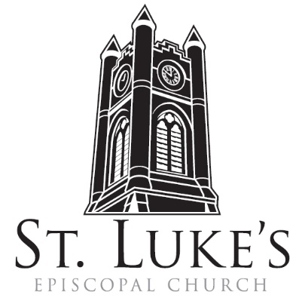
Holy Eucharist ~ April 14, 2024

The 3rd Sunday of Easter

St. Luke’s Episcopal Church
North Main at Fourth Street
Jamestown, New York
The Rt. Rev. Sean Rowe, Bishop
The Rev. Luke Fodor, Rector; The Rev. Deacon Cathy Smith;
Mr. Paul Johnson, Verger; Mr. Loren Masánqué, Minister of Music
The Rev. Jessica Frederick, Curate for Children, Youth & Family Ministry
www.stlukesjamestown.org ~ email: stlukes@stlukesjamestown.org

The mission is simple: to Connect all people, help them Discover God's love, empower them to Serve and watch them Grow.”

WELCOME TO ST. LUKE’S
We welcome you this morning to St. Luke’s Church and are delighted to have you join us for worship today. If you are visiting for the first time, or are looking for a church home, please fill in a pew card and place it in the offering plate.
At the time of Communion, all are invited to God’s Table. In addition to the altar rail, at the 10 a.m. service a floor-level Communion station is made available, which includes gluten-free wafers and grape juice, please indicate your preference.
Available to children is a visit to the Children’s Corner, or the use of a “Children’s Activity Bag” found near the front of the church nave (ask an usher). Children’s Chapel & nursery care is provided downstairs during the 10am service.
Clergy and members of the congregation look forward to greeting you after services. Join us downstairs for refreshments. All are welcome! Audio transmitters are available for those who have difficulty hearing the service; please ask an usher.

~ Copies of today’s sermon are available at the doors. ~

Prelude: Scherzo from Partita on Christ ist erstanden -Brenda Portman

OPENING HYMN #193: THAT EASTER DAY WHEN JOY WAS BRIGHT v. 1, 3-5 -Pew Hymnal

Opening Acclamation
Celebrant: Alleluia. Christ is risen. People: The Lord is risen indeed. Alleluia.

Collect for Purity, said by all
Almighty God, to you all hearts are open, all desires known, and from you no secrets are hid: Cleanse the thoughts of our hearts by the inspiration of your Holy Spirit, that we may perfectly love you, and worthily magnify your holy Name; through Christ our Lord. Amen.

Gloria, said by all at 8am, sung at 10am. -S278 Blue Pew Hymnal
Glory to God in the highest, and peace to God’s people on earth. Lord God, heavenly King, almighty God and Father, we worship you, we give you thanks, we praise you for your glory. Lord Jesus Christ, only Son of the Father, Lord God, Lamb of God, you take away the sin of the world; have mercy on us; you are seated at the right hand of the Father; receive our prayer. For you alone are the Holy One, you alone are the Lord, you alone are the Most High, Jesus Christ, with the Holy Spirit, in the glory of God the Father. Amen.

The Collect of the Day: The Lord be with you. Response: And also with you.
Let us pray: O God, whose blessed Son made himself known to his disciples in the breaking of bread: Open the eyes of our faith, that we may behold him in all his redeeming work; who lives and reigns with you, in the unity of the Holy Spirit, one God, now and for ever. Amen.

The First Reading is from the Acts of the Apostles 3:12-19

Peter addressed the people, “You Israelites, why do you wonder at this, or why do you stare at us, as though by our own power or piety we had made him walk? The God of Abraham, the God of Isaac, and the God of Jacob, the God of our ancestors has glorified his servant Jesus, whom you handed over and rejected in the presence of Pilate, though he had decided to release him. But you rejected the Holy and Righteous One and asked to have a murderer given to you, and you killed the Author of life, whom God raised from the dead. To this we are witnesses. And by faith in his name, his name itself has made this man strong, whom you see and know; and the faith that is through Jesus has given him this perfect health in the presence of all of you. “And now, friends, I know that you acted in ignorance, as did also your rulers. In this way God fulfilled what he had foretold through all the prophets, that his Messiah would suffer. Repent therefore, and turn to God so that your sins may be wiped out.” The Word of the Lord. Thanks be to God.

Psalm #4, please join in saying Psalm 4 responsively by half verse. - Saint Helena Psalter
¹ Answer me when I call, O God, defender of my cause; *
you set me free when I am hard-pressed; have mercy on me and hear my prayer.
² “You mortals, how long will you dishonor my glory; *
how long will you worship dumb idols and run after false gods?”
³ Know that God does wonders for the faithful; *
when I call, God will hear me.
⁴ Tremble, then, and do not sin; *
speak to your heart in silence upon your bed.
⁵ Offer the appointed sacrifices, *
and put your trust in the Most High.
⁶ Many are saying, “Oh, that we might see better times!” *
Lift up the light of your countenance upon us, O God.
⁷ You have put gladness in my heart, *
more than when grain and wine and oil increase.
⁸ I lie down in peace; at once I fall asleep; *
for only you, God, make me dwell in safety.

The Second Reading is from the 1st Letter of John 3:1-7

See what love the Father has given us, that we should be called children of God; and that is what we are. The reason the world does not know us is that it did not know him. Beloved, we are God's children now; what we will be has not yet been revealed. What we do know is this: when he is revealed, we will be like him, for we will see him as he is. And all who have this hope in him purify themselves, just as he is pure. Everyone who commits sin is guilty of lawlessness; sin is lawlessness. You know that he was revealed to take away sins, and in him there is no sin. No one who abides in him sins; no one who sins has either seen him or known him. Little children, let no one deceive you. Everyone who does what is right is righteous, just as he is righteous. The Word of the Lord. Thanks be to God.

GOSPEL SEQUENCE HYMN: O LIVING GOD V. 1-2 -see next page

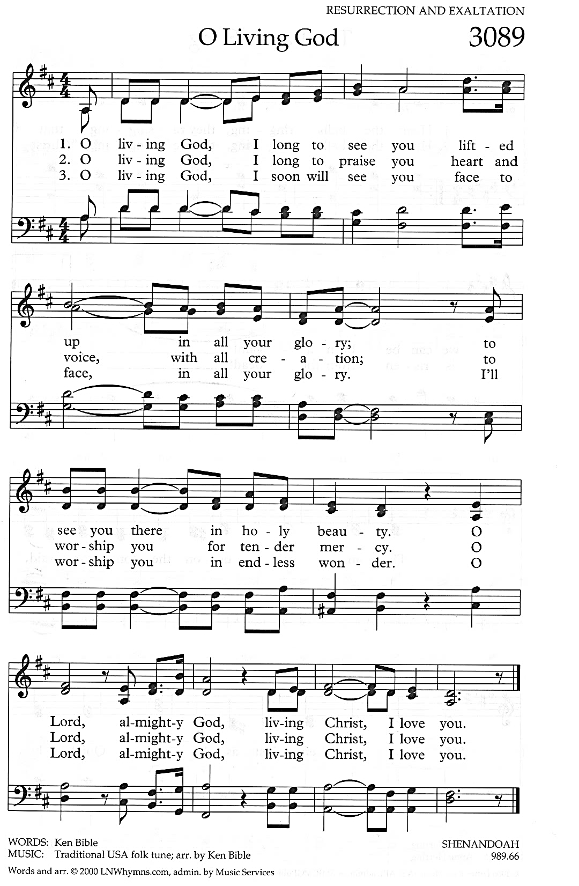

The Holy Gospel of our Lord Jesus Christ, according to Luke 24:36b-48
Response before the Gospel: Glory to you, Lord Christ.
Jesus himself stood among the disciples and said to them, “Peace be with you.” They were startled and terrified and thought that they were seeing a ghost. He said to them, “Why are you frightened, and why do doubts arise in your hearts? Look at my hands and my feet; see that it is I myself. Touch me and see; for a ghost does not have flesh and bones as you see that I have.” And when he had said this, he showed them his hands and his feet. While in their joy they were disbelieving and still wondering, he said to them, “Have you anything here to eat?” They gave him a piece of broiled fish, and he took it and ate in their presence. Then he said to them, “These are my words that I spoke to you while I was still with you—that everything written about me in the law of Moses, the prophets, and the psalms must be fulfilled.” Then he opened their minds to understand the scriptures, and he said to them, “Thus it is written, that the Messiah is to suffer and to rise from the dead on the third day, and that repentance and forgiveness of sins is to be proclaimed in his name to all nations, beginning from Jerusalem. You are witnesses of these things. The Gospel of the Lord. Praise to you, Lord Christ.

GOSPEL SEQUENCE HYMN: O LIVING GOD V. 3

Sermon -The Rev. Luke Fodor, Rector

Nicene Creed, said by all, standing as able
We believe in one God, the Father, the Almighty, maker of heaven and earth,
of all that is, seen and unseen. We believe in one Lord, Jesus Christ, the only Son of God,
eternally begotten of the Father, God from God, Light from Light, true God from true God, begotten, not made, of one Being with the Father; through him all things were made.
For us and for our salvation he came down from heaven, was incarnate of the Holy Spirit and the Virgin Mary and became truly human. For our sake he was crucified under Pontius Pilate; he suffered death and was buried. On the third day he rose again in accordance with the Scriptures; he ascended into heaven and is seated at the right hand of the Father.
He will come again in glory to judge the living and the dead, and his kingdom will have no end. We believe in the Holy Spirit, the Lord, the giver of life, who proceeds from the Father,
who with the Father and the Son is worshiped and glorified, who has spoken through the prophets. We believe in one holy catholic and apostolic Church. We acknowledge one baptism for the forgiveness of sins. We look for the resurrection of the dead, and the life of the world to come. Amen.

Prayers of the People: Form III BCP 388
Let us pray for the Church and for the world.

Father, we pray for your holy Catholic Church; That we all may be one.

Grant that every member of the Church may truly and humbly serve you; That your Name may be glorified by all people.

We pray for Michael our Presiding Bishop; for Sean the Bishop of our Diocesan Partnership; for the Episcopal Partnership churches of Trinity (New Castle), Advent (Kenmore) and Trinity (Lancaster), The Anglican churches in New Zealand and Polynesia, and for our clergy Luke, Jessica, Cathy and Tom, and for all bishops, priests, and deacons; That they may be faithful ministers of your Word and Sacraments.

We pray for peace and good will among all nations; for Joe, our President; for Kathy, our Governor; for Kim, our Mayor, for the members Congress and the Supreme Court; for the safety of the men and women of our armed forces, for the people of Ukraine and the people of the Holy Land, and for all who govern and hold authority in the nations of the world; That there may be justice and peace on the earth.

Give us grace to do your will in all that we undertake; That our works may find favor in your sight.

Comfort, O Lord, all those in trouble, sorrow, need, or any other adversity. Please join me in saying aloud the names of the people on our prayer list: Tim Pickett, Carol Boling, Joyce Crate, Mary Holton, Mac Dawson, Deacon Pierce, Mark Fiore, Connie Whitman, Becky Svetz, Nan Eaker, Noah Larson, Fran Stahley, Johnny, David Small, Abigail Ferrari, Bobby Jo, and those others we now name. Silence

Have compassion on those who suffer from any illness, grief or trouble; That they may be delivered from their distress.

Give to the departed eternal rest; Let light perpetual shine upon them.

We praise you for your saints who have entered into joy; May we also come to share in your heavenly kingdom.

The celebrant concludes with a collect.
Almighty God, to whom our needs are known before we ask: Help us to ask only what accords with your will; and those good things which we dare not, or in our blindness cannot ask, grant us for the sake of your Son Jesus Christ our Lord. Amen.

The Peace Let us exchange the Peace of Christ with one another!
The peace of the Lord be always with you. People And also with you.

THE HOLY COMMUNION
If you’d like to give electronically, use your phone’s camera to scan the QR code.
Offertory 8am: All things come of thee, O Lord. And of thine own have we given Thee. Amen.
10am: offertory: now the green blade riseth -Judith Ward

doxology: Praise God from whom all blessings flow; praise God all creatures here below. Alleluia, alleluia! Praise God above, ye heav’nly host. Praise Father, Son and Holy Ghost.
Alleluia, alleluia; alleluia, alleluia; alleluia!

The Great Thanksgiving: Enriching Our Worship: Supplemental Eucharistic Prayer 3
The Lord be with you. And also with you.
Lift up your hearts. We lift them to the Lord.
Let us give thanks to the Lord our God. It is right to give God thanks and praise.
All thanks and praise are yours at all times and in all places, our true and loving God; through Jesus Christ, your eternal Word, the Wisdom from on high by whom you created all things. You laid the foundations of the world and enclosed the sea when it burst out from the womb; You brought forth all creatures of the earth and gave breath to humankind. Wondrous are you, Holy One of Blessing, all you create is a sign of hope for our journey; and so as the morning stars sing your praises we join the heavenly beings and all creation as we shout with joy:
8am: Holy, Holy, Holy Lord, God of power and might, heaven and earth are full of your glory. Hosanna in the highest. Blessed is the One who comes in the name of the Lord. Hosanna in the highest.
10 am:
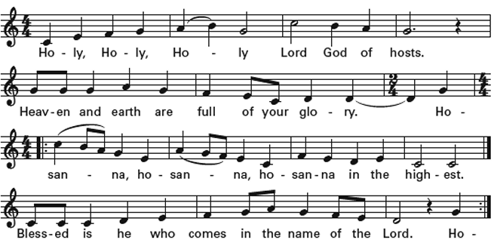
Glory and honor are yours, Creator of all, your Word has never been silent;
you called a people to yourself, as a light to the nations, you delivered them from bondage and led them to a land of promise. Of your grace, you gave Jesus to be human, to share our life, to proclaim the coming of your holy reign and give himself for us, a fragrant offering. Through Jesus Christ our Redeemer, you have freed us from sin, brought us into your life, reconciled us to you, and restored us to the glory you intend for us. We thank you that on the night before he died for us Jesus took bread, and when he had given thanks to you, he broke it, gave it to his friends and said: “Take, eat, this is my Body, broken for you. Do this for the remembrance of me.”
After supper Jesus took the cup of wine, said the blessing, gave it to his friends and said: “Drink this, all of you: this cup is the new Covenant in my Blood, poured out for you and for all for the forgiveness of sin. Do this for the remembrance of me.”
And so, remembering all that was done for us: the cross, the tomb, the resurrection and ascension, longing for Christ’s coming in glory, and presenting to you these gifts your earth has formed and human hands have made, we acclaim you, O Christ:
Dying, you destroyed our death. Rising, you restored our life. Christ Jesus, come in glory!
Send your Holy Spirit upon us and upon these gifts of bread and wine that they may be to us the Body and Blood of your Christ. Grant that we, burning with your Spirit’s power, may be a people of hope, justice and love. Giver of Life, draw us together in the Body of Christ, and in the fullness of time gather us with blessed Saint Luke, and all your people into the joy of our true eternal home.
Through Christ and with Christ and in Christ, by the inspiration of your Holy Spirit, we worship you our God and Creator in voices of unending praise:
Blessed are you now and for ever. 8am: Amen (Amen sung at 10am.)
10am: 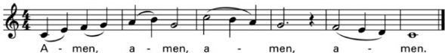

And now, as our Savior Christ has taught us, we are bold to say,
Our Father, who art in heaven, hallowed be thy Name, thy kingdom come, thy will be done, on earth as it is in heaven. Give us this day our daily bread, and forgive us our trespasses, as we forgive those who trespass against us. And lead us not into temptation, but deliver us from evil. For thine is the kingdom, and the power, and the glory, for ever and ever. Amen.

The Breaking of the Bread Silent moment

8am: Alleluia, Christ our Passover is sacrificed for us; Therefore let us keep the feast. Alleluia.

10am:

The Communion Wherever you are on your spiritual journey, all are invited to receive Communion.
Gluten-free wafers, as well as grape juice, are available, please indicate your preference;
If you have difficulty coming forward, communion can be brought to you at your seat.
You are invited to light a candle for a person or concern in your prayers.
A candle station is located at the back of the Chapel or to the right of the pulpit in the Church.

communion hymns: #335 i am the bread of life -Blue Pew Hymnal
#417 this is the feast, v. 4

Post Communion Prayer, said by all
Eternal God, heavenly Father, you have graciously accepted us as living members
of your Son, our Savior Jesus Christ, and you have fed us with spiritual food in the
sacrament of his Body and Blood. Send us now into the world in peace, and grant
us strength and courage to love and serve you, with gladness and singleness of heart; through Christ our Lord. Amen.

Blessing

closing Hymn: #192 this joyful eastertide -blue pew hymnal

Dismissal Let us go forth in the name of the risen Christ. Alleluia, alleluia, alleluia!
Response: Thanks be to God! Alleluia, Alleluia, Alleluia!

postlude: Toccata from Partida on Christ ist erstanden -Brenda Portman

The altar flowers are given to the Glory of God by Bonnie Rappole in loving memory of Dad and Gram.

Announcements
CSA Sign-Up NOW is the time to sign up for the CSA.
You can now sign up for the Grow Jamestown CSA program. Produce boxes range from $200 to $500 for the entire season. The CSA program will run from June through September. Shares will be available for pick-up at St. Luke’s on Wednesdays from noon to 7pm. We are offering shares in three sizes (and price points):
• Fun Size ($200) — Perfect for an individual, couple or family looking to introduce 3-4 unique and local veggies to your household.
•Family Size ($375) — For households looking to try new produce options, with 5-7 fresh fruit/veggie varieties.
•Full Size ($500) — For larger families or households that LOVE their fruits and veggies and wish to receive larger servings of seasonal options. Each week you’ll receive an email detailing what to expect in your share, as well as suggested recipes of what to do with your veggies and tips for preserving their freshness. This year you can also add on eggs, pork products, and fresh sourdough bread! All sourced, grown, and made right here in New York State and near Chautauqua County. Purchase your share at jtownpublicmarket.org.

Children’s Choir
A reminder that Children’s Choir rehearsals are right after the 10am service in the church. All are welcome!

Cozy Creations: Quilt Raffle to Raise Money for St. Luke’s Youth
Nancy Frederick has donated a quilt to raise money for St. Luke’s Youth – this lovely creation can be
yours with the purchase of raffle tickets. Ticket prices are $1 per ticket, or $10 for an arm’s length of tickets. Jessica has tickets available after church on Sunday (or in the parish house during the week) The drawing will take place at coffee hour on Youth Sunday (April 21st). Proceeds will go towards St. Luke’s youth ministries, including youth pilgrimages, youth group events and field trips, and covering the cost of future Youth Sundays.

Pasta Pilgrimage Dinner & Trivia Night on 4/20
With the generous support of the whole congregation, 8 youth and 3 adult pilgrims went on the journey of a lifetime—walking over 75 miles from the medieval city of Viterbo to the Vatican in Rome. On Saturday April 20th at 5:30pm, you are invited to come feast on the experience as the youth prepare a special pasta dinner and “fill up” on all the details of the trip. There is no cost for the dinner, but we will invite donations to start saving for the next youth pilgrimage in 2026. Come for dinner and stay for Trivia Night afterwards!

Our own Gavin Card will lead us in a fun trivia night on Saturday, April 20th at 7 pm in the Undercroft. We promise the questions will not all be about St Luke’s! Drinks and snacks will be provided & prizes will be awarded.

Living As Leading: 4/21 @ 10am Youth Sunday
The youth have chosen “Living as Leading” as the theme for the day’s service. On Youth Sunday, the mood tends to be more playful, and the music a bit more secular and rambunctious. Aidan McCleery, one of St. Luke’s remarkable high school seniors, will be the morning’s guest preacher. In preparation for Youth Sunday, teens from 6th through 12th grade are invited to join the youth group for lock-in the night before (April 20th at 7 pm): a rehearsal of the worship service, games, an overnight in the Undercroft, and breakfast together the next morning.

Blue Bag Sunday 4/21
This Month’s Blue Bag collection will support the Safe House. Please shop for the following items and bring them back on Blue Bag Sunday, which will be 4/21: arts & crafts type projects (no glitter, please!); construction paper; glue; paints, brushes & canvass; card games; board games; gym bags/backpacks; hair brushes, combs, and hair ties & headbands.

