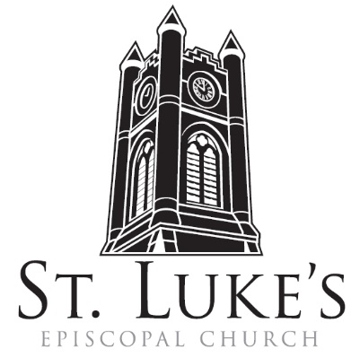
Holy Eucharist ~ Sunday, February 25, 2024

The 2nd Sunday in Lent

St. Luke’s Episcopal Church
North Main at Fourth Street
Jamestown, New York
The Rt. Rev. Sean Rowe, Bishop
The Rev. Luke Fodor, Rector; The Rev. Deacon Cathy Smith;
Mr. Paul Johnson, Verger; Mr. Loren Masánqué, Minister of Music
The Rev. Jessica Frederick, Curate for Children, Youth & Family Ministry
www.stlukesjamestown.org ~ email: stlukes@stlukesjamestown.org
The mission is simple: to Connect all people, help them Discover God's love, empower them to Serve and watch them Grow.”

WELCOME TO ST. LUKE’S
We welcome you this morning to St. Luke’s Church and are delighted to have you join us for worship today. If you are visiting for the first time, or are looking for a church home, please fill in a pew card and place it in the offering plate.
At the time of Communion, all are invited to God’s Table. In addition to the altar rail, at the 10 a.m. service a floor-level Communion station is made available, which includes gluten-free wafers and grape juice, please indicate your preference.
Available to children is a visit to the Children’s Corner, Children’s Chapel during the 10am service in the Undercroft, or the use of a “Children’s Activity Bag” found near the front of the church nave (ask an usher). Join us downstairs for refreshments. All are welcome! Audio transmitters are available for those who have difficulty hearing the service; please ask an usher.
~ Copies of today’s sermon are available at the doors. ~
PRELUDE: Elegy -Franklin Riter The Penitent Heart -Ester S. Higgins

Introit: #715 when Jesus wept -1982 Blue Pew Hymnal

Opening Hymn # 401, The God of Abraham praise -1982 Blue Pew Hymnal

the penitential rite

Celebrant: Bless the Lord who forgives all our sins;
People: God’s mercy endures for ever.

The Decalogue, the people kneeling
Hear the commandments of God to his people: I am the Lord your God who brought you out of bondage. You shall have no other gods but me. Amen. Lord have mercy.
You shall not make for yourself any idol. Amen. Lord have mercy.
You shall not invoke with malice the Name of the Lord your God. Amen. Lord have mercy.
Remember the Sabbath day and keep it holy. Amen. Lord have mercy.
Honor your father and your mother. Amen. Lord have mercy.
You shall not commit murder. Amen. Lord have mercy.
You shall not commit adultery. Amen. Lord have mercy.
You shall not steal. Amen. Lord have mercy.
You shall not be a false witness. Amen. Lord have mercy.
You shall not covet anything that belongs to your neighbor. Amen. Lord have mercy.

Let us confess our sins against God and our neighbor.
Confession of Sin, said by all, kneeling as able.
Most merciful God, we confess that we have sinned against you in thought, word, and deed, by what we have done, and by what we have left undone. We have not loved you with our whole heart; we have not loved our neighbors as ourselves. We are truly sorry and we humbly repent.
For the sake of your Son Jesus Christ, have mercy on us and forgive us; that we may delight in your will, and walk in your ways, to the glory of your Name. Amen.

Absolution
8:00 am Lord, have mercy upon us.
Christ, have mercy upon us.
Lord, have mercy upon us.
10:00 am - S102, front pages of 1982 pew Hymnal

The Collect of the Day: The Lord be with you. Response: And also with you.
Let us pray: O God, whose glory it is always to have mercy: Be gracious to all who have gone astray from your ways, and bring them again with penitent hearts and steadfast faith to embrace and hold fast the unchangeable truth of your Word, Jesus Christ your Son; who with you and the Holy Spirit lives and reigns, one God, for ever and ever. Amen.

The First Reading is from Genesis 17:1-7, 15-16

When Abram was ninety-nine years old, the Lord appeared to Abram, and said to him, “I am God Almighty; walk before me, and be blameless. And I will make my covenant between me and you, and will make you exceedingly numerous.” Then Abram fell on his face; and God said to him, “As for me, this is my covenant with you: You shall be the ancestor of a multitude of nations. No longer shall your name be Abram, but your name shall be Abraham; for I have made you the ancestor of a multitude of nations. I will make you exceedingly fruitful; and I will make nations of you, and kings shall come from you. I will establish my covenant between me and you, and your offspring after you throughout their generations, for an everlasting covenant, to be God to you and to your offspring after you. God said to Abraham, “As for Sarai your wife, you shall not call her Sarai, but Sarah shall be her name. I will bless her, and moreover I will give you a son by her. I will bless her, and she shall give rise to nations; kings of peoples shall come from her.” The Word of the LORD. Thanks be to God.

Psalm #22:22-30 please join in saying the psalm responsively by half verse. -Saint Helena Psalter
22 May all who fear you, O God, give praise; *
may the offspring of Israel stand in awe, and all of Jacob’s line give glory.
23 For you do not despise nor abhor the poor in their poverty, neither do you hide your face from them,* but when they cry to you, you hear them.
24 My praise is of you in the great assembly; *
I will perform my vows in the presence of those who worship you.
25 The poor shall eat and be satisfied, and those who seek you shall praise you: *
“May your heart live for ever!”
26 All the ends of the earth shall remember and turn to you, *
and all the families of the nations shall bow before you.
27 For yours is the royal power, O God; * you rule over the nations.
28 To you alone all who sleep in the earth bow down in worship; *
all who go down to the dust fall before you.
29 My soul shall live for you; my descendants shall serve you; *
they shall be known as yours for ever.
30 They shall come and make known to a people yet unborn *
the saving deeds that you have done.

The Second Reading is from Romans 4:13-25

For the promise that he would inherit the world did not come to Abraham or to his descendants through the law but through the righteousness of faith. If it is the adherents of the law who are to be the heirs, faith is null and the promise is void. For the law brings wrath; but where there is no law, neither is there violation. For this reason it depends on faith, in order that the promise may rest on grace and be guaranteed to all his descendants, not only to the adherents of the law but also to those who share the faith of Abraham (for he is the father of all of us, as it is written, “I have made you the father of many nations”) —in the presence of the God in whom he believed, who gives life to the dead and calls into existence the things that do not exist. Hoping against hope, he believed that he would become “the father of many nations,” according to what was said, “So numerous shall your descendants be.” He did not weaken in faith when he considered his own body, which was already as good as dead (for he was about a hundred years old), or when he considered the barrenness of Sarah’s womb. No distrust made him waver concerning the promise of God, but he grew strong in his faith as he gave glory to God, being fully convinced that God was able to do what he had promised. Therefore his faith “was reckoned to him as righteousness.” Now the words, “it was reckoned to him,” were written not for his sake alone, but for ours also. It will be reckoned to us who believe in him who raised Jesus our Lord from the dead, who was handed over to death for our trespasses and was raised for our justification. The Word of the LORD. Thanks be to God.

Gospel Sequence Hymn #142, Lord who throughout these forty days v. 1 & 3

The Holy Gospel of our Lord Jesus Christ, according to Mark 8:31-38
Response before the Gospel: Glory to you, Lord Christ.
Jesus began to teach his disciples that the Son of Man must undergo great suffering, and be rejected by the elders, the chief priests, and the scribes, and be killed, and after three days rise again. He said all this quite openly. And Peter took him aside and began to rebuke him. But turning and looking at his disciples, he rebuked Peter and said, “Get behind me, Satan! For you are setting your mind not on divine things but on human things.” He called the crowd with his disciples, and said to them, “If any want to become my followers, let them deny themselves and take up their cross and follow me. For those who want to save their life will lose it, and those who lose their life for my sake, and for the sake of the gospel, will save it. For what will it profit them to gain the whole world and forfeit their life? Indeed, what can they give in return for their life? Those who are ashamed of me and of my words in this adulterous and sinful generation, of them the Son of Man will also be ashamed when he comes in the glory of his Father with the holy angels.” The Gospel of the Lord. Praise to you, Lord Christ.

Gospel Sequence Hymn #142, Lord who throughout these forty days v. 4

Sermon -The Rector

Nicene Creed, said by all, standing as able
We believe in one God, the Father, the Almighty, maker of heaven and earth, of all that is, seen and unseen. We believe in one Lord, Jesus Christ, the only Son of God, eternally begotten of the Father, God from God, Light from Light, true God from true God, begotten, not made, of one Being with the Father; through him all things were made. For us and for our salvation he came down from heaven, was incarnate of the Holy Spirit and the Virgin Mary and became truly human.
For our sake he was crucified under Pontius Pilate; he suffered death and was buried. On the third day he rose again in accordance with the Scriptures; he ascended into heaven and is seated at the right hand of the Father. He will come again in glory to judge the living and the dead, and his kingdom will have no end. We believe in the Holy Spirit, the Lord, the giver of life,
who proceeds from the Father, who with the Father and the Son is worshiped and glorified,
who has spoken through the prophets. We believe in one holy catholic and apostolic Church.
We acknowledge one baptism for the forgiveness of sins. We look for the resurrection of the dead, and the life of the world to come. Amen.

Prayers of the People (Form I, BCP pg 384)
With all our heart and with all our mind, let us pray to the Lord, saying “Lord, have mercy.”
For the peace of the world, for the welfare of the Holy Church of God, and for the unity of all peoples, let us pray to the Lord. Lord, have mercy.
For Michael, our Presiding Bishop, for Sean, our Bishop, for the Episcopal partnership churches of St. John’s (Frankin), St. Patrick’s (Cheektowaga) and St. John’s the Baptist (Dunkirk), for the Anglican Church of Tanzania, for Luke, Jessica and Cathy, and for all the clergy and people, let us pray to the Lord. Lord, have mercy.
For the leaders of all the nations, for the nation of Ukraine and its people, for the Holy Land and its people, and for all in authority, let us pray to the Lord. Lord, have mercy.
For every city and community, and for those who live in them, let us pray to the Lord. Lord, have mercy.

For seasonable weather, and for an abundance of the fruits of the earth, let us pray to the Lord.
Lord, have mercy.
For the good earth which God has given us, and for the wisdom and will to conserve it, let us pray to the Lord. Lord, have mercy.
For those who travel on land, on water, in the air and through outer space, let us pray to the Lord.
Lord, have mercy.
For the aged and infirm, for the widowed and orphans, and for the sick and the suffering,
let us pray to the Lord. Lord, have mercy.

Please join me in saying aloud the names of the people on our prayer list:
Tim Pickett, Carol Boling, Pete Nagle, Joyce Crate, Mary Holton, Deacon Pierce, Mac Dawson, Mark Fiore, Brooke, and those others we now name. Silence. Let us pray to the Lord. Lord, have mercy.
For the poor and the oppressed, for the unemployed and the destitute, for prisoners and captives, and for all who remember and care for them, let us pray to the Lord. Lord, have mercy.
For all who have died in the hope of the resurrection, and for all the departed, let us pray to the Lord.
Lord, have mercy.
For deliverance from all danger, violence, oppression, and degradation, let us pray to the Lord.
Lord, have mercy.
That we may end our lives in faith and hope, without suffering and without reproach, let us pray to the Lord. Lord, have mercy.
Defend us, deliver us, and in thy compassion protect us, O Lord, by thy grace. Lord, have mercy.
In the communion of Saint Luke and of all the saints, let us commend ourselves, and one another,
and all our life, to Christ our God. To thee, O Lord our God.

The Celebrant adds a concluding Collect.
Almighty and eternal God, ruler of all things in heaven and earth: Mercifully accept the prayers of your people and strengthen us to do your will; through Jesus Christ our Lord. Amen.

The Peace Let us exchange the Peace of Christ with one another!
The peace of the Lord be always with you. People: And also with you.

THE HOLY COMMUNION
Offertory
If you’d like to give electronically, use your phone’s camera to scan the QR code.

8am: All things come of Thee, O Lord. And of thine own have we given Thee. Amen.
10am: Choir Offertory Anthem Let us Break Bread Together -St. Luke’s Choir
The composer of this traditional Christian hymn is anonymous. Scholar Dr. Carlton Young suggests that this "spiritual was formed in the West African Gullah/Geechee slave culture that developed in the coastal areas of South-Eastern colonial America, including St Helena Island, Beaufort, and Charleston, South Carolina …” This hymn of the Underground Railroad was used by American slaves to communicate their intention to escape by singing Let us break bread together. The tune varied but the spiritual gained broad recognition after its publication in The Second Book of Negro Spirituals in 1926.Trivia Prompt: Why was it not included in the 2nd edition of Lead Me, Guide Me?

10am: Doxology, sung by all
Praise God throughout these forty days. Praise Christ, our Lord, whom God did raise.
And praise the Spirit who imparts God’s love in Christ into our hearts. Amen.

The Great Thanksgiving: Eucharistic Prayer A
The Lord be with you. And also with you. Lift up your hearts. We lift them to the Lord.
Let us give thanks to the Lord our God. It is right to give God thanks and praise.
It is right, and a good and joyful thing, always and everywhere to give thanks to you, Father Almighty, Creator of heaven and earth. Through Jesus Christ our Lord; who was tempted in every way as we are, yet did not sin. By his grace we are able to triumph over every evil, and to live no longer for ourselves alone, but for him who died for us and rose again. Therefore we praise you, joining our voices with Angels and Archangels and with all the company of heaven, who forever sing this hymn to proclaim the glory of your Name:
Sanctus & Benedictus, spoken at 8am, sung at 10am - S122, front pages of 1982 pew Hymnal
Holy, holy, holy Lord, God of power and might, heaven and earth are full of your glory. Hosanna in the highest. Blessed is he who comes in the name of the Lord. Hosanna in the
highest.
The Celebrant continues
Holy and gracious Father: In your infinite love you made us for yourself, and, when we had fallen into sin and become subject to evil and death, you, in your mercy, sent Jesus Christ, your only and eternal Son, to share our human nature, to live and die as one of us, to reconcile us to you, the God and Father of all. He stretched out his arms upon the cross, and offered himself, in obedience to your will, a perfect sacrifice for the whole world. On the night he was handed over to suffering and death, our Lord Jesus Christ took bread; and when he had given thanks to you, he broke it, and gave it to his disciples, and said, "Take, eat: This is my Body, which is given for you. Do this for the remembrance of me. "After supper he took the cup of wine; and when he had given thanks, he gave it to them, and said, "Drink this, all of you: This is my Blood of the new Covenant, which is shed for you and for many for the forgiveness of sins. Whenever you drink it, do this for the remembrance of me." Therefore we proclaim the mystery of faith:
Celebrant and People
Christ has died. Christ is risen. Christ will come again.
The Celebrant continues
We celebrate the memorial of our redemption, O Father, in this sacrifice of praise and thanksgiving. Recalling his death, resurrection, and ascension, we offer you these gifts. Sanctify them by your Holy Spirit to be for your people the Body and Blood of your Son, the holy food and drink of new and unending life in him. Sanctify us also that we may faithfully receive this holy Sacrament, and serve you in unity, constancy, and peace; and at the last day bring us with all your saints into the joy of your eternal kingdom. All this we ask through your Son Jesus Christ: By him, and with him, and in him, in the unity of the Holy Spirit all honor and glory is yours, Almighty Father, now and for ever. AMEN.
And now, as our Savior Christ has taught us, we are bold to say,
Our Father, who art in heaven, hallowed be thy Name, thy kingdom come, thy will be done, on earth as it is in heaven. Give us this day our daily bread.
And forgive us our trespasses, as we forgive those who trespass against us.
And lead us not into temptation, but deliver us from evil.
For thine is the kingdom, and the power, and the glory, for ever and ever. Amen.

The Breaking of the Bread Silent moment

Agnus Dei, spoken at the 8am, sung at the 10am - S-160, the front pages of the 1982 pew Hymnal
Lamb of God you take away the sin of the world, have mercy on us.
Lamb of God you take away the sin of the world, have mercy on us.
Lamb of God you take away the sin of the world, grant us your peace.

The Communion
Wherever you are on your spiritual journey, all are invited to receive Communion. Gluten-free wafers, as well as grape juice, are available, please indicate your preference; at the 10AM service, at the floor communion station. If you have difficulty coming forward, communion can be brought to you at your seat. You are invited to light a candle for a person or concern in your prayers. A candle station is located at the rear of the Chapel; and to the right of the pulpit in the Church.

Music at Communion
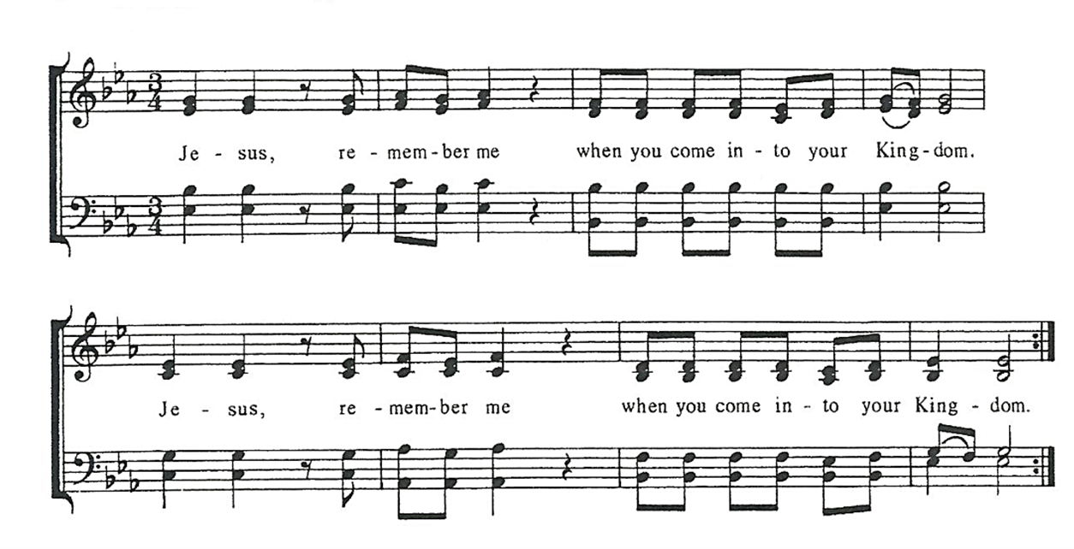
Post Communion Prayer, said by all
Eternal God, heavenly Father, you have graciously accepted us as living members
of your Son, our Savior Jesus Christ, and you have fed us with spiritual food in the
sacrament of his Body and Blood. Send us now into the world in peace, and grant
us strength and courage to love and serve you with gladness and singleness of heart;
through Christ our Lord. Amen.

solemn prayer

Sending Hymn # 470, There’s a Wideness in God’s Mercy - 1982 pew Hymnal

Dismissal Go in peace to love and serve the Lord.
Response: Thanks be to God.

Postlude: Wondrous Love -Dale Wood

Announcements
Lenten Program On Tuesday 2/27 at 6:30 pm in the Undercroft, we will learn the story of our Anglican Palestine siblings using a curriculum called, Bearing Witness, created by the American Friends of the Episcopal Diocese of Jerusalem. The Rev. Jessica Frederick will lead most of these sessions. Each week we’ll begin with the ancient Stations of the Cross service, using a special set of stations that imagines Jesus as a monarch butterfly on migration to his eventual transformation.
Service on the Slopes If you enjoy a snowy mountaintop experience on Sundays, be sure to visit Holiday Valley for the Service on the Slopes, a brief ecumenical service of prayer, scripture reading and communion with a conversational sermon on the slopes. We meet in the Warming Hut on top of Cindy's lift weekly on Sundays at 2:30pm beginning January 7 until March 17.
The Philadelphia 11: Film screening 3/1 at 7pm at the Robert H. Jackson Center
The year 2024 marks the 50th anniversary of the ordination of women in the Episcopal Church. At the beginning of Women’s History Month (March), St. Luke's Church in partnership with the Robert H. Jackson Center is screening a new documentary, "The Philadelphia Eleven," about the timely and daring 1974 ordination of the first eleven women priests in the Episcopal Church. The free screening, March 1st at 7pm, will be open to all who wish to attend.

The Right of Reconciliation—Confession
There is an old saying in the Episcopal Church regarding the Rite of Reconciliation (aka Confession): “All may, none must, some should.” Wherever you are on your spiritual journey, all of us are benefitted by coming to God for forgiveness. Sometimes the formal process of asking for God’s forgiveness through the sacrament of auricular confession presents us with an opportunity for more grace. During Lent, the Rector invites you to explore this seldom used sacrament of the church. To schedule an appointment, send an email (luke.fodor@stlukesjamestown.org).

