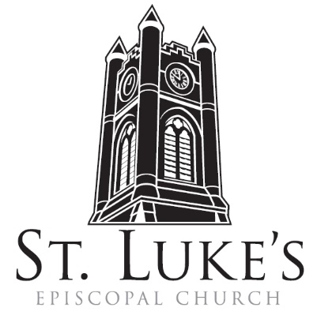
Holy Eucharist ~ April 7, 2024

The 2nd Sunday of Easter

St. Luke’s Episcopal Church
North Main at Fourth Street
Jamestown, New York
The Rt. Rev. Sean Rowe, Bishop
The Rev. Luke Fodor, Rector; The Rev. Deacon Cathy Smith;
Mr. Paul Johnson, Verger; Mr. Loren Masánqué, Minister of Music
The Rev. Jessica Frederick, Curate for Children, Youth & Family Ministry
www.stlukesjamestown.org ~ email: stlukes@stlukesjamestown.org

The mission is simple: to Connect all people, help them Discover God's love, empower them to Serve and watch them Grow.”

WELCOME TO ST. LUKE’S
We welcome you this morning to St. Luke’s Church and are delighted to have you join us for worship today. If you are visiting for the first time, or are looking for a church home, please fill in a pew card and place it in the offering plate.
At the time of Communion, all are invited to God’s Table. In addition to the altar rail, at the 10 a.m. service a floor-level Communion station is made available, which includes gluten-free wafers and grape juice, please indicate your preference.
Available to children is a visit to the Children’s Corner, or the use of a “Children’s Activity Bag” found near the front of the church nave (ask an usher). Children’s Chapel & nursery care is provided downstairs during the 10am service.
Clergy and members of the congregation look forward to greeting you after services. Join us downstairs for refreshments. All are welcome! Audio transmitters are available for those who have difficulty hearing the service; please ask an usher.

~ Copies of today’s sermon are available at the doors. ~

Prelude: 2nd Couplet du Sanctus, Élevation, from Mass for the Convents -Francois Couperin

opening hymn: #204 now the green blade riseth -blue pew hymnal

Opening Acclamation
Celebrant: Alleluia. Christ is risen. People: The Lord is risen indeed. Alleluia.

Collect for Purity, said by all
Almighty God, to you all hearts are open, all desires known, and from you no secrets are hid: Cleanse the thoughts of our hearts by the inspiration of your Holy Spirit, that we may perfectly love you, and worthily magnify your holy Name; through Christ our Lord. Amen.

Gloria, said by all at 8am, sung at 10am. -S278 Blue Pew Hymnal
Glory to God in the highest, and peace to God’s people on earth. Lord God, heavenly King, almighty God and Father, we worship you, we give you thanks, we praise you for your glory. Lord Jesus Christ, only Son of the Father, Lord God, Lamb of God, you take away the sin of the world; have mercy on us; you are seated at the right hand of the Father; receive our prayer. For you alone are the Holy One, you alone are the Lord, you alone are the Most High, Jesus Christ, with the Holy Spirit, in the glory of God the Father. Amen.

The Collect of the Day: The Lord be with you. Response: And also with you.
Let us pray: Almighty and everlasting God, who in the Paschal mystery established the new covenant of reconciliation: Grant that all who have been reborn into the fellowship of Christ's Body may show forth in their lives what they profess by their faith; through Jesus Christ our Lord, who lives and reigns with you and the Holy Spirit, one God, for ever and ever. Amen.

The First Reading is from the Acts of the Apostles 4:32-35

Now the whole group of those who believed were of one heart and soul, and no one claimed private ownership of any possessions, but everything they owned was held in common. With great power the apostles gave their testimony to the resurrection of the Lord Jesus, and great grace was upon them all. There was not a needy person among them, for as many as owned lands or houses sold them and brought the proceeds of what was sold. They laid it at the apostles' feet, and it was distributed to each as any had need.

The Word of the Lord. Thanks be to God.

Psalm # 133, please join in saying Psalm 133 in unison - Saint Helena Psalter
¹Oh, how good and pleasant it is, when kindred live together in unity!
² It is like fine oil upon the head that runs down upon the beard,
³ Upon the beard of Aaron, and runs down upon the collar of his robe.
⁴ It is like the dew of Hermon that falls upon the hills of Zion.
⁵ For there has God ordained the blessing: life for evermore.

The Second Reading is from the 1st Letter of John 1:1-2:2

We declare to you what was from the beginning, what we have heard, what we have seen with our eyes, what we have looked at and touched with our hands, concerning the word of life-- this life was revealed, and we have seen it and testify to it, and declare to you the eternal life that was with the Father and was revealed to us-- we declare to you what we have seen and heard so that you also may have fellowship with us; and truly our fellowship is with the Father and with his Son Jesus Christ. We are writing these things so that our joy may be complete. This is the message we have heard from him and proclaim to you, that God is light and in him there is no darkness at all. If we say that we have fellowship with him while we are walking in darkness, we lie and do not do what is true; but if we walk in the light as he himself is in the light, we have fellowship with one another, and the blood of Jesus his Son cleanses us from all sin. If we say that we have no sin, we deceive ourselves, and the truth is not in us. If we confess our sins, he who is faithful and just will forgive us our sins and cleanse us from all unrighteousness. If we say that we have not sinned, we make him a liar, and his word is not in us. My little children, I am writing these things to you so that you may not sin. But if anyone does sin, we have an advocate with the Father, Jesus Christ the righteous; and he is the atoning sacrifice for our sins, and not for ours only but also for the sins of the whole world.

The Word of the Lord. Thanks be to God.

gospel sequence hymn: When thomas heard from jesus, v. 1-3 -see next page

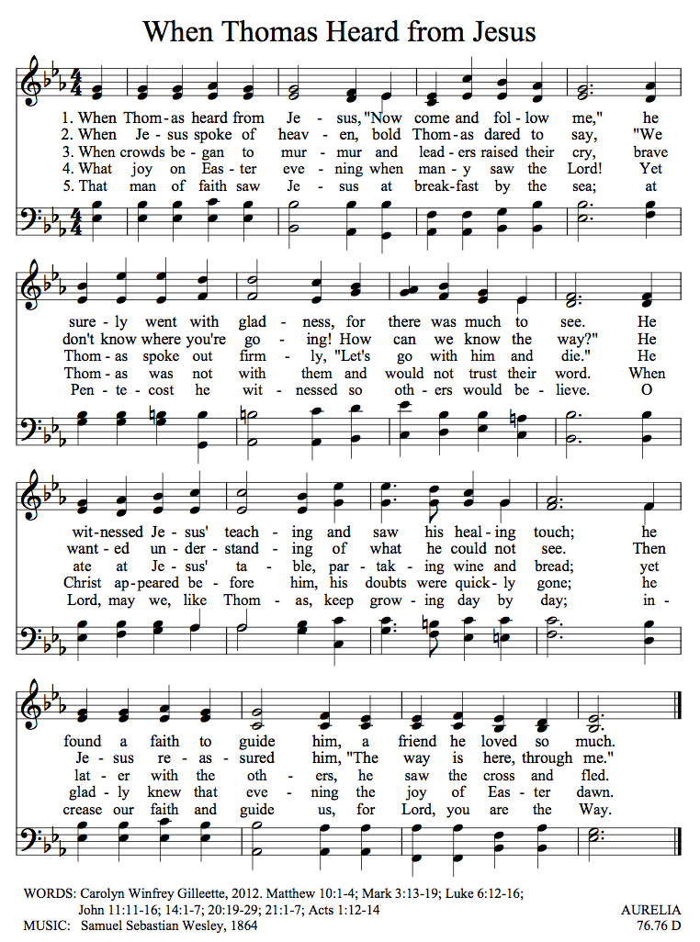

The Holy Gospel of our Lord Jesus Christ, according to John 20:19-31
Response before the Gospel: Glory to you, Lord Christ.
When it was evening on that day, the first day of the week, and the doors of the house where the disciples had met were locked for fear of the Jews, Jesus came and stood among them and said, "Peace be with you." After he said this, he showed them his hands and his side. Then the disciples rejoiced when they saw the Lord. Jesus said to them again, "Peace be with you. As the Father has sent me, so I send you." When he had said this, he breathed on them and said to them, "Receive the Holy Spirit. If you forgive the sins of any, they are forgiven them; if you retain the sins of any, they are retained."
But Thomas, who was called the Twin, one of the twelve, was not with them when Jesus came. So the other disciples told him, "We have seen the Lord." But he said to them, "Unless I see the mark of the nails in his hands and put my finger in the mark of the nails and my hand in his side, I will not believe."
A week later his disciples were again in the house, and Thomas was with them. Although the doors were shut, Jesus came and stood among them and said, "Peace be with you." Then he said to Thomas, "Put your finger here and see my hands. Reach out your hand and put it in my side. Do not doubt but believe." Thomas answered him, "My Lord and my God!" Jesus said to him, "Have you believed because you have seen me? Blessed are those who have not seen and yet have come to believe."
Now Jesus did many other signs in the presence of his disciples, which are not written in this book. But these are written so that you may come to believe that Jesus is the Messiah, the Son of God, and that through believing you may have life in his name.
The Gospel of the Lord. Praise to you, Lord Christ.

Gospel Sequence hymn: when thomas heard from jesus, v. 4-5

Sermon -The Rev. Jessica Frederick, Curate

Nicene Creed, said by all, standing as able
We believe in one God, the Father, the Almighty, maker of heaven and earth,
of all that is, seen and unseen. We believe in one Lord, Jesus Christ, the only Son of God,
eternally begotten of the Father, God from God, Light from Light, true God from true God, begotten, not made, of one Being with the Father; through him all things were made.
For us and for our salvation he came down from heaven, was incarnate of the Holy Spirit and the Virgin Mary and became truly human. For our sake he was crucified under Pontius Pilate; he suffered death and was buried. On the third day he rose again in accordance with the Scriptures; he ascended into heaven and is seated at the right hand of the Father.
He will come again in glory to judge the living and the dead, and his kingdom will have no end. We believe in the Holy Spirit, the Lord, the giver of life, who proceeds from the Father,
who with the Father and the Son is worshiped and glorified, who has spoken through the prophets. We believe in one holy catholic and apostolic Church. We acknowledge one baptism for the forgiveness of sins. We look for the resurrection of the dead, and the life of the world to come. Amen.

Prayers of the People: Form III BCP 388
Let us pray for the Church and for the world. Father, we pray for your holy Catholic Church;
That we all may be one.

Grant that every member of the Church may truly and humbly serve you;
That your Name may be glorified by all people.

We pray for Michael our Presiding Bishop; for Sean the Bishop of our Diocesan Partnership; for the Episcopal Partnership churches of St. Mary’s (Lawrence Park), Christ Church (Meadville), Good Shepherd (Irving) and St. Luke’s (Jamestown), for our clergy Luke, Jessica, Cathy and Tom, and for all bishops, priests, and deacons;
That they may be faithful ministers of your Word and Sacraments.

We pray for peace and good will among all nations; for Joe, our President; for Kathy, our Governor; for the members Congress and the Supreme Court; for the safety of the men and women of our armed forces, for the people of Ukraine and the people of the Holy Land, and for all who govern and hold authority in the nations of the world;
That there may be justice and peace on the earth.

Give us grace to do your will in all that we undertake;
That our works may find favor in your sight.

Comfort, O Lord, all those in trouble, sorrow, need, or any other adversity. Please join me in saying aloud the names of the people on our prayer list: Tim Pickett, Carol Boling, Joyce Crate, Mary Holton, Deacon Pierce, Mark Fiore, Becky Svetz, Nan Eaker, Noah Larson, Fran Stahley, Johnny, and those others we now name. Silence

Have compassion on those who suffer from any illness, grief or trouble;
That they may be delivered from their distress.

Remembering Pete Nagle, give to the departed eternal rest;
Let light perpetual shine upon them.

We praise you for your saints who have entered into joy;
May we also come to share in your heavenly kingdom.

The celebrant concludes with a collect.
Heavenly Father, you have promised to hear what we ask in the Name of your Son: Accept and fulfill our petitions, we pray, not as we ask in our ignorance, nor as we deserve in our sinfulness, but as you know and love us in your Son Jesus Christ our Lord. Amen.

The Peace Let us exchange the Peace of Christ with one another!
The peace of the Lord be always with you. People And also with you.

THE HOLY COMMUNION

Offertory 8am: All things come of thee, O Lord. And of thine own have we given Thee. Amen.
10am: Hymn #206 O Sons & Daughters -Blue Pew Hymnal

doxology: Praise God from whom all blessings flow; praise God all creatures here below. Alleluia, alleluia! Praise God above, ye heav’nly host. Praise Father, Son and Holy Ghost.
Alleluia, alleluia; alleluia, alleluia; alleluia!

The Great Thanksgiving: Eucharistic Prayer A BCP p. 361
The Lord be with you. And also with you.
Lift up your hearts. We lift them to the Lord.
Let us give thanks to the Lord our God. It is right to give God thanks and praise.

It is right, and a good and joyful thing, always and every where to give thanks to you, Father Almighty, Creator of heaven and earth. But chiefly are we bound to praise you for the glorious resurrection of your Son Jesus Christ our Lord; for he is the true Paschal Lamb, who was sacrificed for us, and has taken away the sin of the world. By his death he has destroyed death, and by his rising to life again he has won for us everlasting life.
Therefore we praise you, joining our voices with Angels and Archangels and with all the company of heaven, who for ever sing this hymn to proclaim the glory of your Name:
Sanctus & Benedictus , said by all at 8am, sung by all at 10am.
8am: Holy, Holy, Holy Lord, God of power and might, heaven and earth are full of your glory. Hosanna in the highest. Blessed is the One who comes in the name of the Lord. Hosanna in the highest.
10 am:
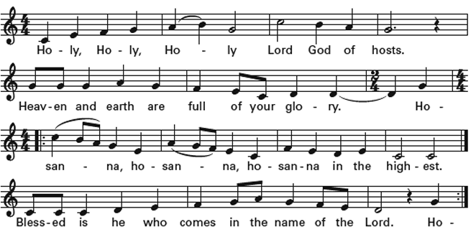

Holy and gracious Father: In your infinite love you made us for yourself, and, when we had fallen into sin and become subject to evil and death, you, in your mercy, sent Jesus Christ, your only and eternal Son, to share our human nature, to live and die as one of us, to reconcile us to you, the God and Father of all.
He stretched out his arms upon the cross, and offered himself, in obedience to your will, a perfect sacrifice for the whole world.
On the night he was handed over to suffering and death, our Lord Jesus Christ took bread; and when he had given thanks to you, he broke it, and gave it to his disciples, and said, "Take, eat: This is my Body, which is given for you. Do this for the remembrance of me."
After supper he took the cup of wine; and when he had given thanks, he gave it to them, and said, "Drink this, all of you: This is my Blood of the new Covenant, which is shed for you and for many for the forgiveness of sins. Whenever you drink it, do this for the remembrance of me."
Therefore we proclaim the mystery of faith:
Celebrant and People: Christ has died. Christ is risen. Christ will come again.
We celebrate the memorial of our redemption, O Father, in this sacrifice of praise and thanksgiving. Recalling his death, resurrection, and ascension, we offer you these gifts.
Sanctify them by your Holy Spirit to be for your people the Body and Blood of your Son, the holy food and drink of new and unending life in him. Sanctify us also that we may faithfully receive this holy Sacrament, and serve you in unity, constancy, and peace; and at the last day bring us with all your saints into the joy of your eternal kingdom.
All this we ask through your Son Jesus Christ: By him, and with him, and in him, in the unity of the Holy Spirit all honor and glory is yours, Almighty Father, now and for ever. 8am: AMEN.
10am: 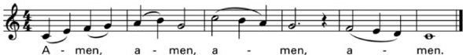
And now, as our Savior Christ has taught us, we are bold to say,
Our Father, who art in heaven, hallowed be thy Name, thy kingdom come, thy will be done, on earth as it is in heaven. Give us this day our daily bread.
And forgive us our trespasses, as we forgive those who trespass against us.
And lead us not into temptation, but deliver us from evil.
For thine is the kingdom, and the power, and the glory, for ever and ever. Amen.

The Breaking of the Bread Silent moment

8am: Alleluia, Christ our Passover is sacrificed for us; Therefore let us keep the feast. Alleluia.

10am:
:

The Communion Wherever you are on your spiritual journey, all are invited to receive Communion.
Gluten-free wafers, as well as grape juice, are available, please indicate your preference;
If you have difficulty coming forward, communion can be brought to you at your seat.
You are invited to light a candle for a person or concern in your prayers.
A candle station is located at the back of the Chapel or to the right of the pulpit in the Church.

communion hymn: #335 i am the bread of life -Blue Pew Hymnal

Post Communion Prayer, said by all
Eternal God, heavenly Father, you have graciously accepted us as living members
of your Son, our Savior Jesus Christ, and you have fed us with spiritual food in the
sacrament of his Body and Blood. Send us now into the world in peace, and grant
us strength and courage to love and serve you with gladness and singleness of heart; through Christ our Lord. Amen.

Blessing

closing Hymn: #209 we walk by faith -blue pew hymnal

Dismissal Let us go forth in the name of the risen Christ. Alleluia, alleluia, alleluia!
Response: Thanks be to God! Alleluia, Alleluia, Alleluia!

postlude: Carillon on “O filii et filiae” (O Sons and daughters) -Biggs

The altar flowers are given to the Glory of God by John Rappole in honor of Bonnie’s 78th gift of life. Happy Birthday!
Announcements
CSA Sign-Up NOW is the time to sign up for the CSA.
Grow Jamestown is getting geared up for a full season of programming, markets, and events! You can now sign up for the CSA program. Produce boxes range from $200 to $500 for the entire season. The CSA program will run from June through September. Shares will be available for pick-up at St. Luke’s on Wednesdays from noon to 7pm.We are offering shares in three sizes (and price points):
• Fun Size ($200) — Perfect for an individual, couple or family looking to introduce 3-4 unique and local veggies to your household.
•Family Size ($375) — For households looking to try new produce options, with 5-7 fresh fruit/veggie varieties.
•Full Size ($500) — For larger families or households that LOVE their fruits and veggies and wish to receive larger servings of seasonal options. Each week you’ll receive an email detailing what to expect in your share, as well as suggested recipes of what to do with your veggies and tips for preserving their freshness. This year you can also add on eggs, pork products, and fresh sourdough bread! All sourced, grown, and made right here in New York State and near Chautauqua County. Purchase your share at jtownpublicmarket.org.

Rhythms of Grace 4/13 at 10am in the Undercroft
A fun, engaging worship service for families with wiggly and exceptional learners. The service includes a special story time, communion, and interactive discovery centers with crafts and activities. Brunch follows the service.

Pasta Pilgrimage Dinner on 4/20
With the generous support of the whole congregation, 8 youth and 3 adult pilgrims went on the journey of a lifetime—walking over 75 miles from the medieval city of Viterbo to the Vatican in Rome. On Saturday April 20th at 5:30pm, you are invited to come feast on the experience as the youth prepare a special pasta dinner and “fill up” on all the details of the trip. There is no cost for the dinner, but we will invite donations to start saving for the next youth pilgrimage in 2026. Come for dinner and stay for Trivia Night afterwards!

