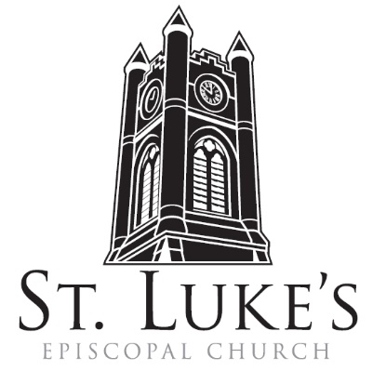
Holy Eucharist ~ Sunday, February 18, 2024

The First Sunday in Lent

St. Luke’s Episcopal Church
North Main at Fourth Street
Jamestown, New York
The Rt. Rev. Sean Rowe, Bishop
The Rev. Tom Broad, Celebrant
The Rev. Luke Fodor, Rector, The Rev. Deacon Cathy Smith;
Mr. Paul Johnson, Verger; Mr. Loren Masánqué, Minister of Music
www.stlukesjamestown.org ~ email: stlukes@stlukesjamestown.org
The mission is simple: to Connect all people, help them Discover God's love, empower them to Serve and watch them Grow.”

WELCOME TO ST. LUKE’S
We welcome you this morning to St. Luke’s Church and are delighted to have you join us for worship today. If you are visiting for the first time, or are looking for a church home, please fill in a pew card and place it in the offering plate.
At the time of Communion, all are invited to God’s Table. In addition to the altar rail, at the 10 a.m. service a floor-level Communion station is made available, which includes gluten-free wafers and grape juice, please indicate your preference.
Available to children is Children’s Chapel downstairs in the undercroft during the 10am service, a visit to the Children’s Corner, or the use of a “Children’s Activity Bag” found near the front of the church nave (ask an usher). Join us downstairs for refreshments. All are welcome! Audio transmitters are available for those who have difficulty hearing the service; please ask an usher.

The Great Litany: petitions and responses - S-67; the front pages of the 1982 pew Hymnal
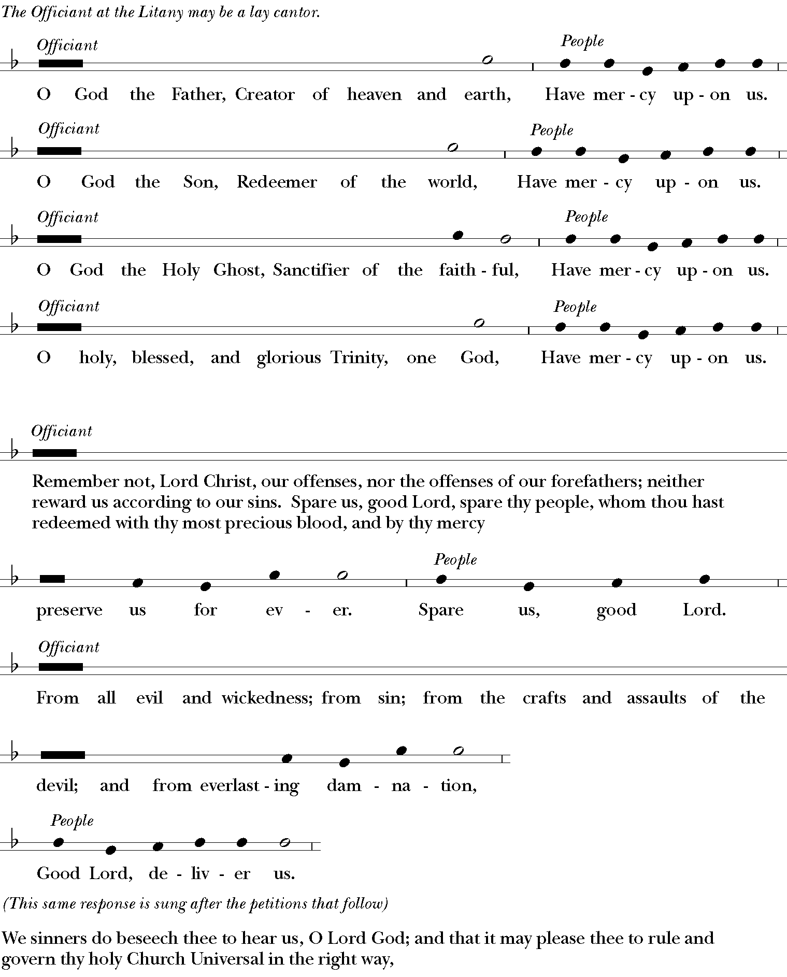

The clergy and choir chant in procession. The responses are pitched as follows:
From all evil and wickedness; from sin; from the crafts and assaults of the devil; and from everlasting damnation,

From all blindness of heart; from pride, vainglory, and hypocrisy; from envy, hatred, and malice; and from all want of charity, Good Lord, deliver us.
From all inordinate and sinful affections; and from all the deceits of the world, the flesh, and the devil,
Good Lord, deliver us.
From all false doctrine, heresy, and schism; from hardness of heart, and contempt of thy Word and commandment, Good Lord, deliver us.
From lightning and tempest; from earthquake, fire, and flood; from plague, pestilence, and famine,
Good Lord, deliver us.
From all oppression, conspiracy, and rebellion; from violence, battle, and murder; and from dying suddenly and unprepared, Good Lord, deliver us.
By the mystery of thy holy Incarnation; by thy holy Nativity and submission to the Law; by thy Baptism, Fasting, and Temptation, Good Lord, deliver us.
By thine Agony and Bloody Sweat; by thy Cross and Passion; by thy precious Death and Burial; by thy glorious Resurrection and Ascension; and by the Coming of the Holy Ghost, Good Lord, deliver us.
In all time of our tribulation; in all time of our prosperity; in the hour of death, and in the day of judgment,
Good Lord, deliver us.
We sinners do beseech thee to hear us, O Lord God; and that it may please thee to rule and govern thy holy Church Universal in the right way,

That it may please thee to illumine all bishops, priests, and deacons, with true knowledge and understanding of thy Word; and that both by their preaching and living, they may set it forth, and show it accordingly, We beseech thee to hear us, good Lord.
That it may please thee to bless and keep all thy people, We beseech thee to hear us, good Lord.

That it may please thee to send forth laborers into thy harvest, and to draw all mankind into thy kingdom,
We beseech thee to hear us, good Lord.
That it may please thee to give to all people increase of grace to hear and receive thy Word, and to bring forth the fruits of the Spirit, We beseech thee to hear us, good Lord.
That it may please thee to bring into the way of truth all such as have erred, and are deceived,
We beseech thee to hear us, good Lord.
That it may please thee to give us a heart to love and fear thee, and diligently to live after thy commandments, We beseech thee to hear us, good Lord.
That it may please thee so to rule the hearts of thy servants, the President of the United States, and all others in authority, that they may do justice, and love mercy, and walk in the ways of truth,
We beseech thee to hear us, good Lord.
That it may please thee to make wars to cease in all the world; to give to all nations unity, peace, and concord; and to bestow freedom upon all peoples, We beseech thee to hear us, good Lord.

That it may please thee to show thy pity upon all prisoners and captives, the homeless and the hungry, and all who are desolate and oppressed, We beseech thee to hear us, good Lord.

That it may please thee to give and preserve to our use the bountiful fruits of the earth, so that in due time all may enjoy them, We beseech thee to hear us, good Lord.
That it may please thee to inspire us, in our several callings, to do the work which thou givest us to do with singleness of heart as thy servants, and for the common good, We beseech thee to hear us, good Lord.
That it may please thee to preserve all who are in danger by reason of their labor or their travel,
We beseech thee to hear us, good Lord.
That it may please thee to preserve, and provide for, all women in childbirth, young children and orphans, the widowed, and all whose homes are broken or torn by strife, We beseech thee to hear us, good Lord.

That it may please thee to visit the lonely; to strengthen all who suffer in mind, body, and spirit; and to comfort with thy presence those who are failing and infirm, We beseech thee to hear us, good Lord.

That it may please thee to support, help, and comfort all who are in danger, necessity, and tribulation,
We beseech thee to hear us, good Lord.
That it may please thee to have mercy upon all mankind, We beseech thee to hear us, good Lord.

That it may please thee to give us true repentance; to forgive us all our sins, negligence, and ignorance; and to endue us with the grace of thy Holy Spirit to amend our lives according to thy holy Word,
We beseech thee to hear us, good Lord.
That it may please thee to forgive our enemies, persecutors, and slanderers, and to turn their hearts,
We beseech thee to hear us, good Lord.
That it may please thee to strengthen such as do stand; to comfort and help the weak-hearted; to raise up those who fall; and finally to beat down Satan under our feet,
We beseech thee to hear us, good Lord.
That it may please thee to grant to all the faithful departed eternal life and peace,
We beseech thee to hear us, good Lord.
That it may please thee to grant that, in the fellowship of Saint Luke and all the saints, we may attain to thy heavenly kingdom, We beseech thee to hear us, good Lord.

Son of God, we beseech thee to hear us. Son of God, we beseech thee to hear us.
O Lamb of God, that takest away the sins of the world, Have mercy upon us.
O Lamb of God, that takest away the sins of the world, Have mercy upon us.
O Lamb of God, that takest away the sins of the world, Grant us thy peace.
O Christ, hear us. O Christ, hear us.
Lord, have mercy upon us. Christ, have mercy upon us. Lord, have mercy upon us.

The Collect of the Day: The Lord be with you. Response: And also with you.
Let us pray: Almighty God, whose blessed Son was led by the Spirit to be tempted by Satan: Come quickly to help us who are assaulted by many temptations; and, as you know the weaknesses of each of us, let each one find you mighty to save; through Jesus Christ your Son our Lord, who lives and reigns with you and the Holy Spirit, one God, now and for ever. Amen.

A Reading from Genesis 9:8-17

God said to Noah and to his sons with him, “As for me, I am establishing my covenant with you and your descendants after you, and with every living creature that is with you, the birds, the domestic animals, and every animal of the earth with you, as many as came out of the ark. I establish my covenant with you, that never again shall all flesh be cut off by the waters of a flood, and never again shall there be a flood to destroy the earth.” God said, “This is the sign of the covenant that I make between me and you and every living creature that is with you, for all future generations: I have set my bow in the clouds, and it shall be a sign of the covenant between me and the earth. When I bring clouds over the earth and the bow is seen in the clouds, I will remember my covenant that is between me and you and every living creature of all flesh; and the waters shall never again become a flood to destroy all flesh. When the bow is in the clouds, I will see it and remember the everlasting covenant between God and every living creature of all flesh that is on the earth.” God said to Noah, “This is the sign of the covenant that I have established between me and all flesh that is on the earth.” The Word of the LORD. Thanks be to God.

Psalm #25:1-9, Please Join in saying the Psalm responsively by whole verse. - Saint Helena Psalter
1 To you, O God, I lift up my soul; my God, I put my trust in you; *
let me not be humiliated, nor let my enemies triumph over me.
2 Let none who look to you be put to shame; *
let the treacherous be disappointed in their schemes.
3 Show me your ways, O God, *
and teach me your paths.
4 Lead me in your truth and teach me, *
for you are the God of my salvation; in you have I trusted all the day long.
5 Remember, O God, your compassion and love, *
for they are from everlasting.
6 Remember not the sins of my youth and my transgressions; *
remember me according to your love and for the sake of your goodness, O God.
7 Gracious and upright are you; *
therefore you teach sinners in your way.
8 You guide the humble in doing right *
and teach your way to the lowly.
9 All your paths are love and faithfulness *
to those who keep your covenant and your testimonies.

A Reading from 1 Peter 3:18-22

Christ also suffered for sins once for all, the righteous for the unrighteous, in order to bring you to God. He was put to death in the flesh, but made alive in the spirit, in which also he went and made a proclamation to the spirits in prison, who in former times did not obey, when God waited patiently in the days of Noah, during the building of the ark, in which a few, that is, eight persons, were saved through water. And baptism, which this prefigured, now saves you-- not as a removal of dirt from the body, but as an appeal to God for a good conscience, through the resurrection of Jesus Christ, who has gone into heaven and is at the right hand of God, with angels, authorities, and powers made subject to him. The Word of the LORD. Thanks be to God.

Gospel Sequence Hymn: Stand by me, v. 1 & 2 -Insert

The Holy Gospel of our Lord Jesus Christ, according to Mark 1:9-15
Response before the Gospel: Glory to you, Lord Christ.
In those days Jesus came from Nazareth of Galilee and was baptized by John in the Jordan. And just as he was coming up out of the water, he saw the heavens torn apart and the Spirit descending like a dove on him. And a voice came from heaven, “You are my Son, the Beloved; with you I am well pleased.” And the Spirit immediately drove him out into the wilderness. He was in the wilderness forty days, tempted by Satan; and he was with the wild beasts; and the angels waited on him. Now after John was arrested, Jesus came to Galilee, proclaiming the good news of God, and saying, “The time is fulfilled, and the kingdom of God has come near; repent, and believe in the good news.” The Gospel of the Lord. Praise to you, Lord Christ.

Gospel Sequence Hymn: Stand by me, v. 3 -Insert

Sermon -The Rev. Tom Broad

Nicene Creed, said by all, standing as able
We believe in one God, the Father, the Almighty, maker of heaven and earth, of all that is, seen and unseen. We believe in one Lord, Jesus Christ, the only Son of God, eternally begotten of the Father, God from God, Light from Light, true God from true God, begotten, not made, of one Being with the Father; through him all things were made. For us and for our salvation he came down from heaven, was incarnate of the Holy Spirit and the Virgin Mary and became truly human.
For our sake he was crucified under Pontius Pilate; he suffered death and was buried. On the third day he rose again in accordance with the Scriptures; he ascended into heaven and is seated at the right hand of the Father. He will come again in glory to judge the living and the dead, and his kingdom will have no end. We believe in the Holy Spirit, the Lord, the giver of life,
who proceeds from the Father, who with the Father and the Son is worshiped and glorified,
who has spoken through the prophets. We believe in one holy catholic and apostolic Church.
We acknowledge one baptism for the forgiveness of sins. We look for the resurrection of the dead, and the life of the world to come. Amen.

Deacon: Let us confess our sins against God and our neighbor.
Confession, all, kneeling as able
Most merciful God, we confess that we have sinned against you in thought, word, and deed,
by what we have done, and by what we have left undone. We have not loved you with our whole heart; we have not loved our neighbors as ourselves. We are truly sorry and we humbly repent.
For the sake of your Son Jesus Christ, have mercy on us and forgive us; that we may delight in your will, and walk in your ways, to the glory of your Name. Amen.

Absolution

The Peace Let us exchange the Peace of Christ with one another!
The peace of the Lord be always with you. People: And also with you.

THE HOLY COMMUNION

If you’d like to give electronically, use your phone’s camera to scan the QR code.
Offertory
8am: Celebrant: All things come of thee, O Lord. People: And of thine own have we given thee. Amen
10am: Choir Offertory Anthem When Jesus Wept - St. Luke’s Choir

10am: Presentation of the Blue Bags -Blue Bag Processional words & music by Cáitlín O'Reilly
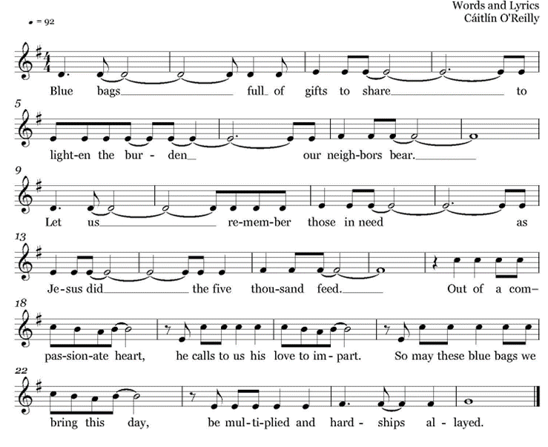
10am: Doxology, sung by all
Praise God throughout these forty days. Praise Christ, our Lord, whom God did raise.
And praise the Spirit who imparts God’s love in Christ into our hearts. Amen.

The Great Thanksgiving: Eucharistic Prayer A
The Lord be with you. And also with you. Lift up your hearts. We lift them to the Lord.
Let us give thanks to the Lord our God. It is right to give God thanks and praise.
Celebrant continues
It is right, and a good and joyful thing, always and every where to give thanks to you, Father Almighty, Creator of heaven and earth. Through Jesus Christ our Lord; who was tempted in every way as we are, yet did not sin. By his grace we are able to triumph over every evil, and to live no longer for ourselves alone, but for him who died for us and rose again. Therefore we praise you, joining our voices with Angels and Archangels and with all the company of heaven, who for ever sing this hymn to proclaim the glory of your Name:

Sanctus & Benedictus, Said at 8am, sung at 10am - S122, Martens; front pages of 1982 pew Hymnal
Holy, holy, holy Lord, God of power and might,
heaven and earth are full of your glory. Hosanna in the highest.
Blessed is he who comes in the name of the Lord. Hosanna in the highest.
The Celebrant continues
Holy and gracious Father: In your infinite love you made us for yourself, and, when we had fallen into sin and become subject to evil and death, you, in your mercy, sent Jesus Christ, your only and eternal Son, to share our human nature, to live and die as one of us, to reconcile us to you, the God and Father of all. He stretched out his arms upon the cross, and offered himself, in obedience to your will, a perfect sacrifice for the whole world. On the night he was handed over to suffering and death, our Lord Jesus Christ took bread; and when he had given thanks to you, he broke it, and gave it to his disciples, and said, "Take, eat: This is my Body, which is given for you. Do this for the remembrance of me." After supper he took the cup of wine; and when he had given thanks, he gave it to them, and said, "Drink this, all of you: This is my Blood of the new Covenant, which is shed for you and for many for the forgiveness of sins. Whenever you drink it, do this for the remembrance of me."
Therefore we proclaim the mystery of faith:
Celebrant and People
Christ has died. Christ is risen. Christ will come again.
We celebrate the memorial of our redemption, O Father, in this sacrifice of praise and thanksgiving. Recalling his death, resurrection, and ascension, we offer you these gifts. Sanctify them by your Holy Spirit to be for your people the Body and Blood of your Son, the holy food and drink of new and unending life in him. Sanctify us also that we may faithfully receive this holy Sacrament, and serve you in unity, constancy, and peace; and at the last day bring us with all your saints into the joy of your eternal kingdom. All this we ask through your Son Jesus Christ: By him, and with him, and in him, in the unity of the Holy Spirit all honor and glory is yours, Almighty Father, now and for ever. AMEN.
And now, as our Savior Christ has taught us, we are bold to say,
Our Father, who art in heaven, hallowed be thy Name, thy kingdom come, thy will be done, on earth as it is in heaven. Give us this day our daily bread.
And forgive us our trespasses, as we forgive those who trespass against us.
And lead us not into temptation, but deliver us from evil.
For thine is the kingdom, and the power, and the glory, for ever and ever. Amen.

The Breaking of the Bread Silent moment

Agnus Dei, spoken at 8am, sung at 10am - S-160, Martens; the front pages of the 1982 pew Hymnal
Lamb of God you take away the sin of the world, have mercy on us.
Lamb of God you take away the sin of the world, have mercy on us.
Lamb of God you take away the sin of the world, grant us your peace.

The Communion
Wherever you are on your spiritual journey, all are invited to receive Communion. Gluten-free wafers, as well as grape juice, are available, please indicate your preference; at the 10AM service, at the floor communion station. If you have difficulty coming forward, communion can be brought to you at your seat. You are invited to light a candle for a person or concern in your prayers. A candle station is located at the rear of the Chapel; and to the right of the pulpit in the Church.

Music at Communion
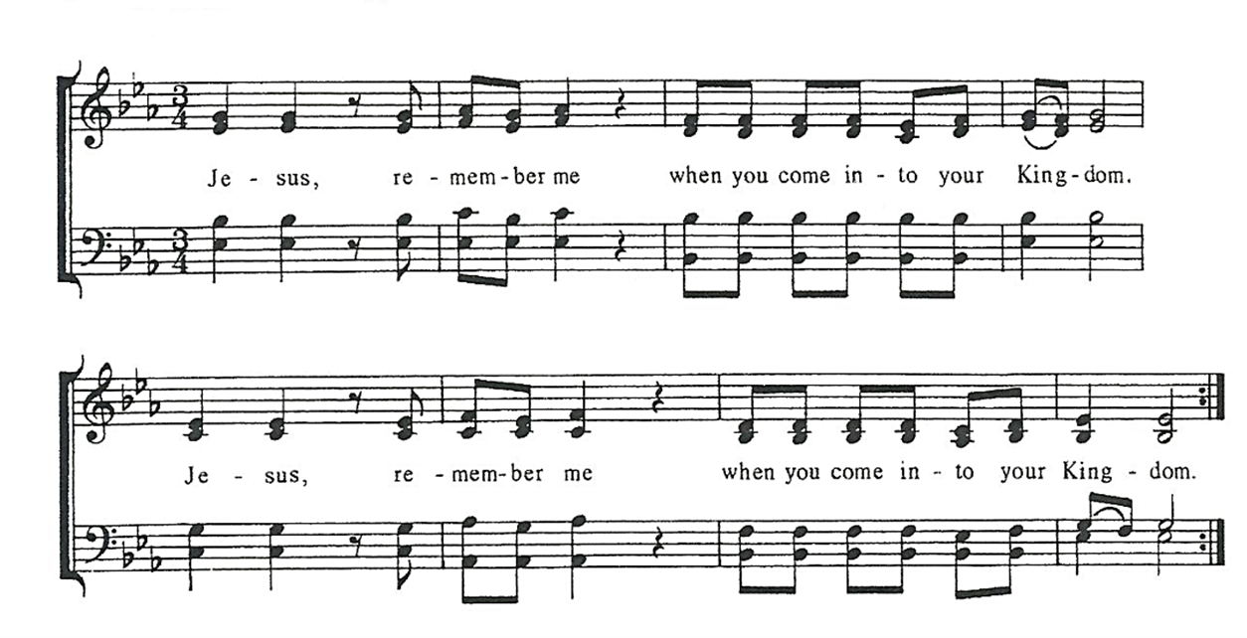
Post Communion Prayer, said by all
Eternal God, heavenly Father, you have graciously accepted us as living members of your Son,
our Savior Jesus Christ, and you have fed us with spiritual food in the sacrament of his Body and Blood. Send us now into the world in peace, and grant us strength and courage to love and serve you with gladness and singleness of heart; through Christ our Lord. Amen.

Solem Prayer

Sending Hymn # 310, O Saving Victim -Blue Pew Hymnal

Dismissal Go in peace to love and serve the Lord.
Response: Thanks be to God!

Postlude

