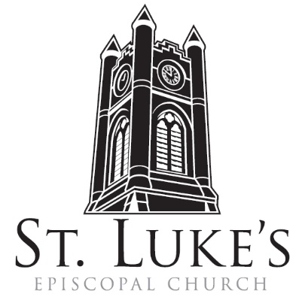
The Holy Eucharist
Religious Life Sunday

Sunday, January 21, 2024

St. Luke’s Episcopal Church
North Main at Fourth Street, Jamestown, New York
The Rt. Rev. Sean Rowe, Bishop
The Rev. Luke Fodor, Rector; The Rev. Deacon Cathy Smith;
Mr. Paul Johnson, Verger; Mr. Loren Masánqué, Minister of Music
The Rev. Deacon Jessica Frederick, Curate for Children, Youth & Family Ministry
www.stlukesjamestown.org ~ email: stlukes@stlukesjamestown.org

The mission is simple: to Connect all people, help them Discover God's love, empower them to Serve and watch them Grow.”

WELCOME TO ST. LUKE’S
We welcome you this morning to St. Luke’s Church and are delighted to have you join us for worship today. If you are visiting for the first time, or are looking for a church home, please fill in a pew card and place it in the offering plate.
At the time of Communion, all are invited to God’s Table. In addition to the altar rail, at the 10 a.m. service a floor-level Communion station is made available, which includes gluten-free wafers and grape juice. Please indicate your preference.
Available to children is Children’s Chapel downstairs during the 10am service, a visit to the Children’s Corner, or the use of a “Children’s Activity Bag” found near the front of the church nave (ask an usher). Join us downstairs for refreshments. All are welcome! Audio transmitters are available for those who have difficulty hearing the service; please ask an usher.
~ Copies of today’s sermon are available at the doors. ~

Prelude: Ut, Re, Me, Fa, Sol, La -William Byrd
Opening Hymn #518: Christ is made the Foundation -Blue Pew Hymnal

Opening Acclamation
Celebrant: Blessed be God: Father, Son, and Holy Spirit.
People: And blessed be God’s kingdom, now and for ever. Amen.

Collect for Purity, said by all
Almighty God, to you all hearts are open, all desires known, and from you no secrets are hid: Cleanse the thoughts of our hearts by the inspiration of your Holy Spirit, that we may perfectly love you, and worthily magnify your holy Name; through Christ our Lord. Amen.

Gloria, all S-280, Powell; the front pages of the 1982 pew Hymnal
Glory to God in the highest, and peace to God’s people on earth. Lord God, heavenly King, almighty God and Father, we worship you, we give you thanks, we praise you for your glory. Lord Jesus Christ, only Son of the Father, Lord God, Lamb of God, you take away the sin of the world; have mercy on us; you are seated at the right hand of the Father; receive our prayer. For you alone are the Holy One, you alone are the Lord, you alone are the Most High, Jesus Christ, with the Holy Spirit, in the glory of God the Father. Amen.
The Collect of the Day:
The Lord be with you. Response: And also with you.
Let us pray. Give us grace, O Lord, to answer readily the call of our Savior Jesus Christ and proclaim to all people the Good News of his salvation, that we and the whole world may perceive the glory of his marvelous works; who lives and reigns with you and the Holy Spirit, one God, for ever and ever. Amen.

The First Reading is from Jonah 3:1-5, 10

The word of the Lord came to Jonah a second time, saying, “Get up, go to Nineveh, that great city, and proclaim to it the message that I tell you.” So Jonah set out and went to Nineveh, according to the word of the Lord. Now Nineveh was an exceedingly large city, a three days' walk across. Jonah began to go into the city, going a day's walk. And he cried out, “Forty days more, and Nineveh shall be overthrown!” And the people of Nineveh believed God; they proclaimed a fast, and everyone, great and small, put on sackcloth. When God saw what they did, how they turned from their evil ways, God changed his mind about the calamity that he had said he would bring upon them; and he did not do it. The Word of the LORD. Thanks be to God.

Psalm #62:6-14, 8:00 AM, read responsively by half verse, 10:00 AM, see insert.

6 For God alone my soul in silence waits; * truly, there is my hope.

7 God alone is my rock and my salvation, * my stronghold, so that I shall not be shaken.

8 In God is my safety and my honor; * God is my strong rock and my refuge.

9 Put your trust in God always, O people; * pour out your hearts before the One who is our refuge.

10 Those of high degree are but a fleeting breath, * even those of low estate cannot be trusted.

11 On the scales they are lighter than a breath, * all of them together.

12 Put no trust in extortion; In robbery take no empty pride; * though wealth increase, set not your heart upon it.

13 God has spoken once, twice have I heard it, * that power belongs to God.

14 Steadfast love is yours, O God, * for you repay everyone according to their deeds.

The Second Reading is from 1st Corinthians 7:29-31

I mean, brothers and sisters, the appointed time has grown short; from now on, let even those who have wives be as though they had none, and those who mourn as though they were not mourning, and those who rejoice as though they were not rejoicing, and those who buy as though they had no possessions, and those who deal with the world as though they had no dealings with it. For the present form of this world is passing away. The Word of the LORD. Thanks be to God.

Gospel Sequence Hymn #525: The Church’s One Foundation, v. 1 & 2 -Blue Pew Hymnal

The Holy Gospel of our Lord Jesus Christ, according to Mark 1:14-20
Response before the Gospel: Glory to you, Lord Christ.

After John was arrested, Jesus came to Galilee, proclaiming the good news of God, and saying, “The time is fulfilled, and the kingdom of God has come near; repent, and believe in the good news.” As Jesus passed along the Sea of Galilee, he saw Simon and his brother Andrew casting a net into the sea—for they were fishermen. And Jesus said to them, “Follow me and I will make you fish for people.” And immediately they left their nets and followed him. As he went a little farther, he saw James son of Zebedee and his brother John, who were in their boat mending the nets. Immediately he called them; and they left their father Zebedee in the boat with the hired men, and followed him. The Gospel of the Lord. Praise to You, Lord Christ.

Gospel Sequence Hymn #525 The Church’s one foundation, v. 5 -Blue Pew Hymnal

Sermon -The Rev. Jessica Frederick

Nicene Creed, said by all, standing in body or in spirit.
We believe in one God, the Father, the Almighty, maker of heaven and earth, of all that is, seen
and unseen. We believe in one Lord, Jesus Christ, the only Son of God, eternally begotten of the
Father, God from God, Light from Light, true God from true God, begotten, not made, of one
Being with the Father; through him all things were made. For us and for our salvation he came
down from heaven, was incarnate of the Holy Spirit and the Virgin Mary and became truly
human. For our sake he was crucified under Pontius Pilate; he suffered death and was buried.
On the third day he rose again in accordance with the Scriptures; he ascended into heaven and is seated at the right hand of the Father. He will come again in glory to judge the living and the dead, and his kingdom will have no end. We believe in the Holy Spirit, the Lord, the giver of life, who proceeds from the Father, who with the Father and the Son is worshiped and glorified, who has spoken through the prophets. We believe in one holy catholic and apostolic Church. We acknowledge one baptism for the forgiveness of sins. We look for the resurrection of the dead, and the life of the world to come. Amen.

The Prayers of the People, Form VI -BCP 392
In peace, we pray to you, Lord God. Silence

For all people in their daily life and work; For our families, friends, and neighbors, and for those who are alone.

For this community, the nation, and the world; For all who work for justice, freedom, and peace.

For the just and proper use of your creation; For the victims of hunger, fear, injustice, and oppression.

For all who are in danger, sorrow, or any kind of trouble; For those who minister to the sick, the friendless, and the needy.

For the peace and unity of the Church of God; For all who proclaim the Gospel, and all who seek the Truth.

For Michael our Presiding Bishop, for Sean, the Bishop of our Diocesan Partnership, for the Episcopal Partnership churches of St. Andrews, Clearfield, St. James, Batavia, St. Andrews, Buffalo and Good Shepherd, Buffalo, for The Church of South India; for Sister Myriam Joy, for Luke, Jessica and Cathy, our clergy, and for all bishops, priests and deacons; For all who serve God in the Church.
For the special needs and concerns of this congregation. Silence
We pray for Tim Pickett, Carol Boling, Pete Nagle, Joyce Crate, Mary Holton, Deacon Pierce, Mac Dawson, Bob Stewart, Casey, for the people of the Ukraine and the People of the Holy Land, and those others we now name. Silence

Hear us, Lord; For your mercy is great.

We thank you, Lord, for all the blessings of this life.

We will exalt you, O God our King; And praise your Name for ever and ever.
We pray for all who have died, that they may have a place in your eternal kingdom. Silence
Lord, let your loving-kindness be upon them; Who put their trust in you.
We pray to you also for the forgiveness of our sins.
Lay Reader and People
God of all mercy, we confess that we have sinned against you, opposing your will in our lives.
We have denied your goodness in each other, in ourselves, and in the world you have created.
We repent of the evil that enslaves us, the evil we have done, and the evil done on our behalf.
Forgive, restore, and strengthen us through our Savior Jesus Christ, that we may abide in your love and serve only your will. Amen.

Absolution

10:00 AM: Altar Guild Commissioning of New Members

Priest: Dear people of God, we are all baptized by the one Spirit into one Body, and given gifts for a variety of ministries for the common good. Our purpose is to commission these persons in the Name of God and of this congregation, to the special ministry to which they are called.
The Priest asks the Sponsors: Are these persons you are to present prepared by a commitment to Christ as Lord, by regular attendance at worship, and by the knowledge of their duties, to exercise their ministry to the honor of God, and the well-being of the Church?
Sponsors: I believe they are.
Priest, to the candidates: Will you faithfully and reverently execute the duties of your ministry to the honor of God, and the benefit of the members of this congregation?
Candidates: I will.
Sacristan: I present to you Terri Rettberg and Sheryl Brunecz to be admitted to full membership in St. Agnes’ Altar Guild in this congregation.
Priest: Do you desire to be admitted to this ministry, and do you cheerfully accept its responsibilities?
Candidates answer: I do.
Priest: May God guide and bless you in the doing of this work.
All Answer: Amen.
Blessing of the Altar Guild Crosses:
Priest: O gracious God, who in your mercy ordained that your Son should suffer death on a cross of shame: we thank you that it has become for us the sign of his triumph and the banner of our salvation. We pray you to bless these crosses, that those who wear them may be urged by his example and presence to offer faithful and conscientious service at your altar; through your Son, our Lord and Savior Jesus Christ. Amen.
V. In the temple of the Lord, all are crying, “Glory!”
R: Holiness adorns your house, O Lord, forever.
Priest: Let us pray: O God, you accepted the service of Levites in your temple, and your Son was pleased to accept the loving service of his friends: Bless the ministry of these persons and give them grace, that they, caring for the vessels and vestments of your worship and the adornment of your sanctuary, may make the place of your presence glorious; through Jesus Christ our Lord. Amen.
Priest: I admit you, Terri and Sheryl, to the Altar Guild of St. Luke’s Church. You are given this cross as a token and symbol of your ministry, in the Name of the Father, and of the Son, and of the Holy Spirit. Amen. The Sacristan presents a cross to each new member.

The Peace Let us exchange the Peace of Christ with one another!
The peace of the Lord be always with you. People: And also with you.

Announcements

THE HOLY COMMUNION
If you’d like to give electronically, use your phone’s camera to scan the QR code.

Offertory

8:00 AM, said by all: All things come of Thee O Lord, and of Thine Own have we given Thee. Amen.

10:00 AM: Offertory Anthem: Pescador Des hombres -St. Luke’s Choir

10:00 AM: Presentation of the Blue Bags
Blue Bag Processional words & music by Cáitlín O'Reilly
Blue bags full of gifts to share, to lighten the burden, our neighbors bear.
Let us remember those in need as Jesus did the five thousand feed.
Out of a compassionate heart, He calls to us His love to impart.
So may these blue bags we bring this day, be multiplied and hardships allayed.

Doxology, sung by all
Praise God from whom all blessings flow; praise God all creatures here below
praise God above, ye heav’nly host, praise Father, Son and Holy Ghost. Amen.

THE GREAT THANKSGIVING: Eucharistic Prayer: Enriching Our Worship 3

The Lord be with you. And also with you.
Lift up your hearts. We lift them to the Lord.
Let us give thanks to the Lord our God. It is right to give our thanks and praise.

All thanks and praise are yours at all times and in all places, our true and loving God; through Jesus Christ, your eternal Word, the Wisdom from on high by whom you created all things. You laid the foundations of the world and enclosed the sea when it burst out from the womb; You brought forth all creatures of the earth and gave breath to humankind. Wondrous are you, Holy One of Blessing, all you create is a sign of hope for our journey; And so as the morning stars sing your praises we join the heavenly beings and all creation as we shout with joy:

Holy, Holy, Holy Lord, God of power and might,
heaven and earth are full of your glory. Hosanna in the highest.
Blessed is the One who comes in the name of the Lord. Hosanna in the highest.

Glory and honor are yours, Creator of all, your Word has never been silent; you called a people to yourself, as a light to the nations, you delivered them from bondage and led them to a land of promise. Of your grace, you gave Jesus to be human, to share our life, to proclaim the coming of your holy reign and give himself for us, a fragrant offering. Through Jesus Christ our Redeemer, you have freed us from sin, brought us into your life, reconciled us to you, and restored us to the glory you intend for us. We thank you that on the night before he died for us Jesus took bread, and when he had given thanks to you, he broke it, gave it to his friends and said: “Take, eat, this is my Body, broken for you. Do this for the remembrance of me.” After supper Jesus took the cup of wine, said the blessing, gave it to his friends and said: “Drink this, all of you: this cup is the new Covenant in my Blood, poured out for you and for all for the forgiveness of sin. Do this for the remembrance of me.” And so, remembering all that was done for us: the cross, the tomb, the resurrection and ascension, longing for Christ’s coming in glory, and presenting to you these gifts your earth has formed and human hands have made, we acclaim you, O Christ:

Celebrant and People:
Dying, you destroyed our death. Rising, you restored our life. Christ Jesus, come in glory!

Send your Holy Spirit upon us and upon these gifts of bread and wine that they may be to us the Body and Blood of your Christ. Grant that we, burning with your Spirit’s power, may be a people of hope, justice and love. Giver of Life, draw us together in the Body of Christ, and in the fullness of time gather us with blessed Saint Luke, and all your people into the joy of our true eternal home. Through Christ and with Christ and in Christ, by the inspiration of your Holy Spirit, we worship you our God and Creator in voices of unending praise.

Celebrant and People: Blessed are you now and forever. 8:00 AM: Amen. 10:00 AM sing Amen below:

And now, as our Savior Christ has taught us, we are bold to say,
Our Father, who art in heaven, hallowed be thy Name, thy kingdom come, thy will be done, on earth as it is in heaven. Give us this day our daily bread. And forgive us our trespasses, as we forgive those who trespass against us. And lead us not into temptation, but deliver us from evil. For thine is the kingdom, and the power, and the glory, for ever and ever. Amen.

The Breaking of the Bread
8:00 AM: Alleluia, Christ our Passover is sacrificed for us. People: Therefore, let us keep the
feast. Alleluia.

10:00 AM: Jesus Lamb of God, have mercy on us. Jesus, bearer of our sins, have mercy on us.
Jesus, Redeemer, Redeemer of the world, give us your peace, give us your peace.

The Communion Wherever you are on your spiritual journey, all are invited to receive Communion. Gluten-free wafers, as well as grape juice, are available, please indicate your preference; If you have difficulty coming forward, communion can be brought to you at your seat. You are invited to light a candle for a person or concern in your prayers. A candle station is located at the rear of the Chapel; and to the right of the pulpit in the Church.

Communion Music
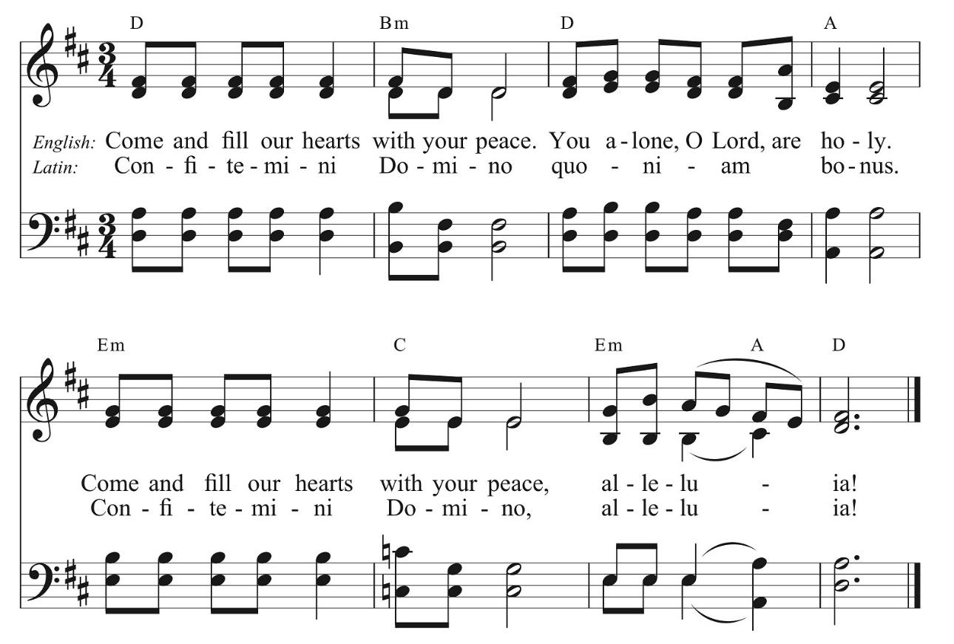

10:00 AM: Sending Forth Eucharistic Visitors
Priest: Karl, in the name of this congregation, I send you forth bearing these holy gifts, that Dave, to whom you go, may share with us in the Communion of Christ’s Body and Blood.
Said by all: We who are many are one Body, because we all share one bread, one cup.

Post Communion Prayer, said by all
Eternal God, heavenly Father, you have graciously accepted us as living members of your Son, our Savior Jesus Christ, and you have fed us with spiritual food in the sacrament of his Body and Blood. Send us now into the world in peace, and grant us strength and courage to love and serve you with gladness and singleness of heart; through Christ our Lord. Amen.

Blessing

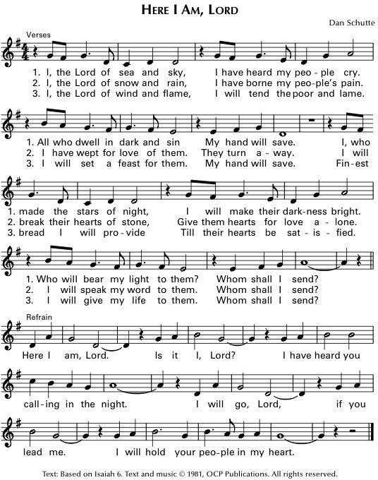

Dismissal Go in peace to love and serve the Lord. Alleluia, Alleluia, Alleluia!
Response: Thanks be to God! Alleluia, Alleluia, Alleluia!

Postlude: Praeludium Nr 8, BWV 560 -J.S. Bach

The altar flowers are given to the Glory of God in celebration of Charles Rice’s 75th Birthday by his family.

