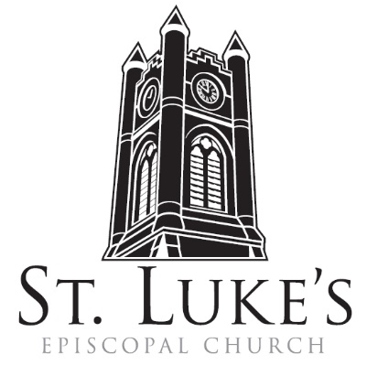
The Holy Eucharist

Sunday, January 14, 2024

St. Luke’s Episcopal Church
North Main at Fourth Street, Jamestown, New York
The Rt. Rev. Sean Rowe, Bishop
The Rev. Luke Fodor, Rector; The Rev. Deacon Cathy Smith;
Mr. Paul Johnson, Verger; Mr. Loren Masánqué, Minister of Music
The Rev. Deacon Jessica Frederick, Curate for Children, Youth & Family Ministry
www.stlukesjamestown.org ~ email: stlukes@stlukesjamestown.org

The mission is simple: to Connect all people, help them Discover God's love, empower them to Serve and watch them Grow.”

WELCOME TO ST. LUKE’S
We welcome you this morning to St. Luke’s Church and are delighted to have you join us for worship today. If you are visiting for the first time, or are looking for a church home, please fill in a pew card and place it in the offering plate.
At the time of Communion, all are invited to God’s Table. In addition to the altar rail, at the 10 a.m. service a floor-level Communion station is made available, which includes gluten-free wafers and grape juice. Please indicate your preference.
Available to children is Children’s Chapel downstairs during the 10am service, a visit to the Children’s Corner, or the use of a “Children’s Activity Bag” found near the front of the church nave (ask an usher). Join us downstairs for refreshments. All are welcome! Audio transmitters are available for those who have difficulty hearing the service; please ask an usher.
~ Copies of today’s sermon are available at the doors. ~

Prelude Elevation -Francois Couperin
Opening Hymn: Christ be Our Light, v. 1, 2 & 5 -Insert

Opening Acclamation
Celebrant: Blessed be God: Father, Son, and Holy Spirit.
People: And blessed be God’s kingdom, now and for ever. Amen.

Collect for Purity, said by all
Almighty God, to you all hearts are open, all desires known, and from you no secrets are hid: Cleanse the thoughts of our hearts by the inspiration of your Holy Spirit, that we may perfectly love you, and worthily magnify your holy Name; through Christ our Lord. Amen.

Gloria, all S-280, Powell; the front pages of the 1982 pew Hymnal
Glory to God in the highest, and peace to God’s people on earth. Lord God, heavenly King, almighty God and Father, we worship you, we give you thanks, we praise you for your glory. Lord Jesus Christ, only Son of the Father, Lord God, Lamb of God, you take away the sin of the world; have mercy on us; you are seated at the right hand of the Father; receive our prayer. For you alone are the Holy One, you alone are the Lord, you alone are the Most High, Jesus Christ, with the Holy Spirit, in the glory of God the Father. Amen.

The Collect of the Day:
The Lord be with you. Response: And also with you.
Let us pray. Almighty God, whose Son our Savior Jesus Christ is the light of the world: Grant that your people, illumined by your Word and Sacraments, may shine with the radiance of Christ's glory, that he may be known, worshipped, and obeyed to the ends of the earth; through Jesus Christ our Lord, who with you and the Holy Spirit lives and reigns, one God, now and for ever. Amen.

The First Reading is from 1 Samuel 3:1-20

Now the boy Samuel was ministering to the Lord under Eli. The word of the Lord was rare in those days; visions were not widespread. At that time Eli, whose eyesight had begun to grow dim so that he could not see, was lying down in his room; the lamp of God had not yet gone out, and Samuel was lying down in the temple of the Lord, where the ark of God was. Then the Lord called, “Samuel! Samuel!” and he said, “Here I am!” and ran to Eli, and said, “Here I am, for you called me.” But he said, “I did not call; lie down again.” So he went and lay down. The Lord called again, “Samuel!” Samuel got up and went to Eli, and said, “Here I am, for you called me.” But he said, “I did not call, my son; lie down again.” Now Samuel did not yet know the Lord, and the word of the Lord had not yet been revealed to him. The Lord called Samuel again, a third time. And he got up and went to Eli, and said, “Here I am, for you called me.” Then Eli perceived that the Lord was calling the boy. Therefore Eli said to Samuel, “Go, lie down; and if he calls you, you shall say, ‘Speak, Lord, for your servant is listening.’” So Samuel went and lay down in his place. Now the Lord came and stood there, calling as before, “Samuel! Samuel!” And Samuel said, “Speak, for your servant is listening.” [Then the Lord said to Samuel, “See, I am about to do something in Israel that will make both ears of anyone who hears of it tingle. On that day I will fulfill against Eli all that I have spoken concerning his house, from beginning to end. For I have told him that I am about to punish his house forever, for the iniquity that he knew, because his sons were blaspheming God, and he did not restrain them. Therefore I swear to the house of Eli that the iniquity of Eli’s house shall not be expiated by sacrifice or offering forever.” Samuel lay there until morning; then he opened the doors of the house of the Lord. Samuel was afraid to tell the vision to Eli. But Eli called Samuel and said, “Samuel, my son.” He said, “Here I am.” Eli said, “What was it that he told you? Do not hide it from me. May God do so to you and more also, if you hide anything from me of all that he told you.” So Samuel told him everything and hid nothing from him. Then he said, “It is the Lord; let him do what seems good to him.” As Samuel grew up, the Lord was with him and let none of his words fall to the ground. And all Israel from Dan to Beer-sheba knew that Samuel was a trustworthy prophet of the Lord.] The Word of the LORD. Thanks be to God.

Psalm #139:1-5, 12-17; Please join in saying the Psalm responsively by whole verse. - The Saint Helena Psalter

1 O God, you have searched me out and known me; *

you know my sitting down and my rising up; you discern my thoughts from afar.

2 You trace my journeys and my resting-places *

and are acquainted with all my ways.

3 Indeed, there is not a word on my lips, *

but you, O God, know it altogether.

4 You press upon me behind and before *

and lay your hand upon me.

5 Such knowledge is too wonderful for me; *

it is so high that I cannot attain to it.
12 For you yourself created my inmost parts; *
you knit me together in my mother’s womb.
13 I will thank you because I am marvelously made; *
your works are wonderful, and I know it well.
14 My body was not hidden from you, *
while I was being made in secret and woven in the depths of the earth.
15 Your eyes beheld my limbs, yet unfinished in the womb;
all of them were written in your book;*
they were fashioned day by day, when as yet there was none of them.
16 How deep I find your thoughts, O God; *
how great is the sum of them!
17 If I were to count them, they would be more in number than the sand; *
to count them all, my life span would need to be like yours.

The Second Reading is from 1st Corinthians 6:12-20

“All things are lawful for me,” but not all things are beneficial. “All things are lawful for me,” but I will not be dominated by anything. “Food is meant for the stomach and the stomach for food,” and God will destroy both one and the other. The body is meant not for fornication but for the Lord, and the Lord for the body. And God raised the Lord and will also raise us by his power. Do you not know that your bodies are members of Christ? Should I therefore take the members of Christ and make them members of a prostitute? Never! Do you not know that whoever is united to a prostitute becomes one body with her? For it is said, “The two shall be one flesh.” But anyone united to the Lord becomes one spirit with him. Shun fornication! Every sin that a person commits is outside the body; but the fornicator sins against the body itself. Or do you not know that your body is a temple of the Holy Spirit within you, which you have from God, and that you are not your own? For you were bought with a price; therefore glorify God in your body. The Word of the LORD. Thanks be to God.

Gospel Sequence Hymn: The Summons, v. 1 & 3 -Insert

The Holy Gospel of our Lord Jesus Christ, according to John 1:43-51
Response before the Gospel: Glory to you, Lord Christ.

Jesus decided to go to Galilee. He found Philip and said to him, “Follow me.” Now Philip was from Bethsaida, the city of Andrew and Peter. Philip found Nathanael and said to him, “We have found him about whom Moses in the law and also the prophets wrote, Jesus son of Joseph from Nazareth.” Nathanael said to him, “Can anything good come out of Nazareth?” Philip said to him, “Come and see.” When Jesus saw Nathanael coming toward him, he said of him, “Here is truly an Israelite in whom there is no deceit!” Nathanael asked him, “Where did you get to know me?” Jesus answered, “I saw you under the fig tree before Philip called you.” Nathanael replied, “Rabbi, you are the Son of God! You are the King of Israel!” Jesus answered, “Do you believe because I told you that I saw you under the fig tree? You will see greater things than these.” And he said to him, “Very truly, I tell you, you will see heaven opened and the angels of God ascending and descending upon the Son of Man.” The Gospel of the Lord. Praise to You, Lord Christ.

Gospel Sequence Hymn: The Summons, v. 5 -Insert

Sermon -The Rector

Nicene Creed, said by all, standing in body or in spirit.
We believe in one God, the Father, the Almighty, maker of heaven and earth, of all that is, seen
and unseen. We believe in one Lord, Jesus Christ, the only Son of God, eternally begotten of the
Father, God from God, Light from Light, true God from true God, begotten, not made, of one
Being with the Father; through him all things were made. For us and for our salvation he came
down from heaven, was incarnate of the Holy Spirit and the Virgin Mary and became truly
human. For our sake he was crucified under Pontius Pilate; he suffered death and was buried.
On the third day he rose again in accordance with the Scriptures; he ascended into heaven and is seated at the right hand of the Father. He will come again in glory to judge the living and the dead, and his kingdom will have no end. We believe in the Holy Spirit, the Lord, the giver of life, who proceeds from the Father, who with the Father and the Son is worshiped and glorified, who has spoken through the prophets. We believe in one holy catholic and apostolic Church. We acknowledge one baptism for the forgiveness of sins. We look for the resurrection of the dead, and the life of the world to come. Amen.

The Prayers of the People, Form VI -BCP 392
In peace, we pray to you, Lord God. Silence

For all people in their daily life and work; For our families, friends, and neighbors, and for those who are alone.

For this community, the nation, and the world; For all who work for justice, freedom, and peace.

For the just and proper use of your creation; For the victims of hunger, fear, injustice, and oppression.

For all who are in danger, sorrow, or any kind of trouble; For those who minister to the sick, the friendless, and the needy.

For the peace and unity of the Church of God; For all who proclaim the Gospel, and all who seek the Truth.

For Michael our Presiding Bishop, for Sean, the Bishop of our Diocesan Partnership, for the Episcopal Partnership churches of Holy Trinity, Brookville, St. Paul’s, Angola and St. Luke’s, Attica, for the Church of the Province of South East Asia; for Luke, Jessica and Cathy, our clergy, and for all bishops, priests and deacons; For all who serve God in the Church.
For the special needs and concerns of this congregation. Silence
We pray for Tim Pickett, Carol Boling, Pete Nagle, Joyce Crate, Mary Holton, Deacon Pierce, Mac Dawson, Bob Stewart, for the people of the Ukraine and the People of the Holy Land, and those others we now name. Silence

Hear us, Lord; For your mercy is great.

We thank you, Lord, for all the blessings of this life.

We will exalt you, O God our King; And praise your Name for ever and ever.
Remembering Joe Johnson, we pray for all who have died, that they may have a place in your eternal kingdom. Silence
Lord, let your loving-kindness be upon them; Who put their trust in you.
We pray to you also for the forgiveness of our sins.
Lay Reader and People
God of all mercy, we confess that we have sinned against you, opposing your will in our lives.
We have denied your goodness in each other, in ourselves, and in the world you have created.
We repent of the evil that enslaves us, the evil we have done, and the evil done on our behalf.
Forgive, restore, and strengthen us through our Savior Jesus Christ, that we may abide in your love and serve only your will. Amen.

Absolution

The Peace Let us exchange the Peace of Christ with one another!
The peace of the Lord be always with you. People And also with you.

Announcements

THE HOLY COMMUNION
If you’d like to give electronically, use your phone’s camera to scan the QR code.

Offertory

8:00 AM, said by all: All things come of Thee O Lord, and of Thine Own have we given Thee. Amen.

10:00 AM: Offertory Anthem: Come Follow me -St. Luke’s Choir
10:00 AM: Doxology, sung by all
Praise God from whom all blessings flow; praise God all creatures here below
praise God above, ye heav’nly host, praise Father, Son and Holy Ghost. Amen.

THE GREAT THANKSGIVING: Eucharistic Prayer: Enriching Our Worship 3

The Lord be with you. And also with you.
Lift up your hearts. We lift them to the Lord.
Let us give thanks to the Lord our God. It is right to give our thanks and praise.

All thanks and praise are yours at all times and in all places, our true and loving God; through Jesus Christ, your eternal Word, the Wisdom from on high by whom you created all things. You laid the foundations of the world and enclosed the sea when it burst out from the womb; You brought forth all creatures of the earth and gave breath to humankind. Wondrous are you, Holy One of Blessing, all you create is a sign of hope for our journey; And so as the morning stars sing your praises we join the heavenly beings and all creation as we shout with joy:
Holy, Holy, Holy Lord, God of power and might,
heaven and earth are full of your glory. Hosanna in the highest.
Blessed is the One who comes in the name of the Lord. Hosanna in the highest.

Glory and honor are yours, Creator of all, your Word has never been silent; you called a people to yourself, as a light to the nations, you delivered them from bondage and led them to a land of promise. Of your grace, you gave Jesus to be human, to share our life, to proclaim the coming of your holy reign and give himself for us, a fragrant offering. Through Jesus Christ our Redeemer, you have freed us from sin, brought us into your life, reconciled us to you, and restored us to the glory you intend for us. We thank you that on the night before he died for us Jesus took bread, and when he had given thanks to you, he broke it, gave it to his friends and said: “Take, eat, this is my Body, broken for you. Do this for the remembrance of me.” After supper Jesus took the cup of wine, said the blessing, gave it to his friends and said: “Drink this, all of you: this cup is the new Covenant in my Blood, poured out for you and for all for the forgiveness of sin. Do this for the remembrance of me.” And so, remembering all that was done for us: the cross, the tomb, the resurrection and ascension, longing for Christ’s coming in glory, and presenting to you these gifts your earth has formed and human hands have made, we acclaim you, O Christ:

Celebrant and People:
Dying, you destroyed our death. Rising, you restored our life. Christ Jesus, come in glory!

Send your Holy Spirit upon us and upon these gifts of bread and wine that they may be to us the Body and Blood of your Christ. Grant that we, burning with your Spirit’s power, may be a people of hope, justice and love. Giver of Life, draw us together in the Body of Christ, and in the fullness of time gather us with blessed Saint Luke, and all your people into the joy of our true eternal home. Through Christ and with Christ and in Christ, by the inspiration of your Holy Spirit, we worship you our God and Creator in voices of unending praise.

Celebrant and People: Blessed are you now and for ever. Amen. 10:00 AM sing below:

And now, as our Savior Christ has taught us, we are bold to say,
Our Father, who art in heaven, hallowed be thy Name,
thy kingdom come, thy will be done, on earth as it is in heaven.
Give us this day our daily bread.
And forgive us our trespasses, as we forgive those who trespass against us.
And lead us not into temptation, but deliver us from evil.
For thine is the kingdom, and the power, and the glory,
for ever and ever. Amen.

The Breaking of the Bread
8:00 AM: Alleluia, Christ our Passover is sacrificed for us. People: Therefore, let us keep the
feast. Alleluia.

10:00 AM: Jesus Lamb of God, have mercy on us. Jesus, bearer of our sins, have mercy on us.
Jesus, Redeemer, Redeemer of the world, give us your peace, give us your peace.

The Communion Wherever you are on your spiritual journey, all are invited to receive Communion.
Gluten-free wafers, as well as grape juice, are available, please indicate your preference;
at the 10AM service, at the floor communion station. If you have difficulty coming forward, communion can be brought to you at your seat. You are invited to light a candle for a person or concern in your prayers.
A candle station is located at the rear of the Chapel; and to the right of the pulpit in the Church.

Communion Music
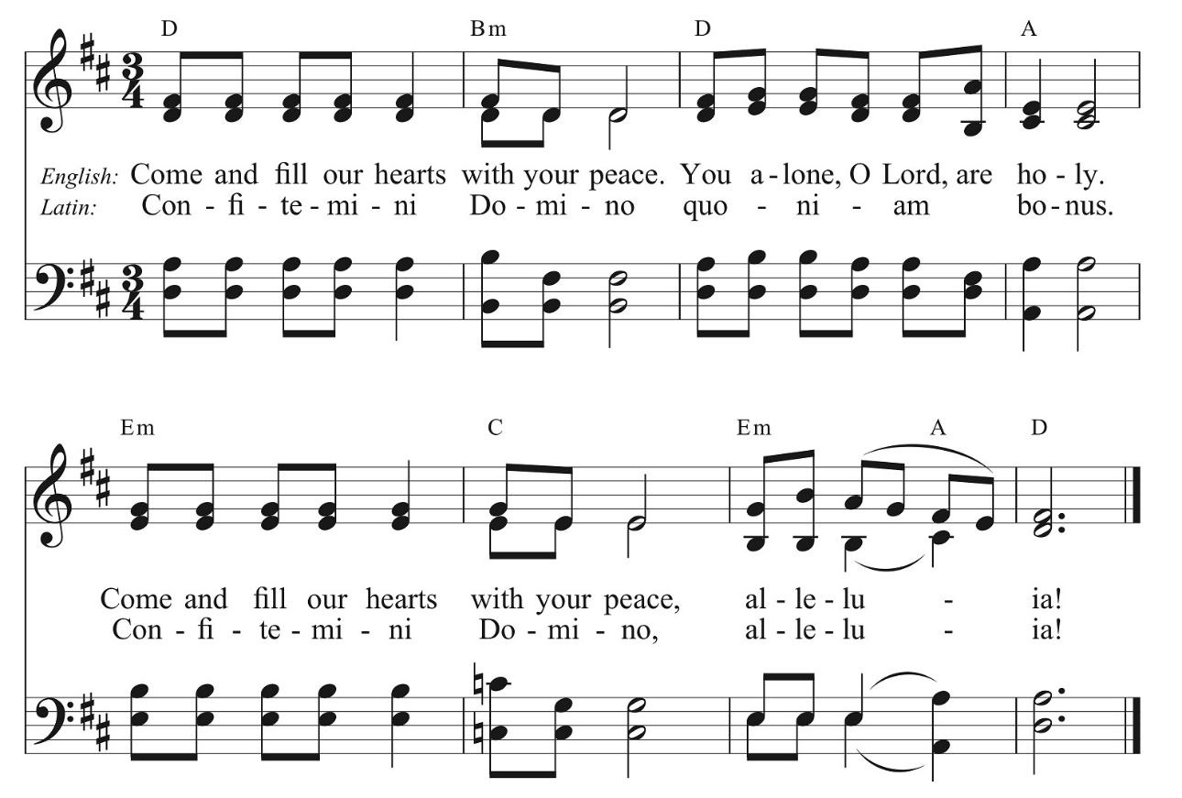

Post Communion Prayer, said by all
Eternal God, heavenly Father, you have graciously accepted us as living members of your Son, our Savior Jesus Christ, and you have fed us with spiritual food in the sacrament of his Body and Blood. Send us now into the world in peace, and grant us strength and courage to love and serve you with gladness and singleness of heart; through Christ our Lord. Amen.

Blessing

Sending Hymn #477, Let Every Tongue Confess, v. 1, 4 & 5 -1982 pew Hymnal

Dismissal Go in peace to love and serve the Lord. Alleluia, Alleluia, Alleluia!
Response: Thanks be to God! Alleluia, Alleluia, Alleluia!

Postlude Organ Sonata 2, 2nd movement -Mendelssohn

The altar flowers are given to the Glory of God by Willow and Luke Fodor in loving memory of Mark E. Bender on his birthday.

If you are interested in sponsoring altar flowers, the cost is $75.
There is a sign-up board in the stairway vestibule where you may write your name.

Announcements

Blue Bag Sunday 1/21 for St. Susan’s Center
January's Blue Bag Ministry benefits the St. Susan's Center. Be sure to grab your Blue Bag at St. Luke's today to bring back next Sunday! Here's a list of suggested items: 100% fruit juice, Saltine crackers, Canned fruit, Large cans of vegetables, Paper towels, Men’s tube socks, Men’s gloves, Men’s and women’s gloves and hats, Children/youth gloves and hats, Gift cards to Tops or Walmart for perishable goods like milk, cheese, etc.

New Neighbors Volunteer Coffee Hour 1/20
If you are interested in volunteering with the New Neighbors Coalition, we are hosting a volunteer coffee every third Saturday of the month, at 9am in the undercroft of St. Luke's Episcopal Church in Jamestown. Stop by to know more about the work we are doing and learn how you can get involved!

Service on the Slopes
If you enjoy a snowy mountaintop experience on Sundays, be sure to visit Holiday Valley for the Service on the Slopes, a brief ecumenical service of prayer, scripture reading and communion with a conversational sermon on the slopes. We meet in the Warming Hut on top of Cindy's lift weekly on Sundays at 2:30pm until March 10.

Annual Meeting
St. Luke’s 190th Annual Meeting is planned for Sunday the 28th during the 8am and 10am services. If you have been asked to provide information regarding one of our ministries, please do your best to email a report to nicole.gustafson@stlukesjamestown.org by January 15th.

Mangia! Soup or Chili Cookoff to benefit Youth Pilgrimage to Italy
Each year, following the final session of the Annual Meeting at the 10 am service, St. Luke’s hosts an annual Soup-or Chili Cook-Off: Chefs donate their best soups and chilis, while St. Luke’s community votes for the best culinary creation. Participants pay $2 to purchase a bowl and spoon – plus $1 per scoop of soup. The soup and chili (one in each category) which receive the most “votes” (that is, scoops of soup) wins! All proceeds from the fundraiser benefit St. Luke’s Youth Service and Pilgrimage trips. This year’s funds will support a particularly exciting opportunity: St. Luke’s youth pilgrimage to Italy in February. Eight of St. Luke’s youth (from the Confirmation Classes of 2022-24) will be walking the Via Francigena, an ancient pilgrimage route from Viterbo to Rome. To make this fundraiser a success, we need YOU: Contestants interested in entering their soup or chili, contact Jessica Frederick to sign up.

Pledging Envelopes Available! If you requested envelopes when you pledged for 2024, they are available by the main doors of the church for pickup. If you haven’t turned in your pledge yet, there’s still time! Forms are available on the tables by the doors in the church. Any questions about pledging, envelopes, etc.? See Janet Card or email her at janet.card@stlukesjamestown.org.

